**ASSIGNMENT 3**

**PROBLEM 1**

Concrete_Slump_Test_Data <- read_excel("Concrete Slump Test Data.xlsx")

Concrete_Slump_Test_Data

**Question 1.1:**

**Scatterplot:**

conc <- Concrete_Slump_Test_Data[,-1]

scatterplotMatrix(conc,spread = FALSE,lty.smooth=2,main="Scatter Plot Matrix")

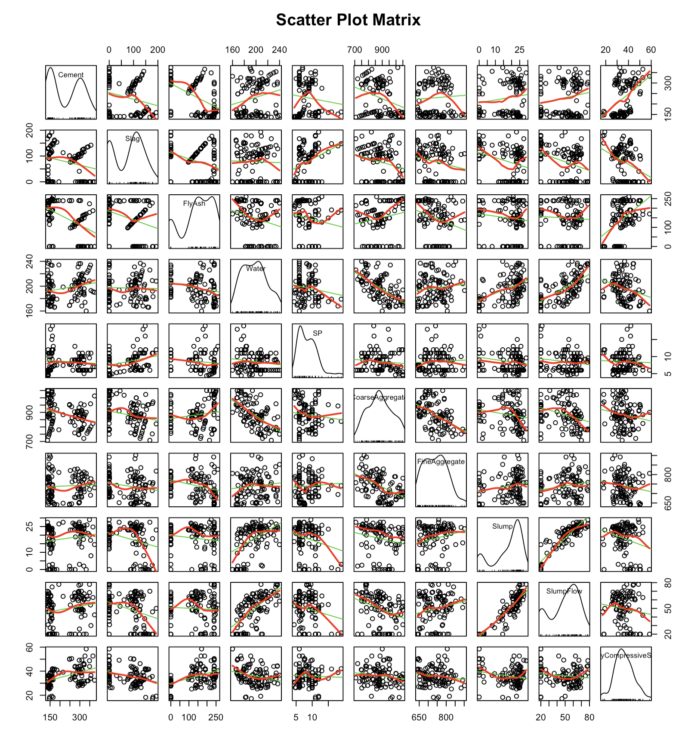

**Interpretation:**

We selected Slump flow as the Output variable, as we see that we can find clear relations among Slump flow and other parameters when compared to the other 2 output variables.

We choose all the 7 input variables for our model, as they all have a linear relationship with Slump flow.

**Question 1.2:**

**Building different regression models:**

**Multiple linear regression:**

fit_MLR<-lm(SlumpFlow~Cement+Slag+FlyAsh+Water+SP+CoarseAggregate+FineAggregate,data=conc)

summary(fit_MLR)

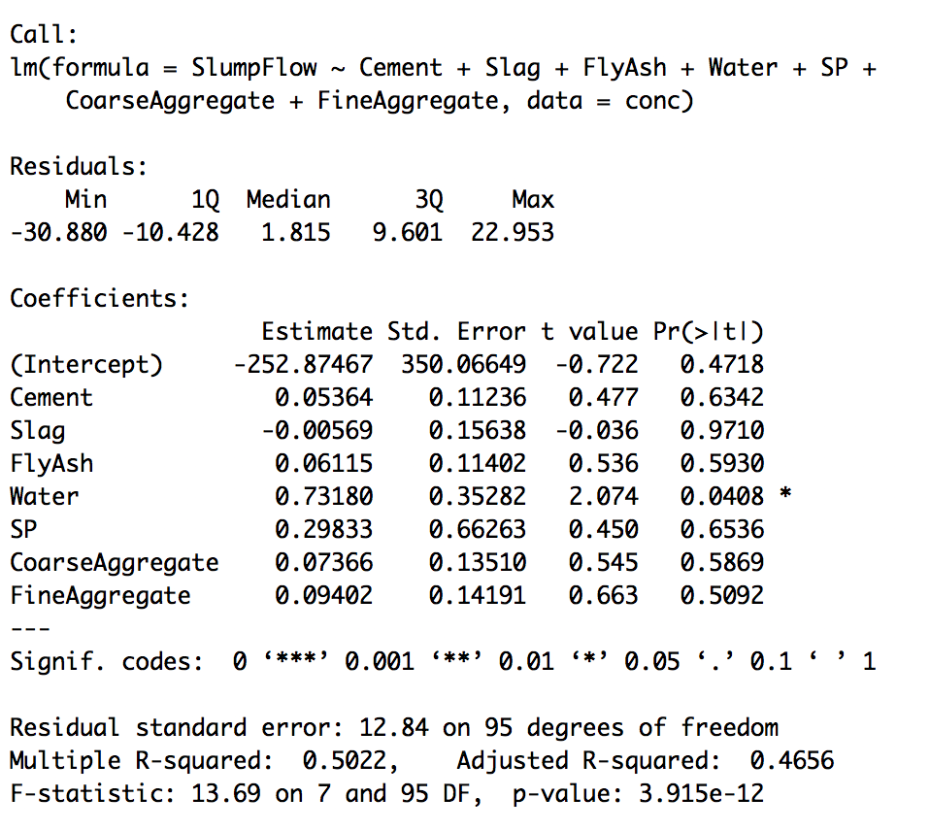

**Interpretation:**

The coefficients show the effect of a predictor variable over the outcome variable, keeping the other input variables constant. Altogether, the predictor variables account for 50% of the total variance.

**Multiple linear regression with interactions:**

fit_LRI<-lm(SlumpFlow~Cement+Slag+FlyAsh+Water+SP+CoarseAggregate+FineAggregate+FineAggregate:FlyAsh+Cement:Water,data=conc)

summary(fit_LRI)

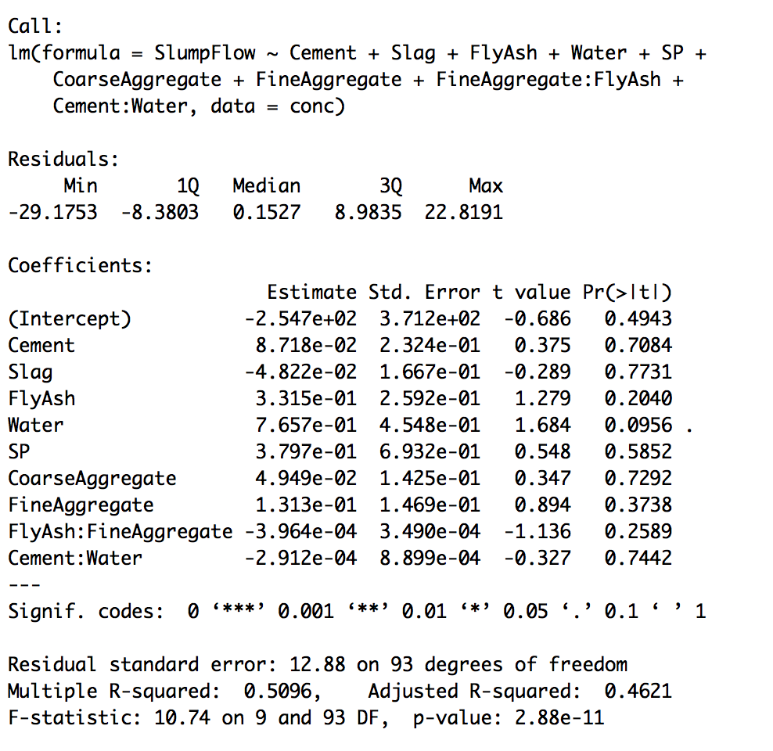

**Interpretation:**

We create interactions between variables with similar linear relationship. We see that the residual error has increased, this is not a better model.

**Second order Regression-** multiple linear regression with interactions between every pair of variables

fit_SLR<-lm(SlumpFlow~Cement+Slag+FlyAsh+Water+SP+CoarseAggregate+FineAggregate+

Cement:Slag+Cement:FlyAsh+Cement:Water+Cement:SP+Cement:CoarseAggregate+Cement:FineAggregate+ Slag:FlyAsh+Slag:Water+Slag:SP+Slag:CoarseAggregate+Slag:FineAggregate+ FlyAsh:Water+FlyAsh:SP+FlyAsh:CoarseAggregate+FlyAsh:FineAggregate+ Water:SP+Water:CoarseAggregate+Water:FineAggregate+

SP:CoarseAggregate+SP:FineAggregate+

CoarseAggregate:FineAggregate, data = conc)

summary(fit_SLR)

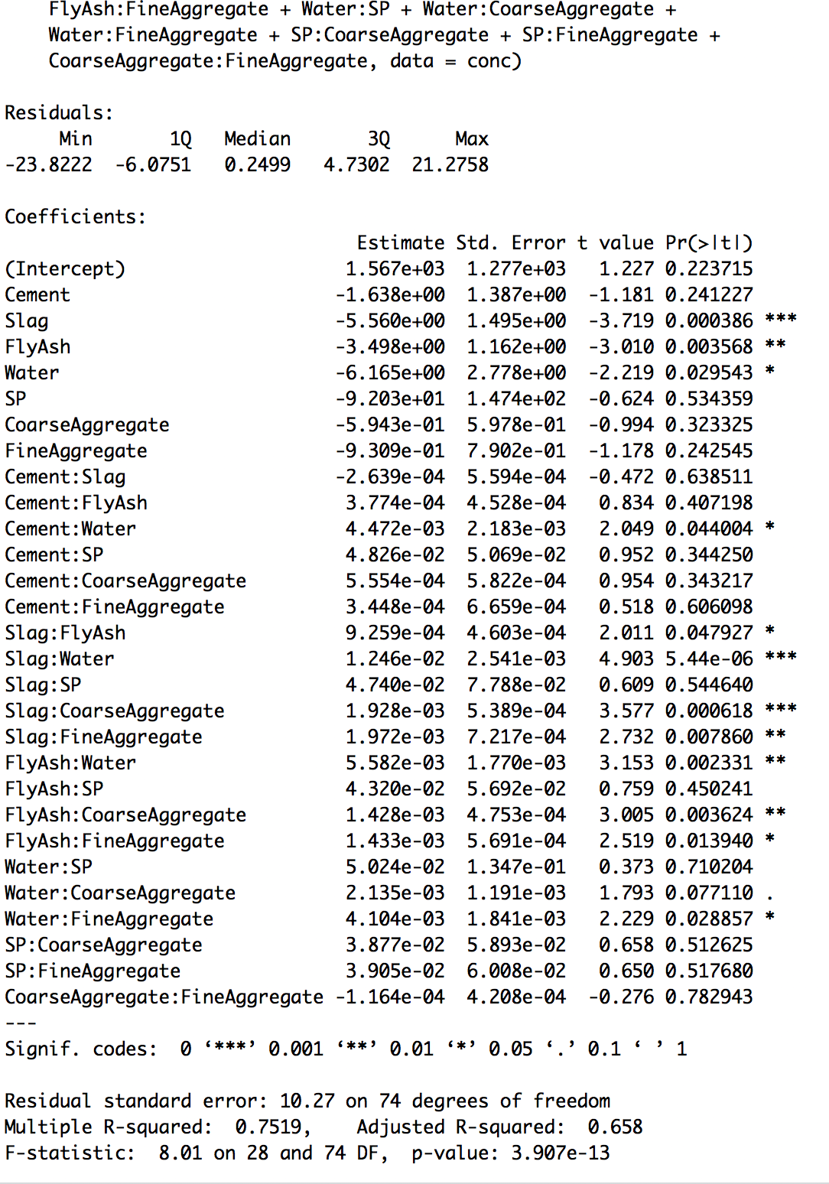

**Interpretation:**

The predictive power of the model has improved. Adjusted R squared value has increased to 0.65. Altogether, the predictor variables account for 75% of the total variance.

**Question 1.3:**

**Regression diagnostics:**

**Typical approach:**

par(mfrow=c(2,2))

plot(fit_MLR)

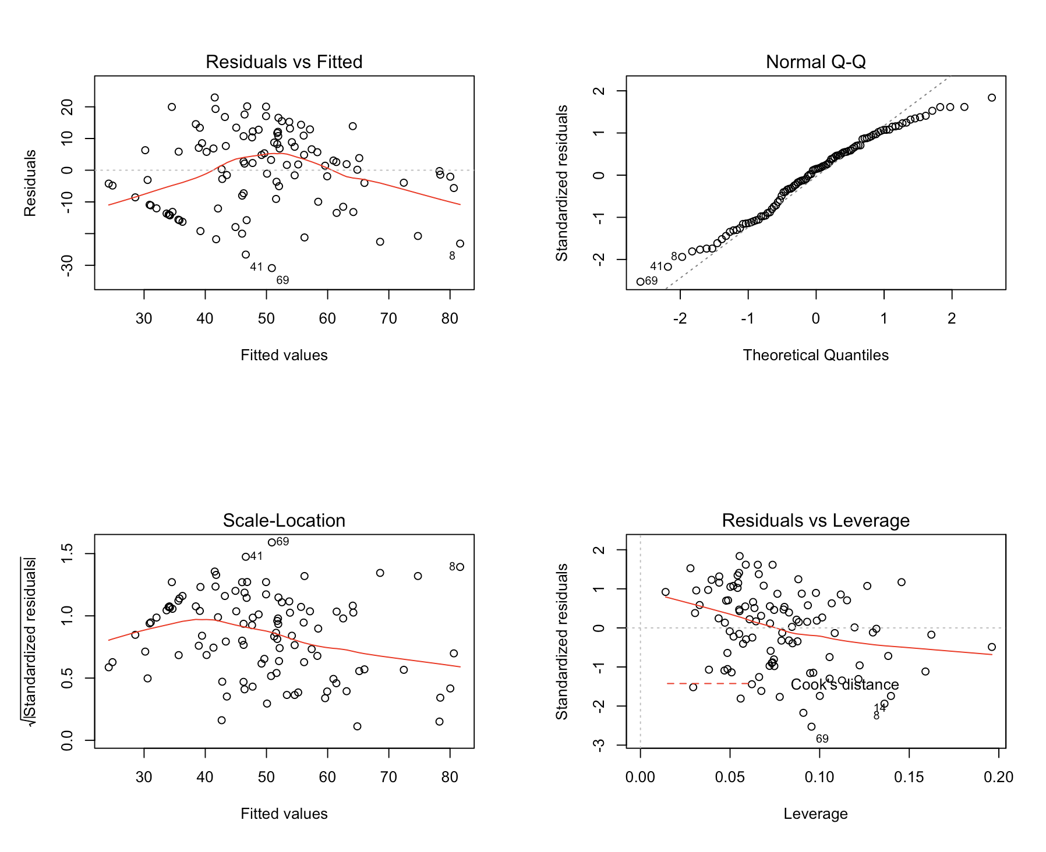

**plot(fit_LRI)**

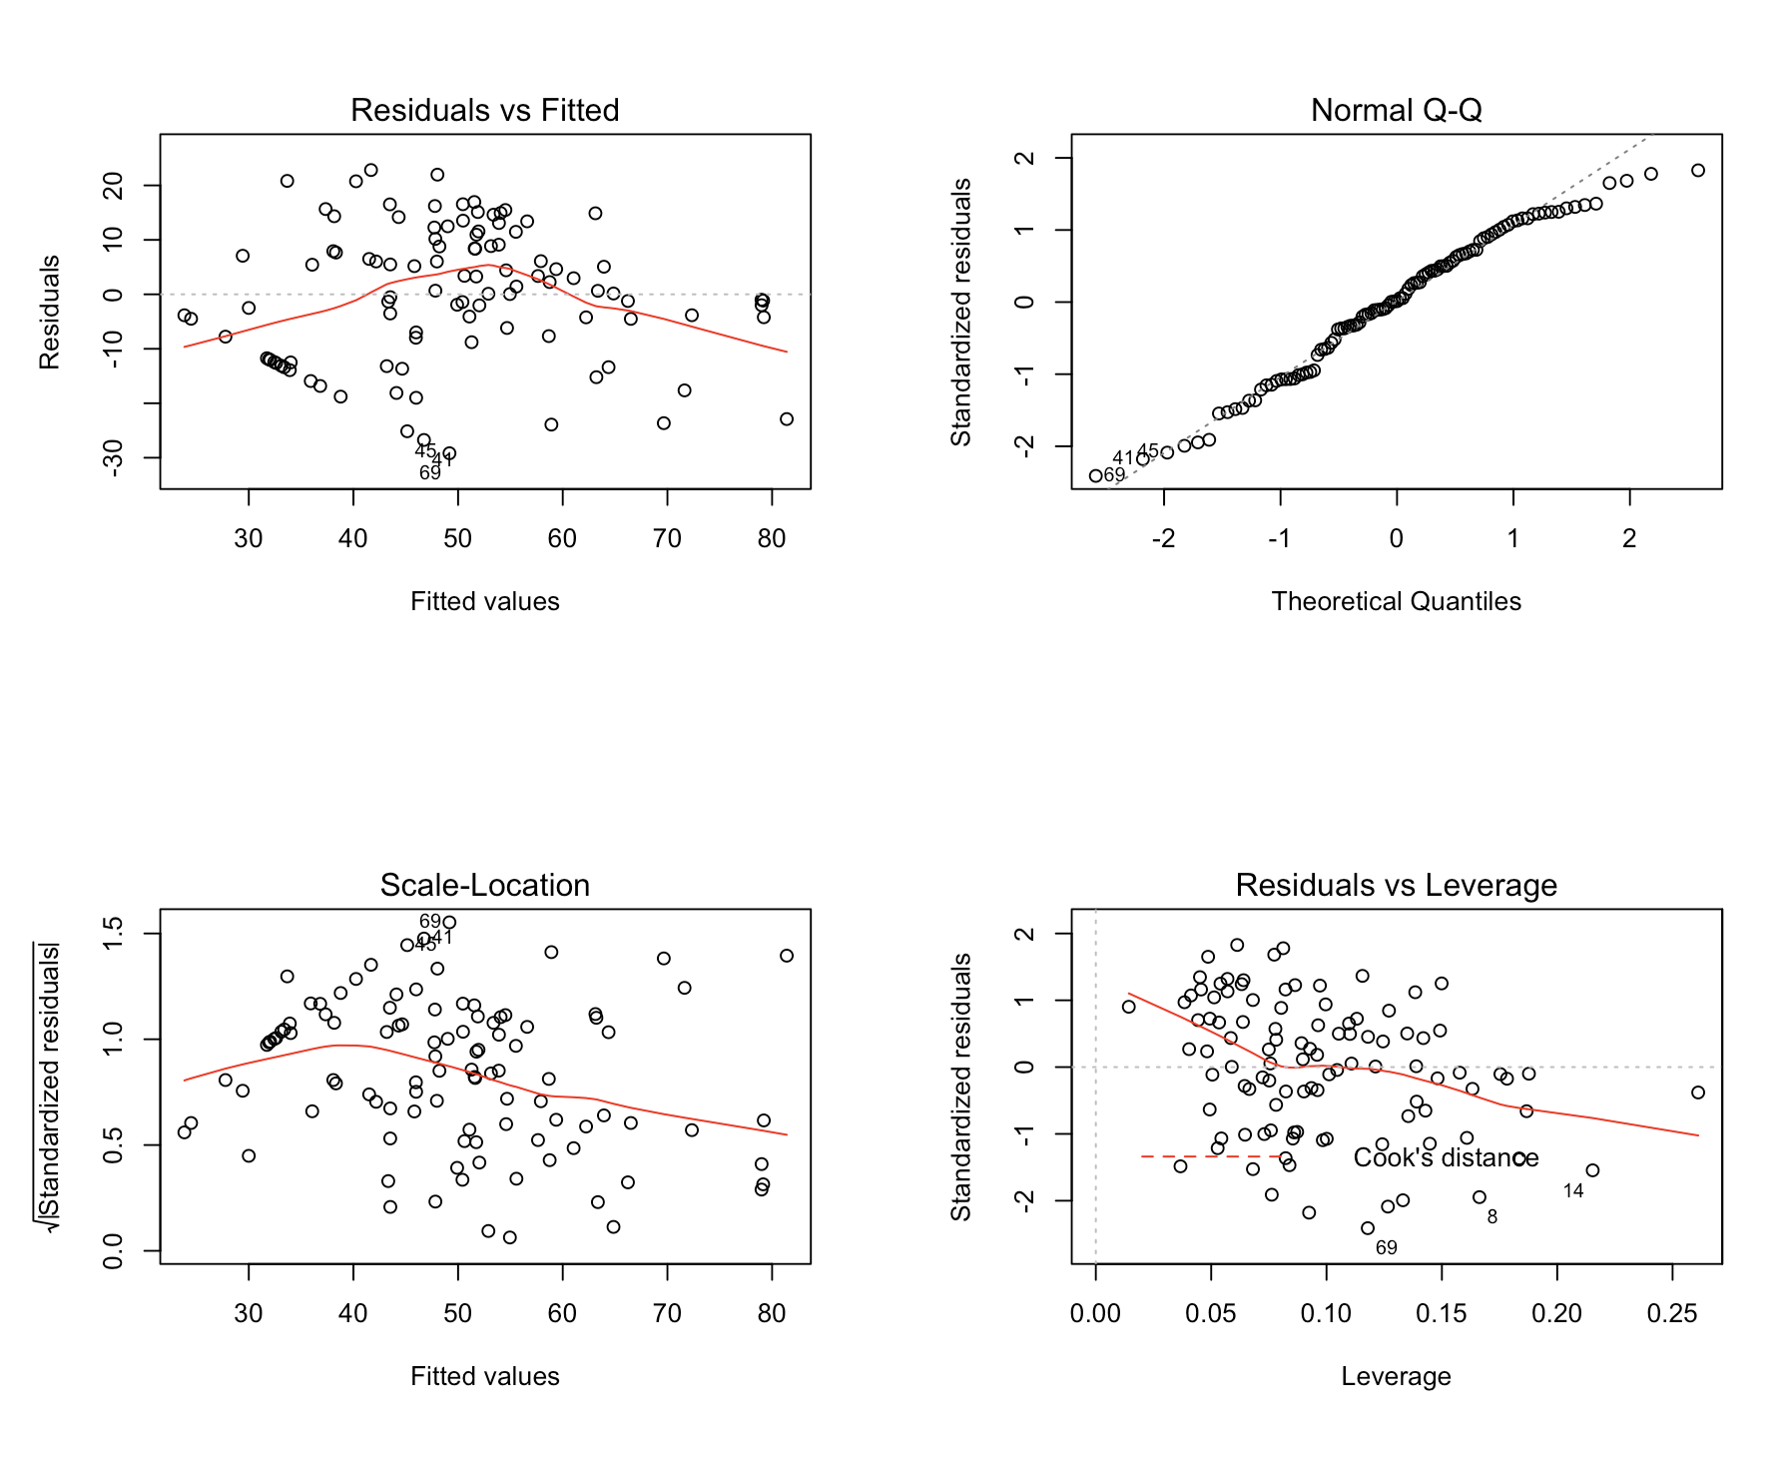

plot(fit_SLR)

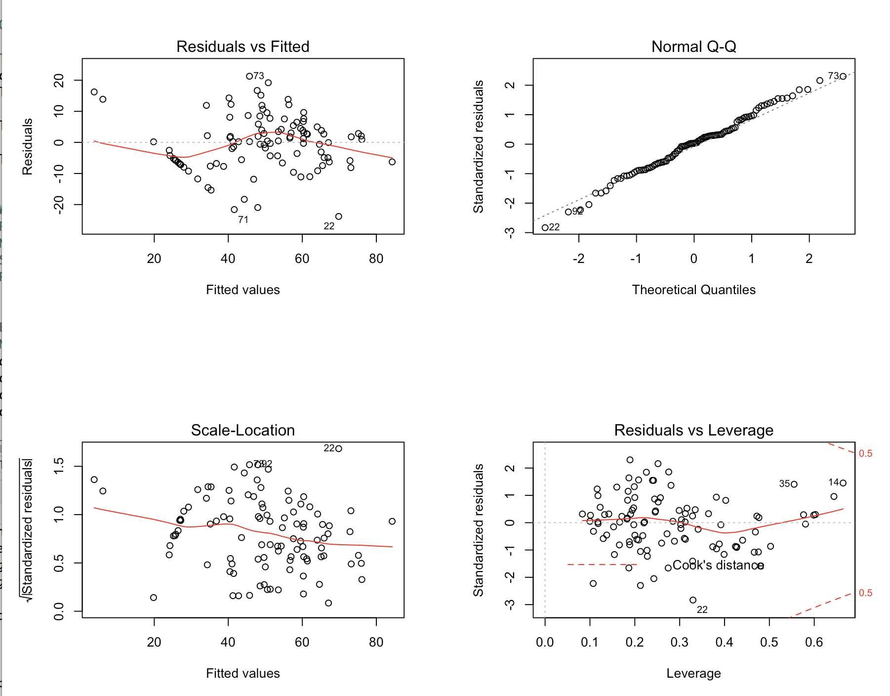

**Interpretation:**

We observe that the resulting graphs are generally similar for all the three cases.

Residual-vs-Fitted represents linearity quality. There should be no systematic relationship between the residuals and the predicted. Normal Q-Q plot represents normality quality. The residual should be normally distributed with the mean “0”. The point on this graph falls on the straight 45-degree line. Scale-Location represents Homoscedasticity. There is constant variance assumption or random band around the horizontal line. Residual-vs-Leverage represents information on individual observations that need attention.

**Enhanced approach:**

**Normality:**

par(mfrow=c(1,1))

qqPlot(fit_MLR, labels=row.names(conc), id.method="identify", simulate=TRUE,main="Linear Regression Q-Q Plot")

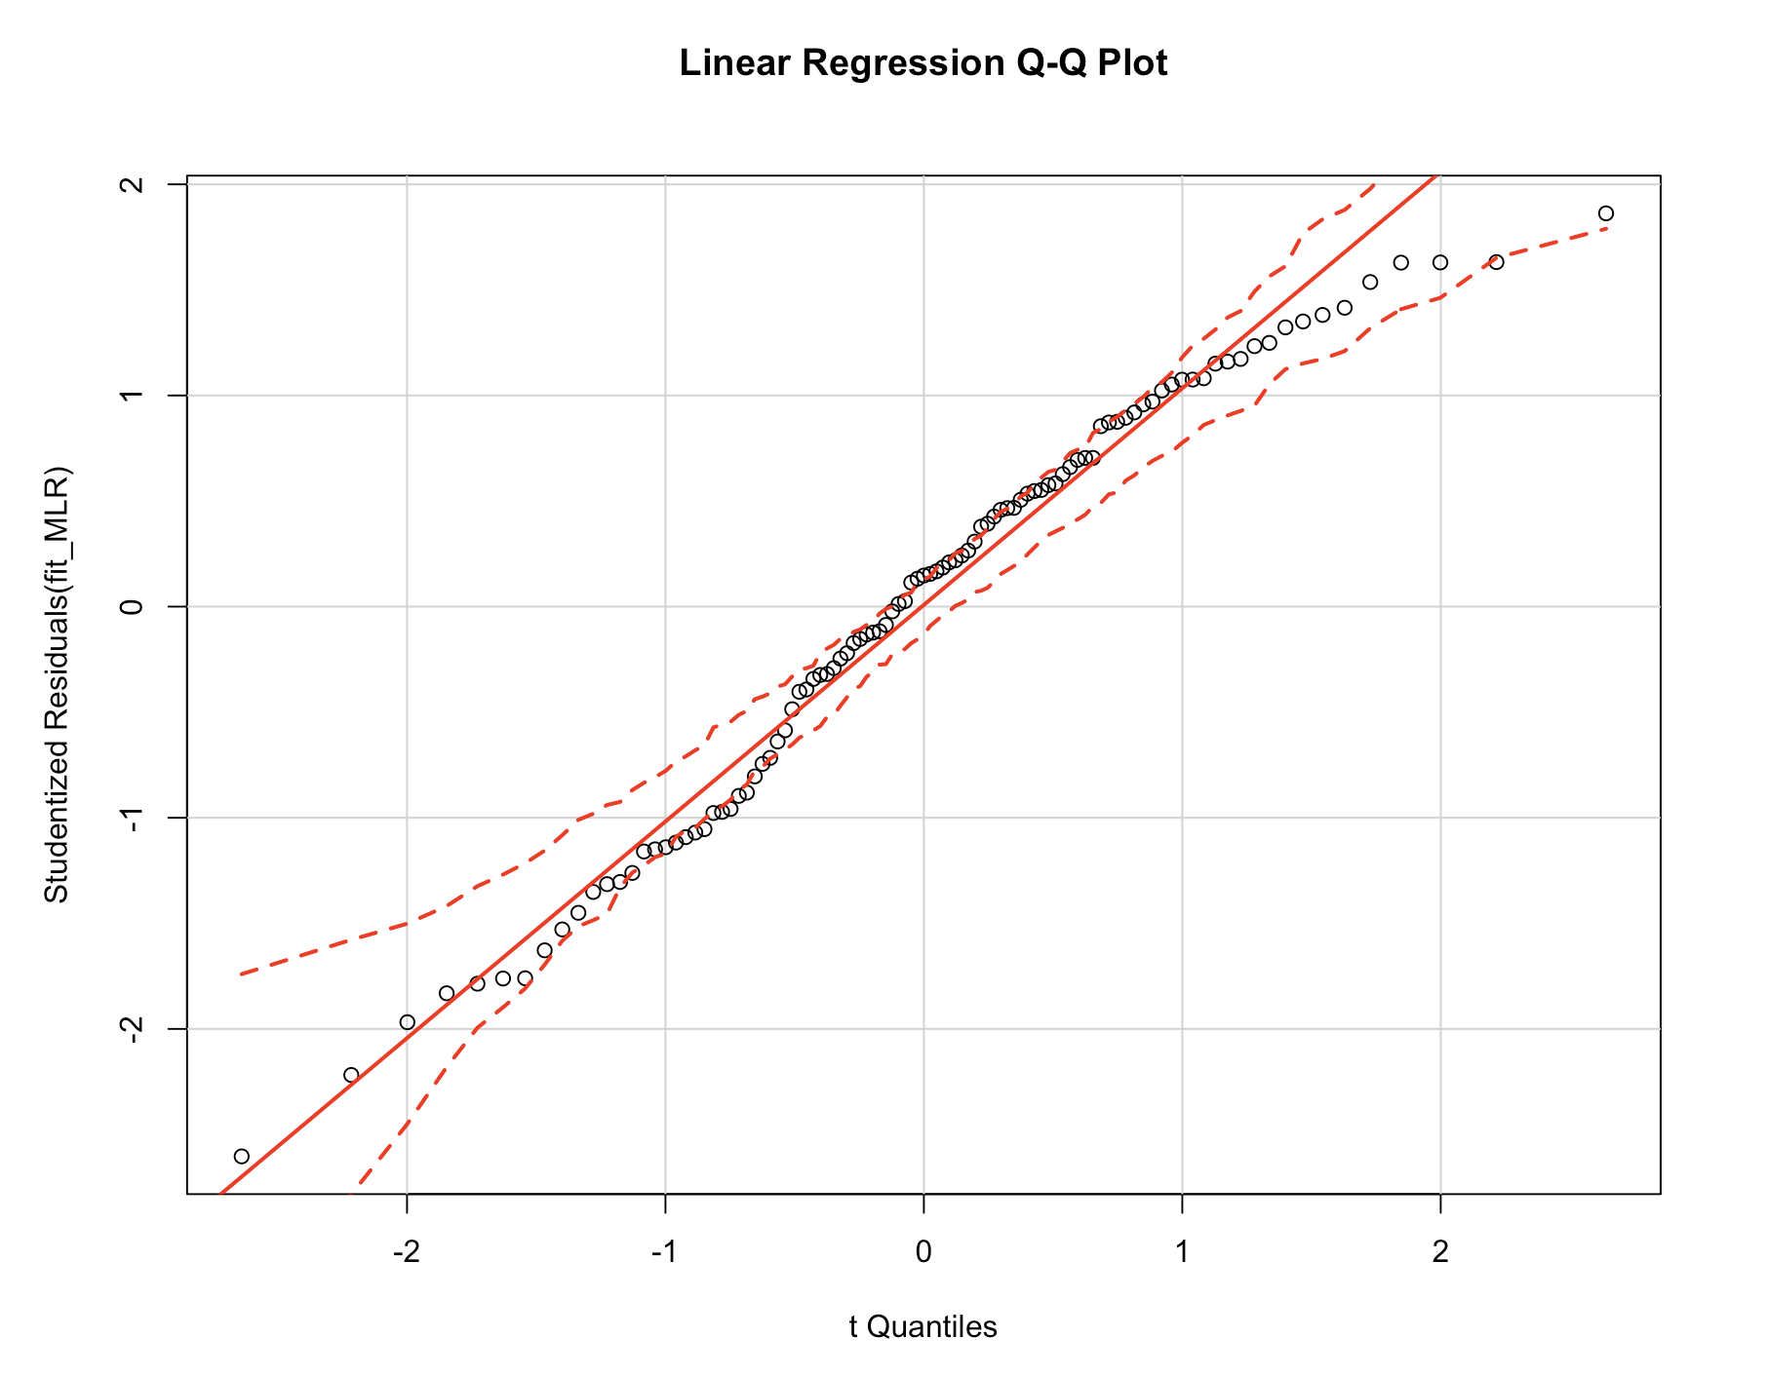

qqPlot(fit_LRI, labels=row.names(conc), id.method="identify", simulate=TRUE,main="Linear Regression Q-Q Plot")

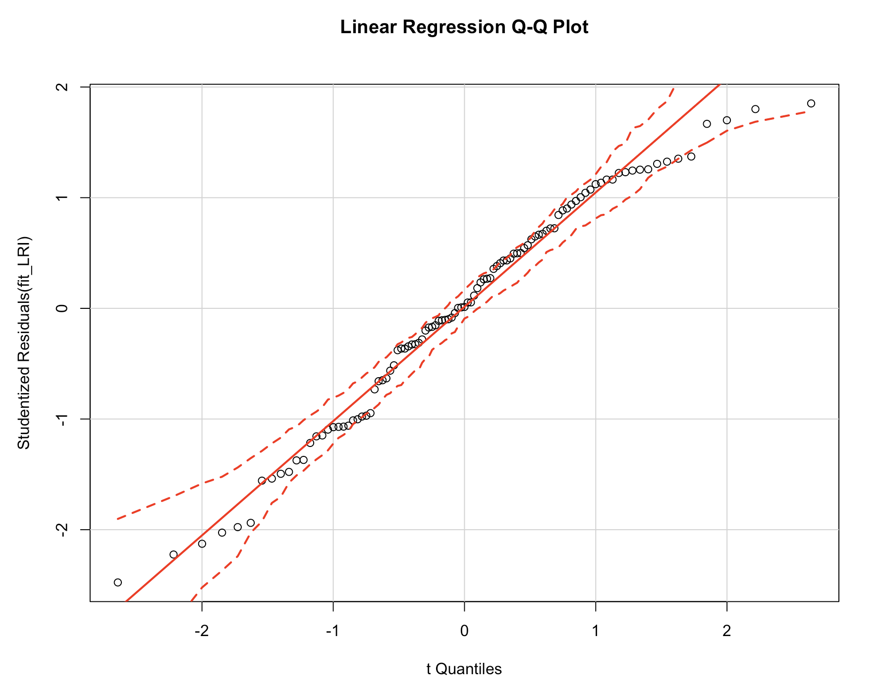

qqPlot(fit_SLR, labels=row.names(conc), id.method="identify", simulate=TRUE,main="Linear Regression Q-Q Plot")

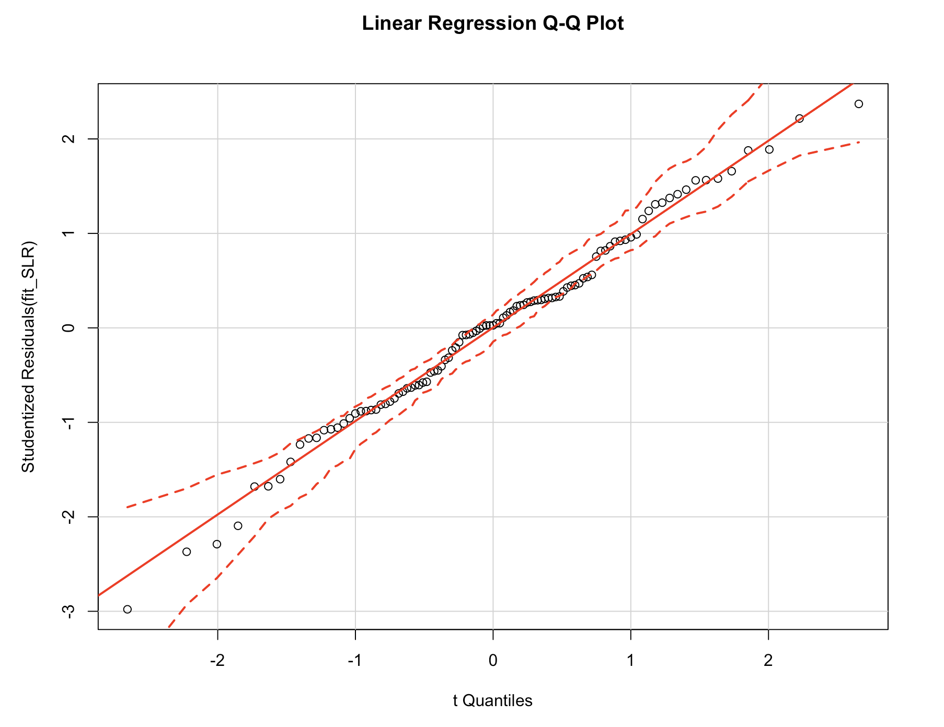

**Interpretation:**

The qqPlot() function provides a more accurate method for assessing the normality assumption.

In the case of all 3 linear regression models, all points fall close to the line and are within the confidence envelope, suggesting that the normality condition has been met.

**Plotting Studentized residuals:**

residualPlot = function(fit, nbreaks = 10){

z = rstudent(fit)

hist(z, breaks = nbreaks, freq = FALSE, xlab = "Studentized Residual", main = "Distribution of Errors")

rug(jitter(z), col="brown")

curve(dnorm(x, mean=mean(z), sd=sd(z)), add=TRUE, col="blue", lwd=2)

lines(density(z)$x, density(z)$y, col="red", lwd=2, lty=2)

legend("topright", legend = c("Normal Curve", "Kernel Density Curve"), lty = 1:2, col=c("blue", "red"), cex=.7 )

}

residualPlot(fit_MLR)

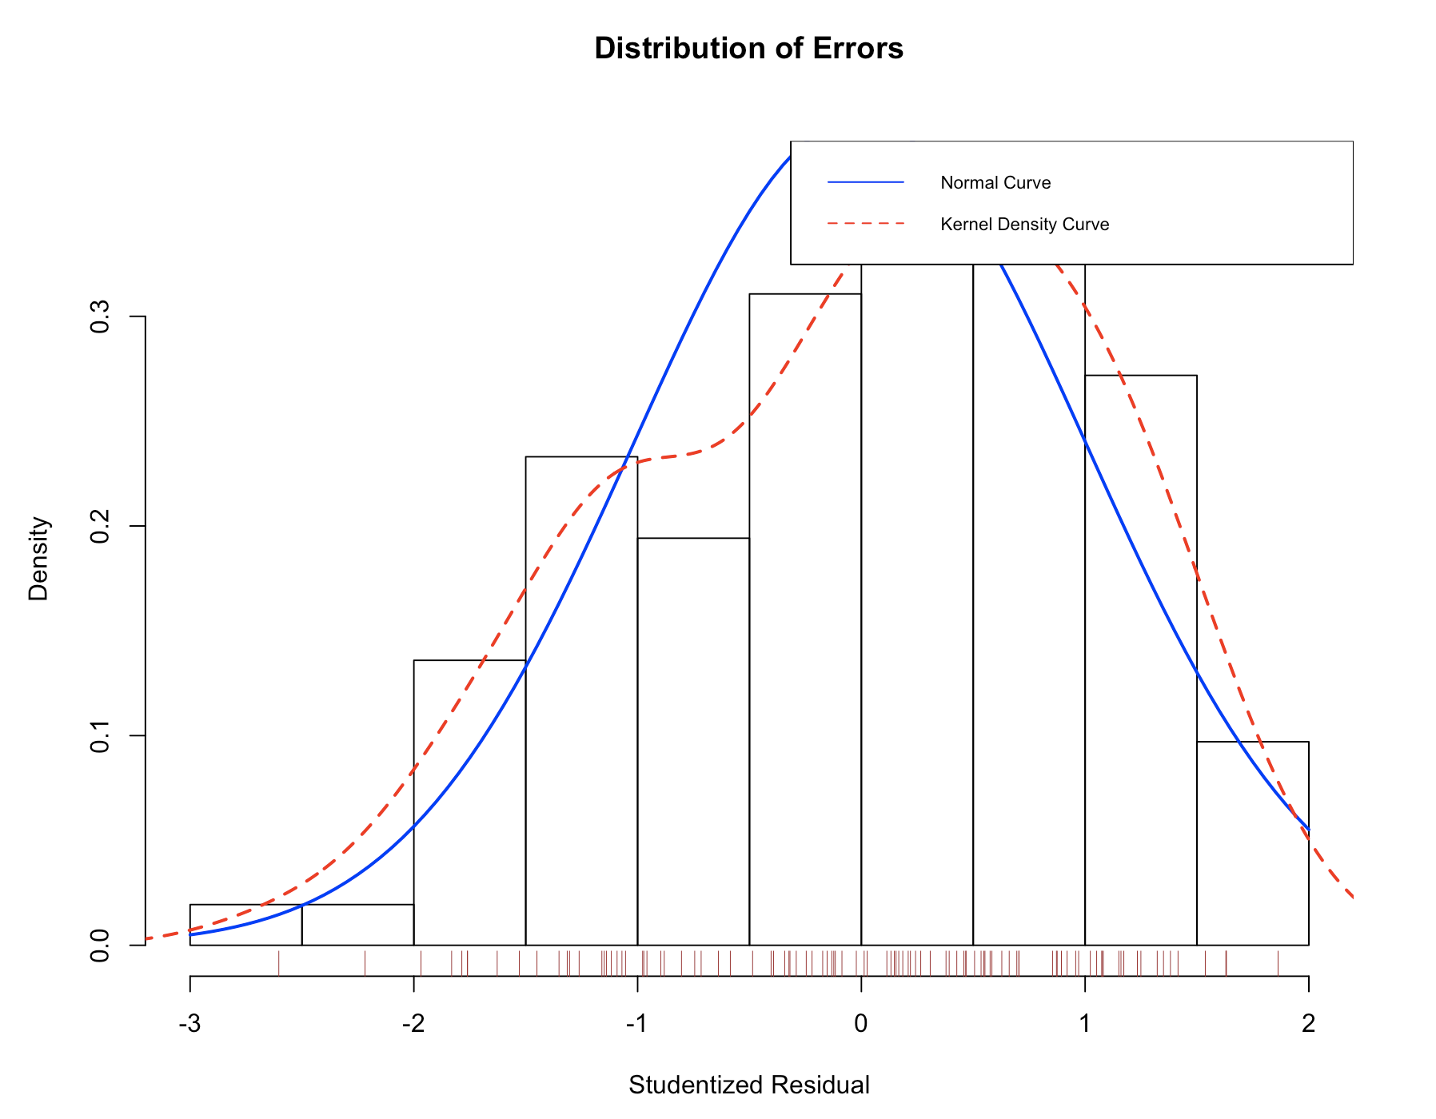

residualPlot(fit_LRI)

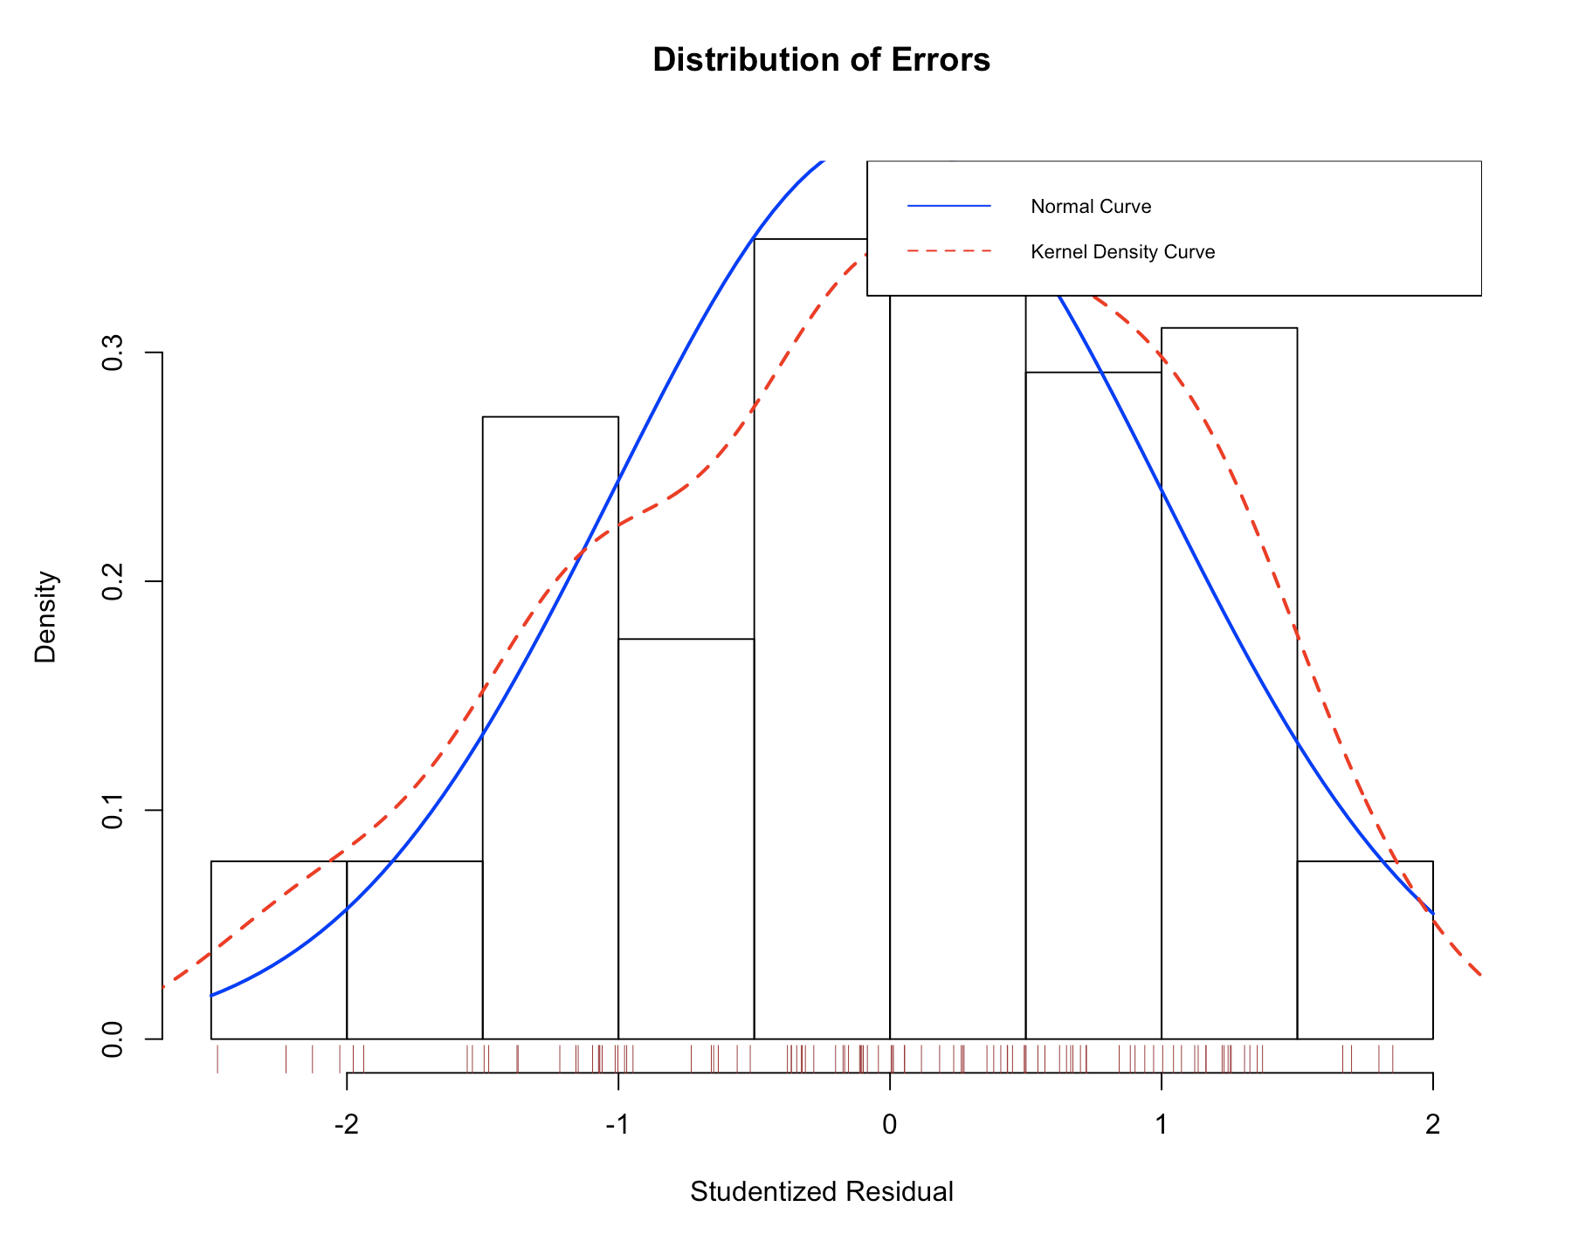

residualPlot(fit_SLR)

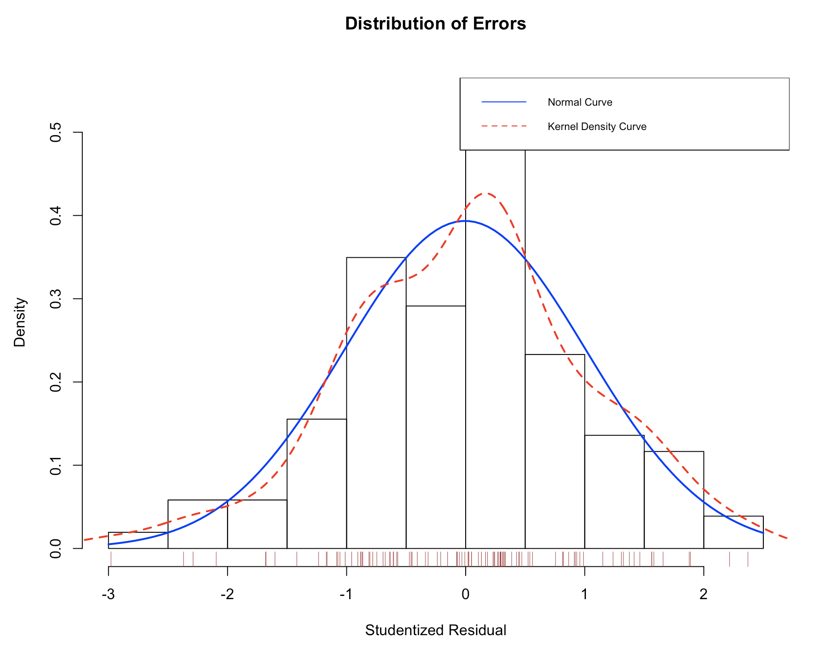

**Interpretation:**

All three models are consistent with respect to the normal distribution.

**Independence of Errors- Durbin-Watson Test**

durbinWatsonTest(fit_MLR)

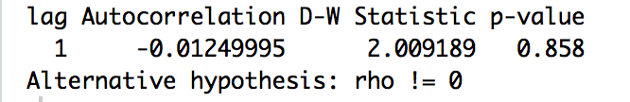

durbinWatsonTest(fit_LRI)

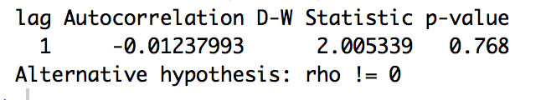

durbinWatsonTest(fit_SLR)

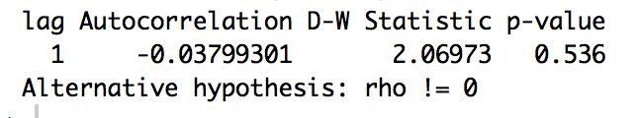

**Interpretation:**

The durbinWatsonTest checks the residuals for autocorrelation. When the p-value is < 0.5, the residuals are significantly correlated whereas p > 0.05 provides no evidence of correlation. All 3 models are significantly correlated since p>0.5.

**Linearity- Component plus residual plots**

**crPlots(fit_MLR)**

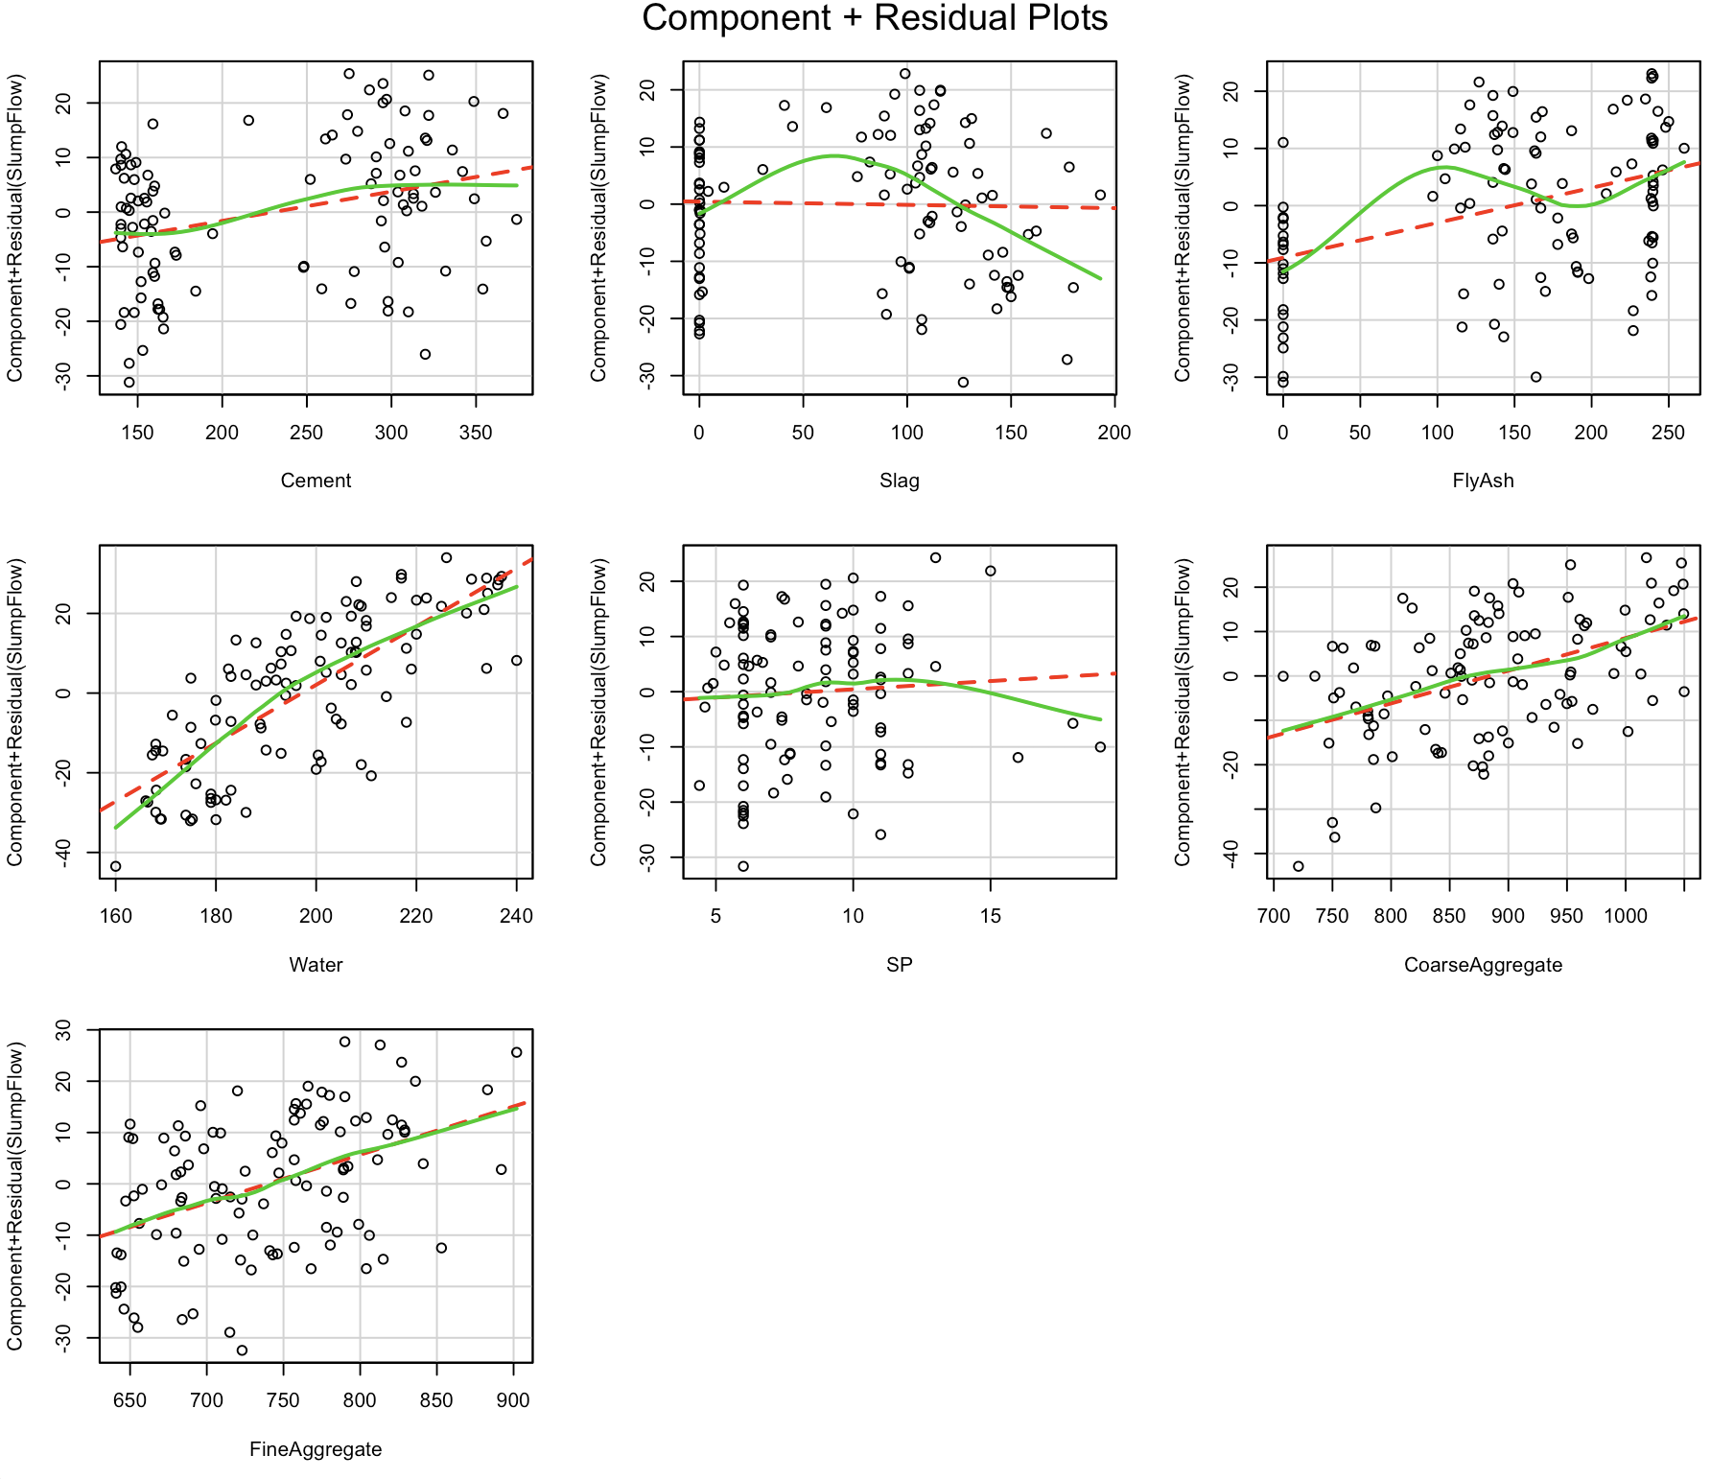

**Interpretation:**

Any nonlinearity in any of the above graphs suggest that we may have not adequately modeled the functional form of that predictor in the regression. From above graphs, we can confirm that we have met the linearity assumption.

**Homoscedasticity:**

ncvTest(fit_MLR)

spreadLevelPlot(fit_MLR)

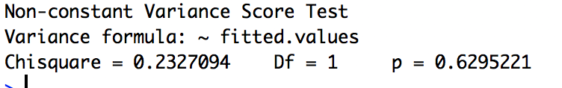

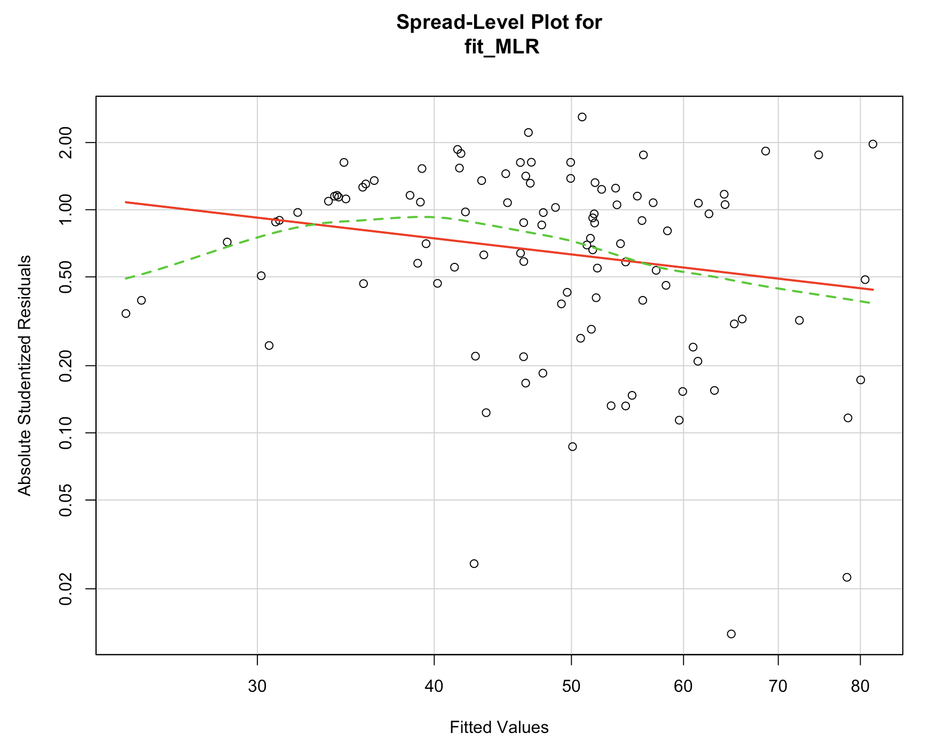

ncvTest(fit_LRI)

spreadLevelPlot(fit_LRI)

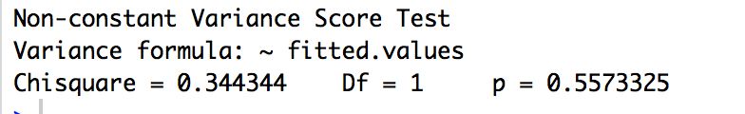

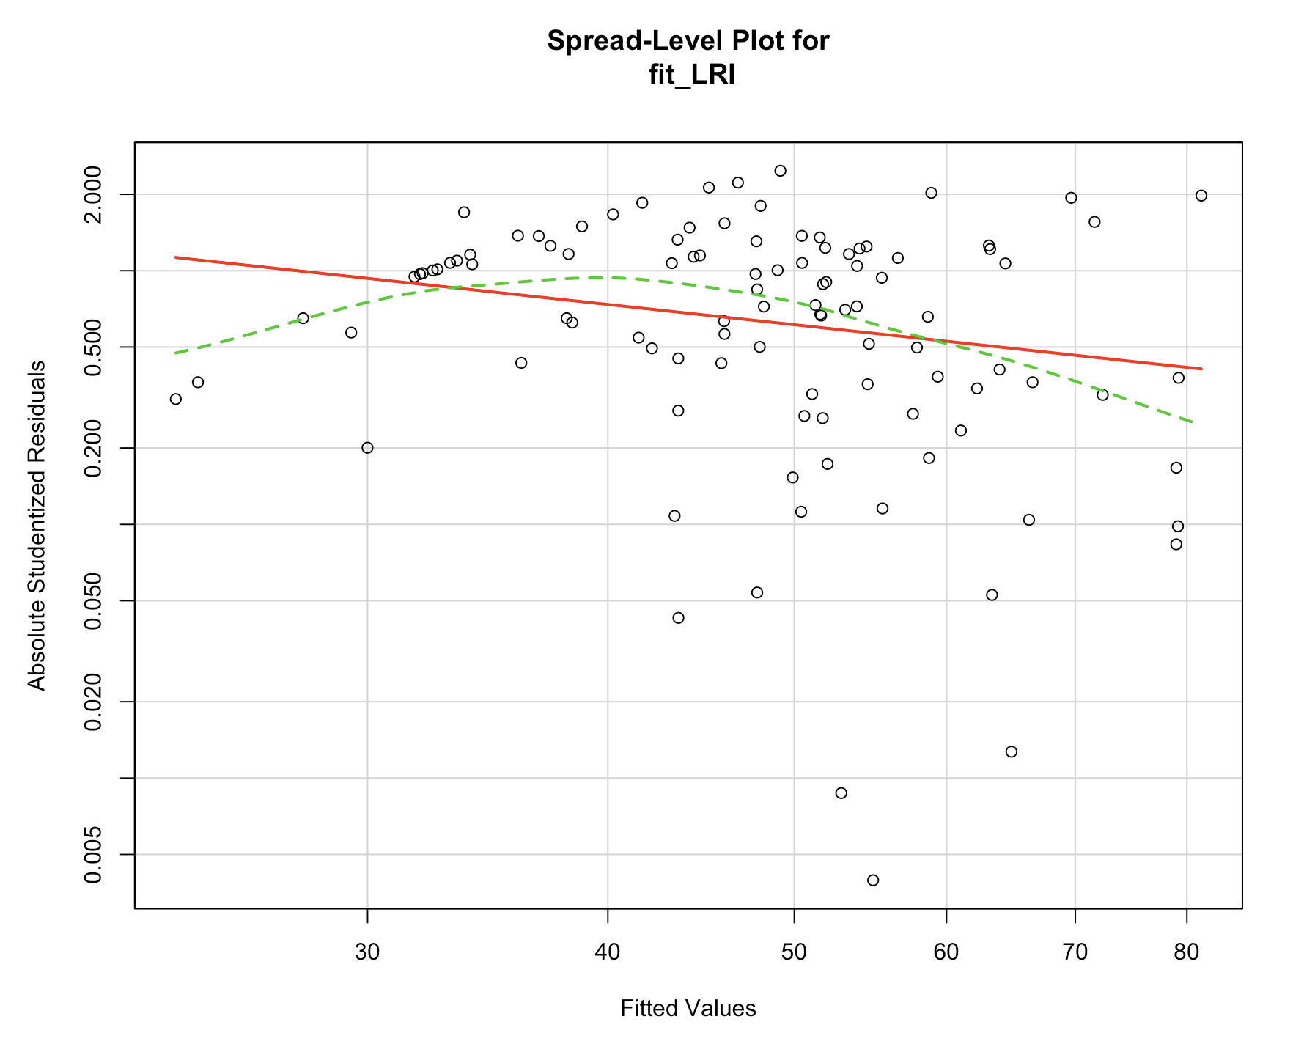

ncvTest(fit_SLR)

spreadLevelPlot(fit_SLR)

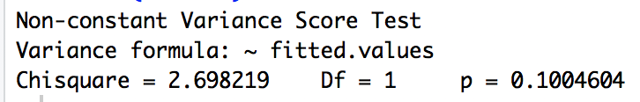

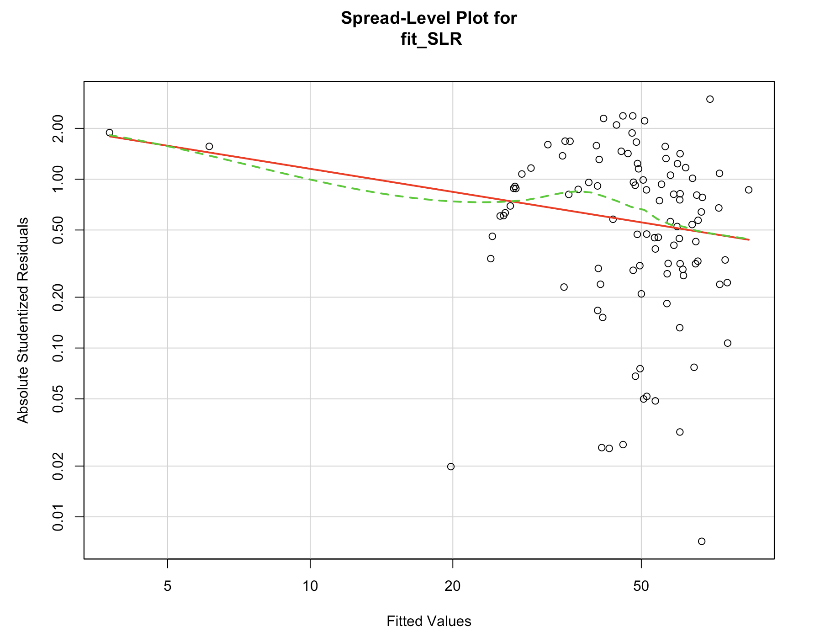

**Interpretation:**

All 3 models met the constant variance assumption with p = 0.6295221, 0.5573325, 0.1004604, respectively. Also, in all three graphs above, there are random points about the horizontal best fit line. If we had violated the assumption, we would see non-horizontal line.

**Global validation of linear model assumption:**

**library(gvlma)**

**gvlma(fit_MLR)**

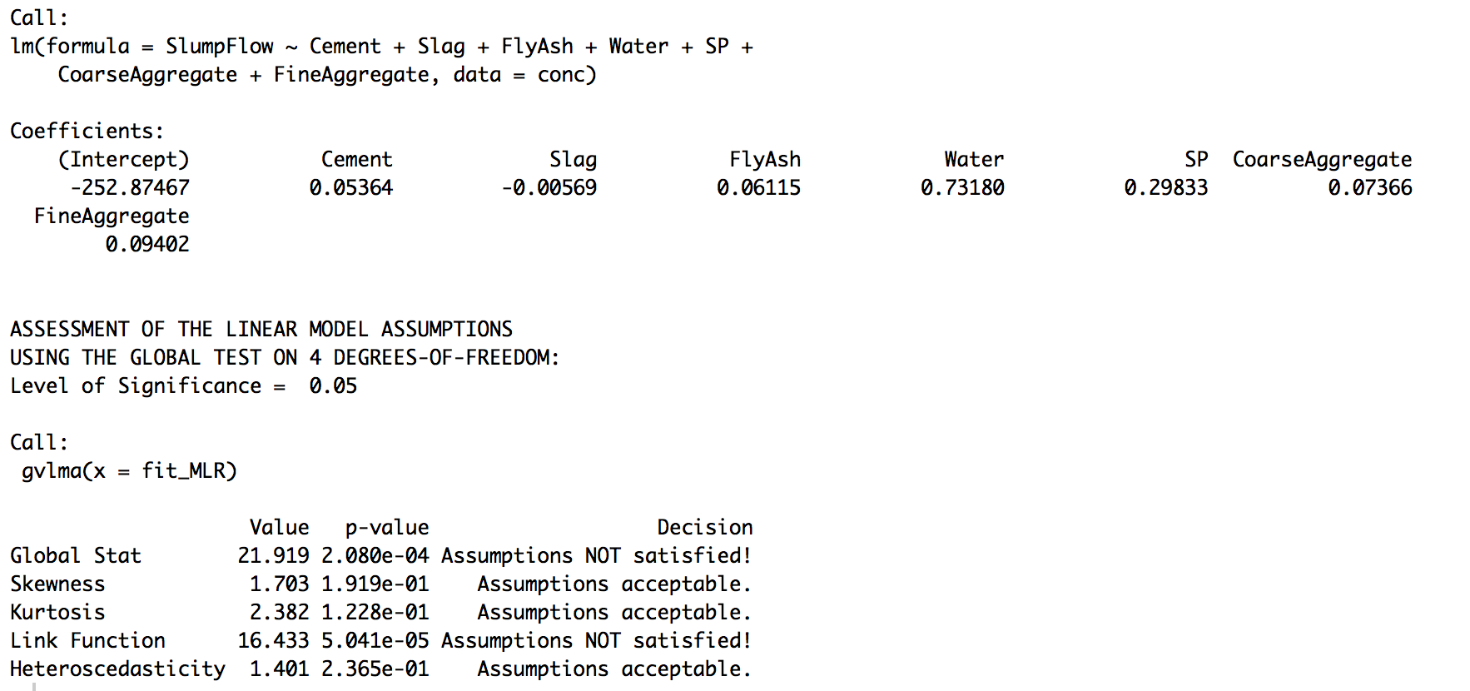

**gvlma(fit_LRI)**

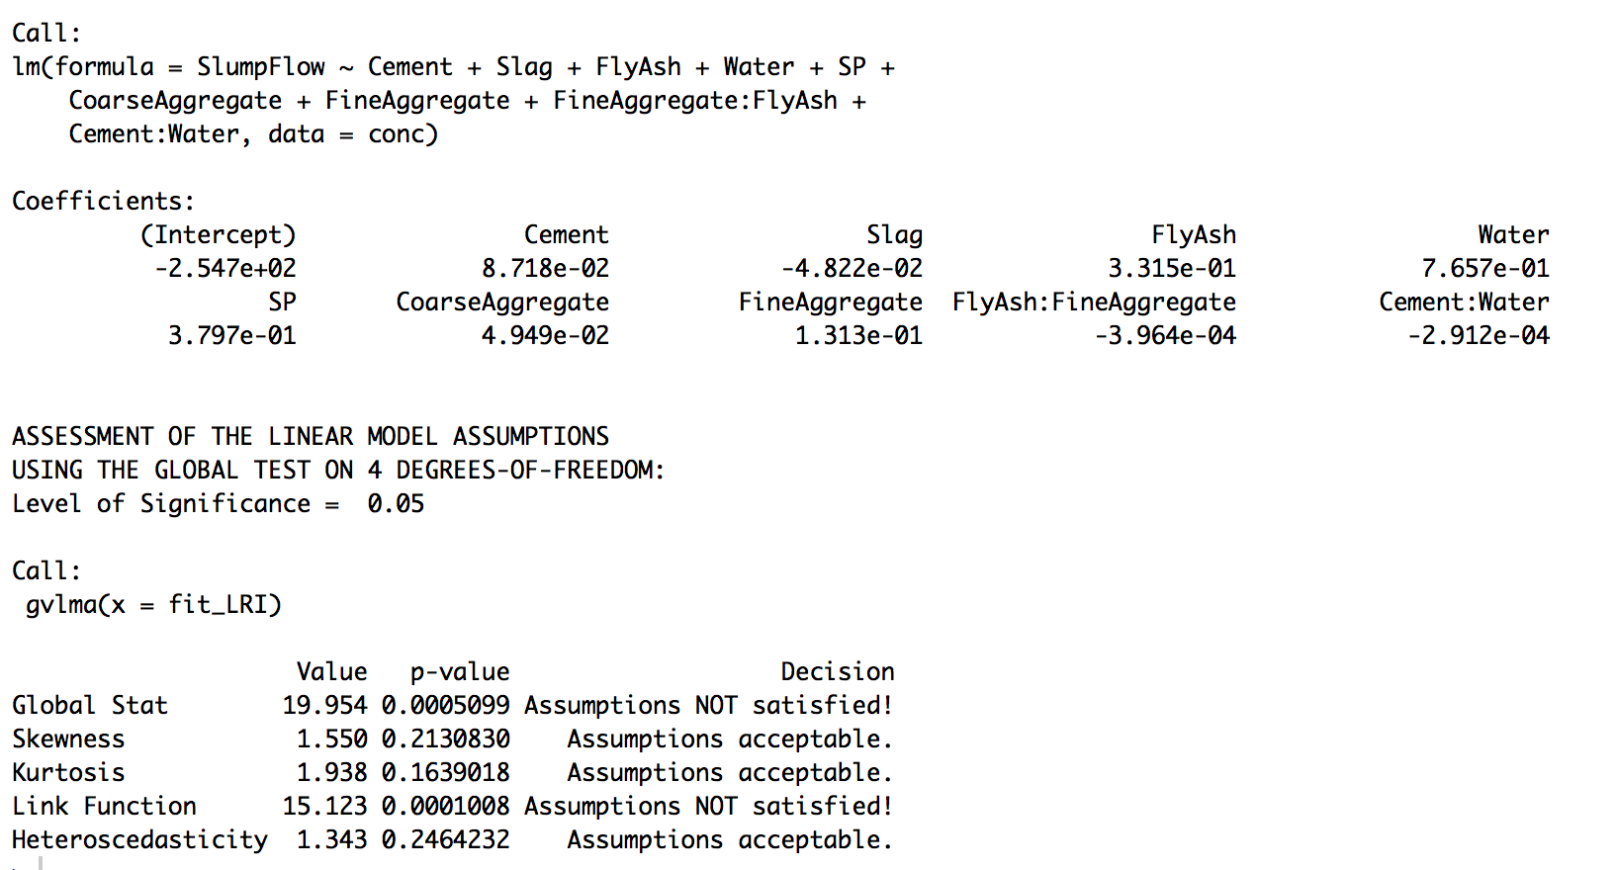

**gvlma(fit_SLR)**



**Interpretation:**

The gvlma() function provides a go/no-go test of model assumption. Based on the result ,SecondOrderRegression passes with all test condition. Multiple linear regression with and without interaction did not pass on Link and Global Stat.

**Multicollinearity:**

vif(fit_MLR)

sqrt(vif(fit_MLR))>2

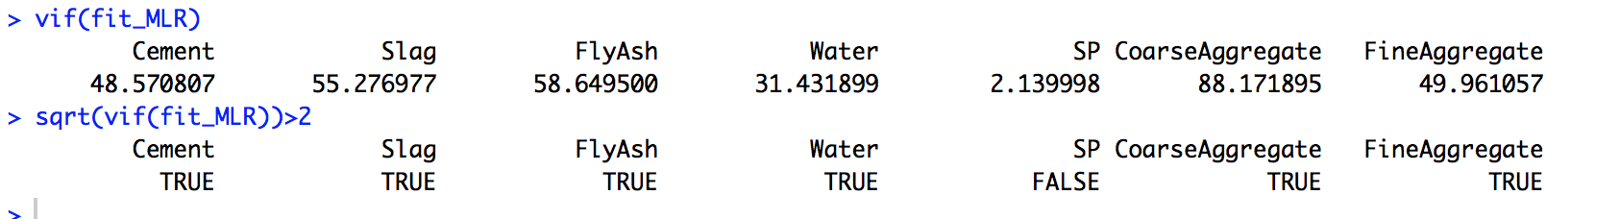

**vif(fit_LRI)**

**sqrt(vif(fit_LRI))>2**

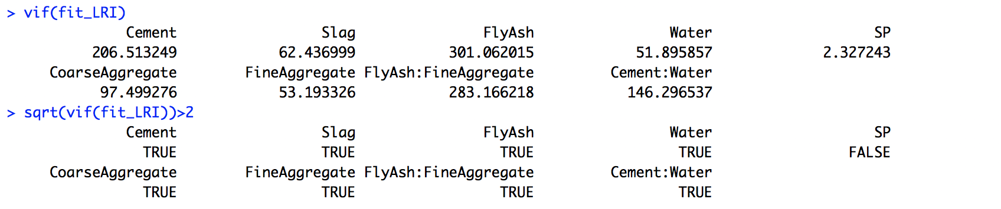

vif(fit_SLR)

sqrt(vif(fit_SLR))>2

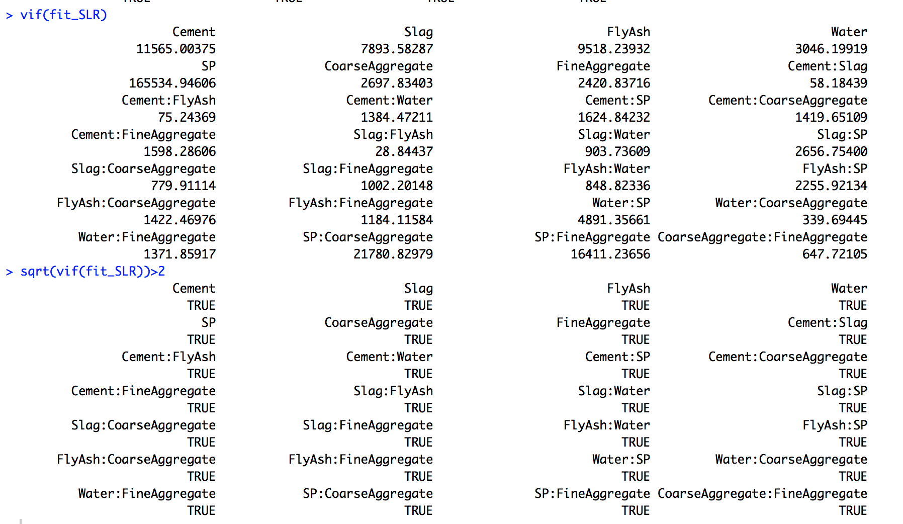

**Interpretation:**

The vif() function provides a check for multicollinearity condition using variance inflation factor. If SQRT(vif) >2 it indicates a multicollinearity problem. Based on the result , in all 3 models have multicollinearity problem. It doesn’t make any sense to drop them all,so we would keep the model as what they were and not drop any variables.

**Question 1.4:**

**Unusual observations:**

**Outliers:**

outlierTest(fit_MLR)

outlierTest(fit_LRI)

outlierTest(fit_SLR)

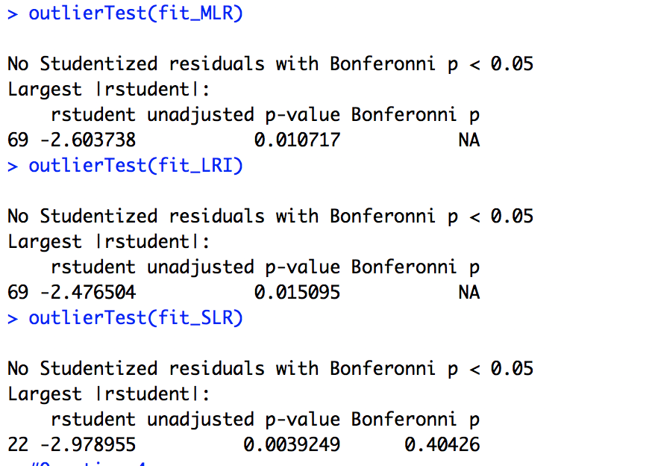

**Interpretation:**

The results of three models show no outliers. However, the points 69 and 22 have the largest studentized residual and should be considered to delete in the following corrective steps.

**High Leverage points:**

hat.plot<-function(fit){

p<-length(coefficients(fit))

n<-length(fitted(fit))

plot(hatvalues(fit),ylim=c(0,3.2)*p/n,main="Index plot of Hat values")

abline(h=c(2,3)*p/n,col="red",lty=2)

identify(1:n,hatvalues(fit),names(hatvalues(fit)))

}

hat.plot(fit_MLR)

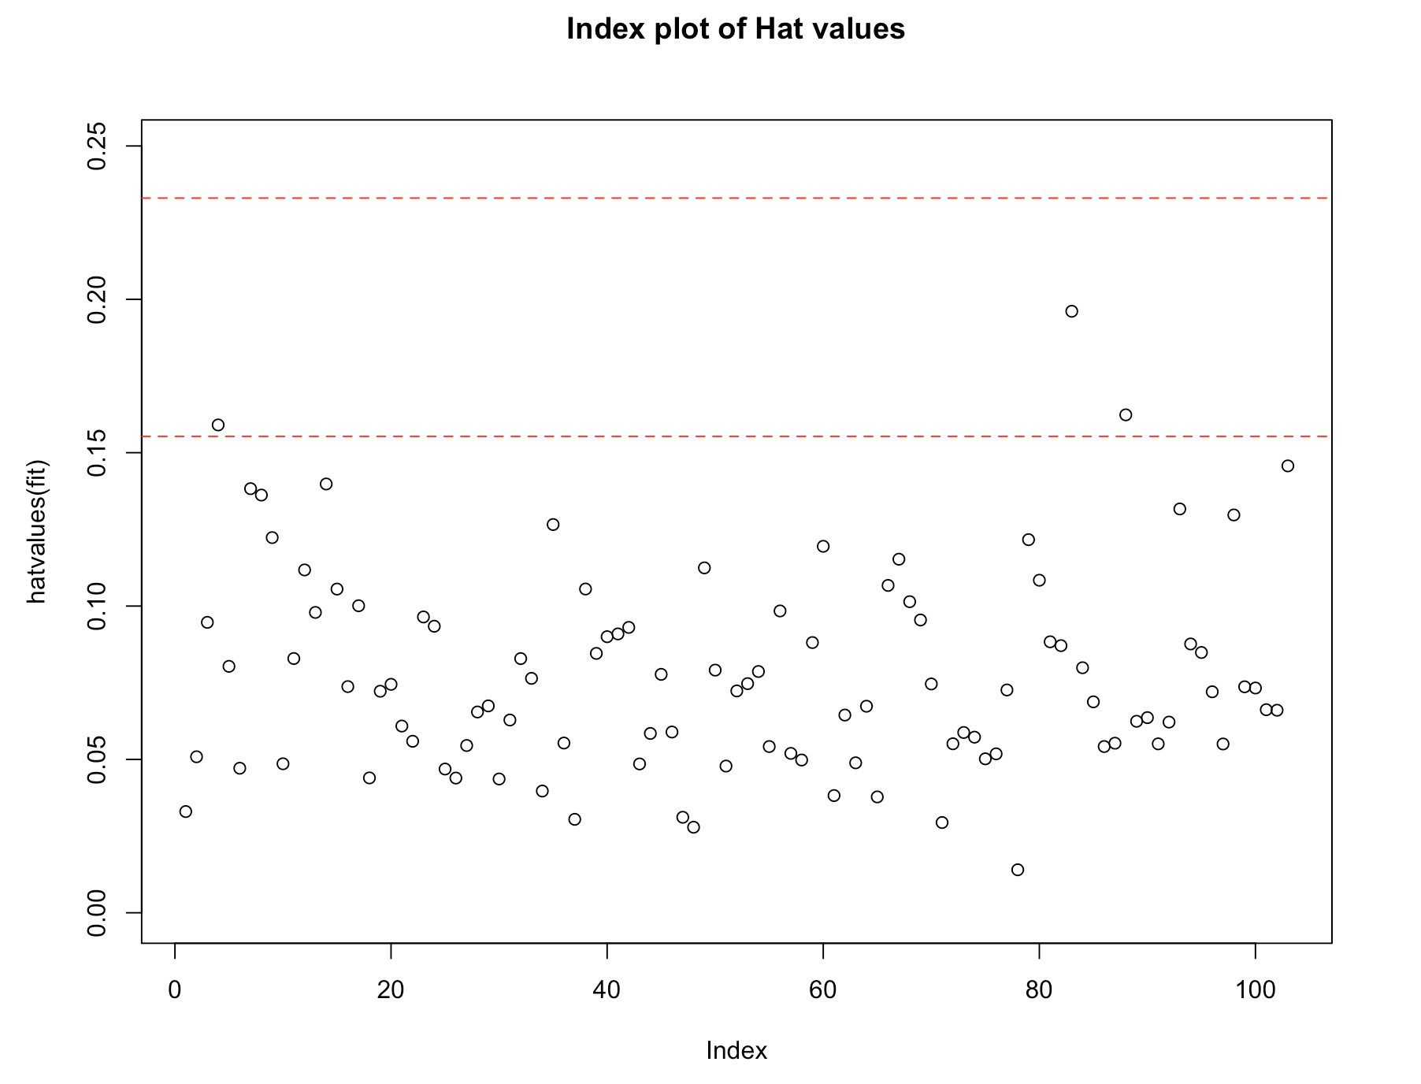

**hat.plot(fit_LRI)**

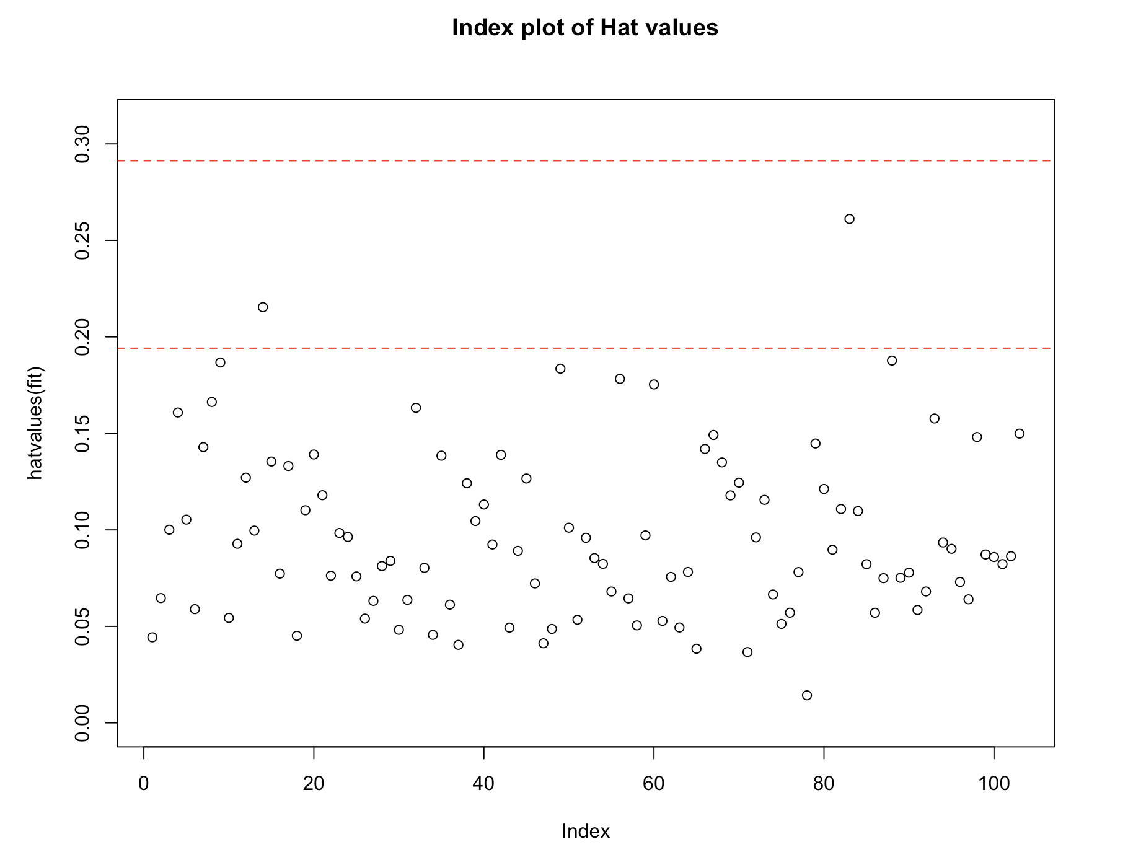

hat.plot(fit_SLR)

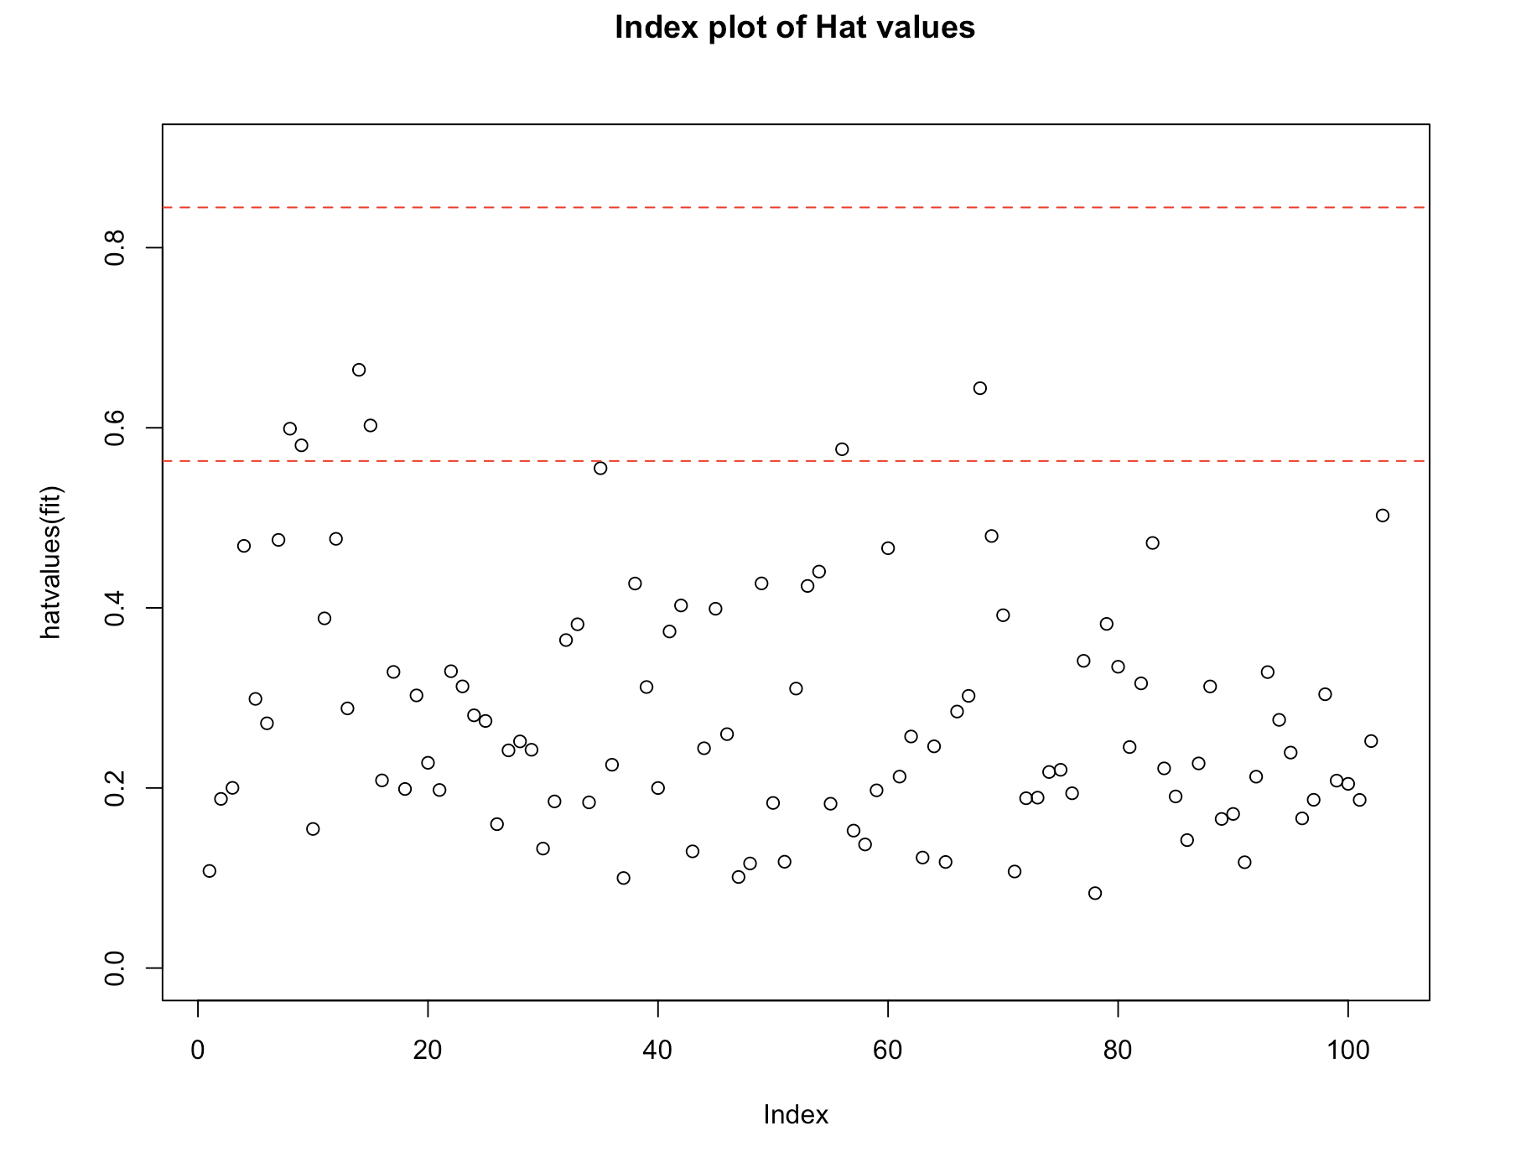

**Interpretation:**

There are no high leverage points greater than 3 times average hat value, which would facilitate the process of deleting outliers in the following steps.

**Influential observations:**

**Cook's distance:**

Dplot=function(fit,data){

cutoff<-4/(nrow(data)-length(fit$coefficients)-2)

plot(fit,which=4,cook.levels=cutoff)

abline(h=cutoff,lty=2,col="blue")

}

Dplot(fit_MLR,conc)

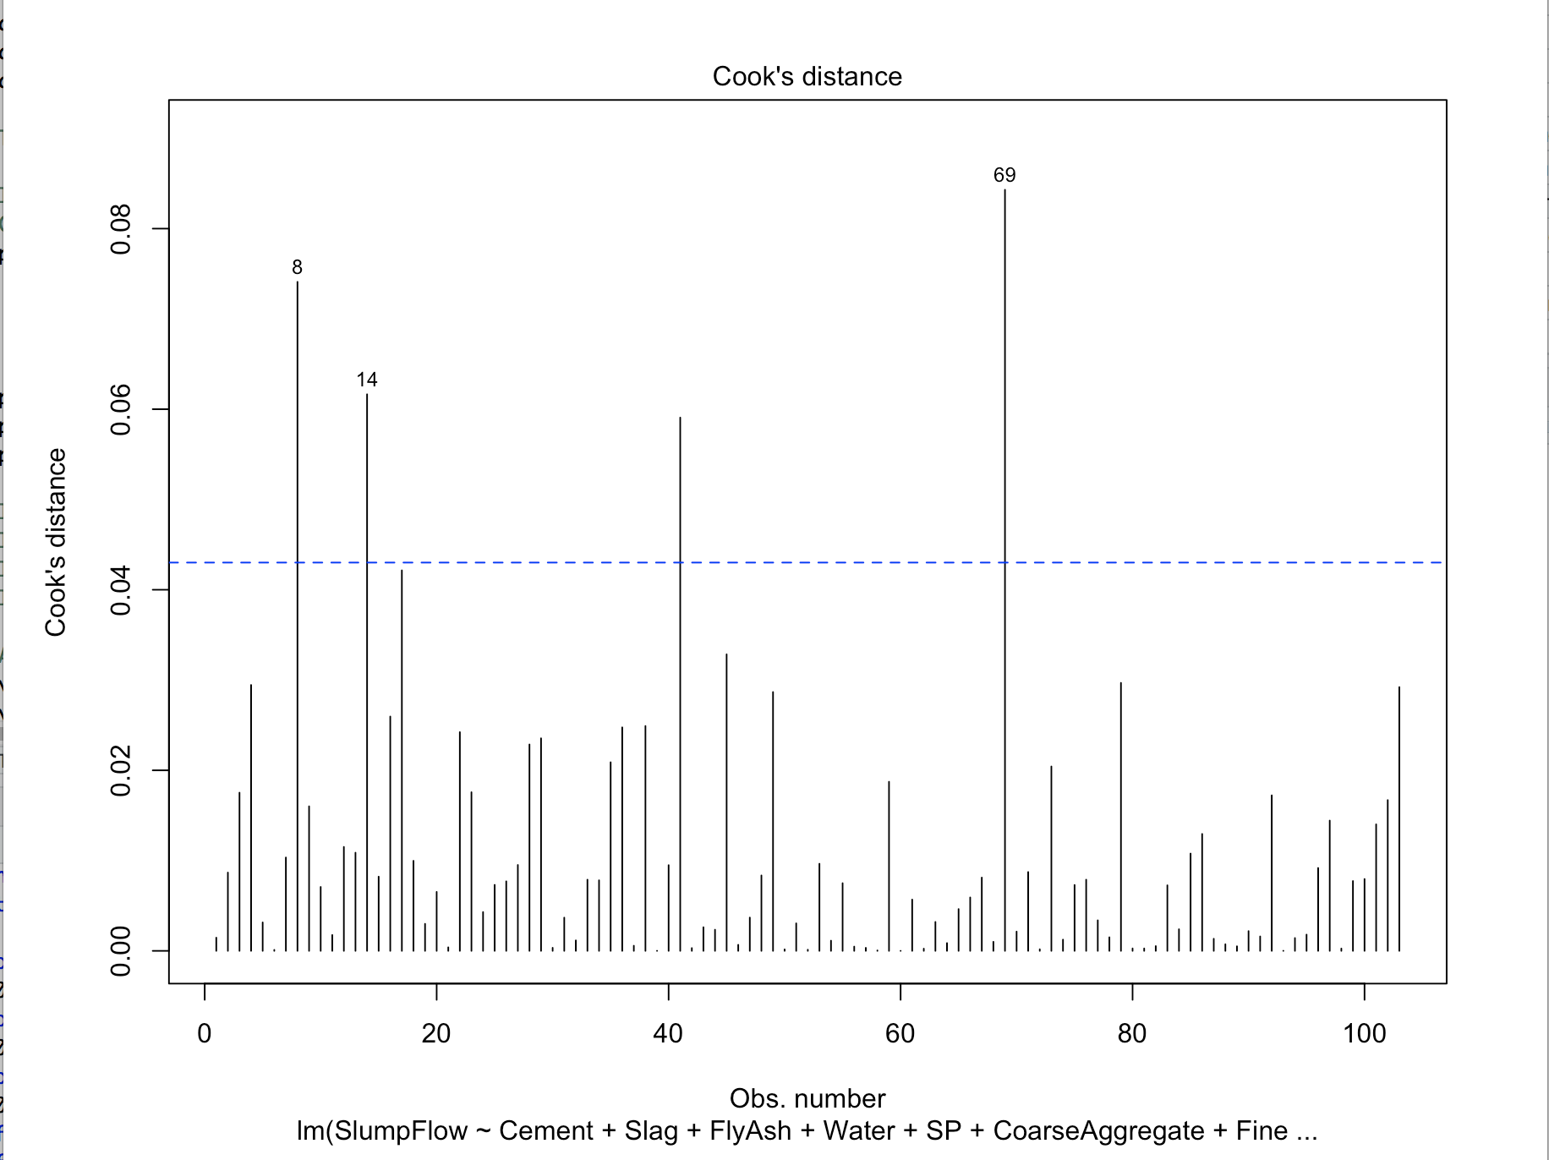

Dplot(fit_LRI,conc)

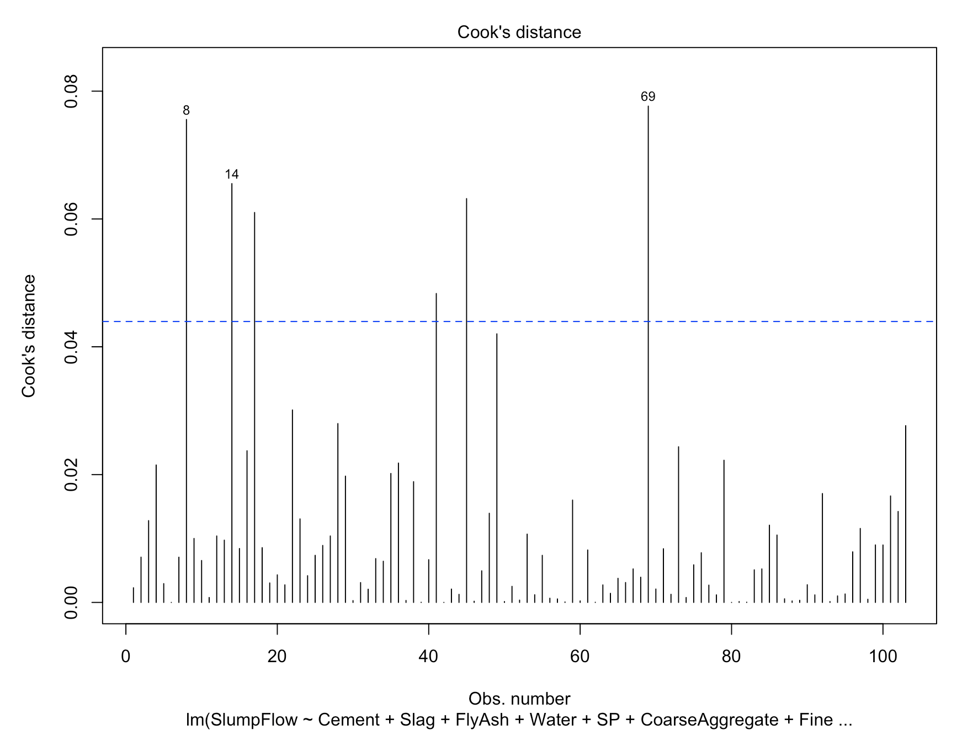

Dplot(fit_SLR,conc)

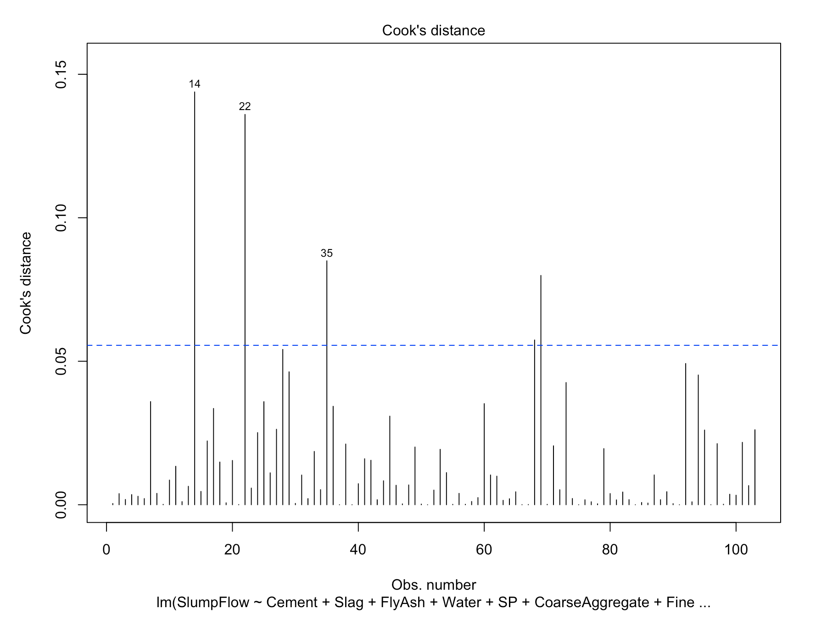

**Interpretation:**

Influence observations are observations that have a disproportionate impact on the values of the model parameters. In LR, 69, 8, and 14, are those with most influence among the model parameters. In LR with Interactions, 69,49,41 are those with most influence. In Second Order Regression, 14, 22, 35 are those with most influence.

**Added variable plots:**

avPlots(fit_MLR, ask=FALSE, id.method ="identify",onepage=TRUE )

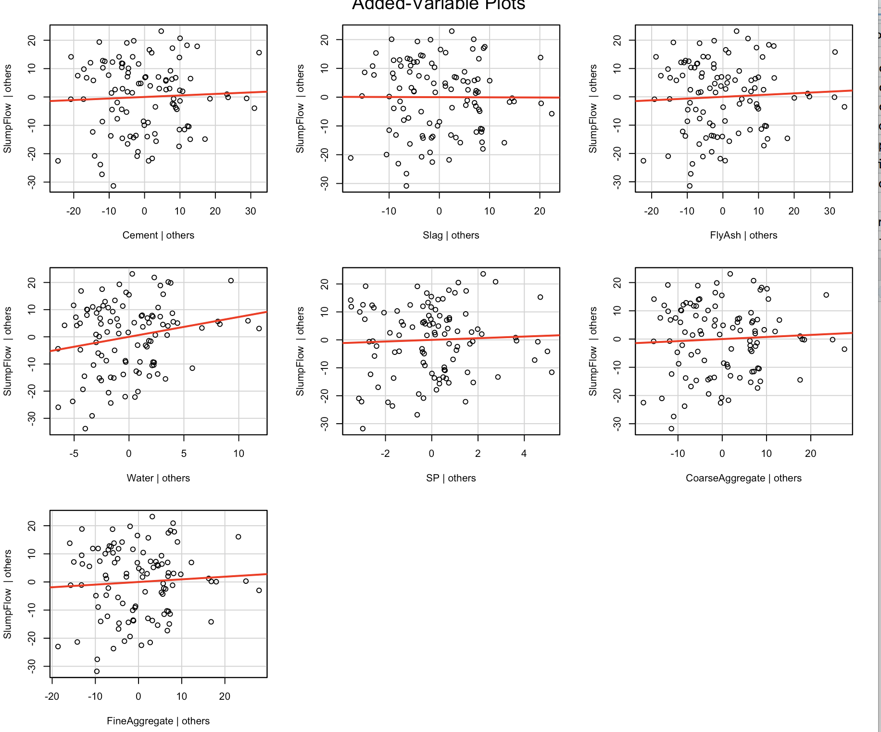

avPlots(fit_LRI, ask=FALSE, id.method ="identify",onepage=TRUE )

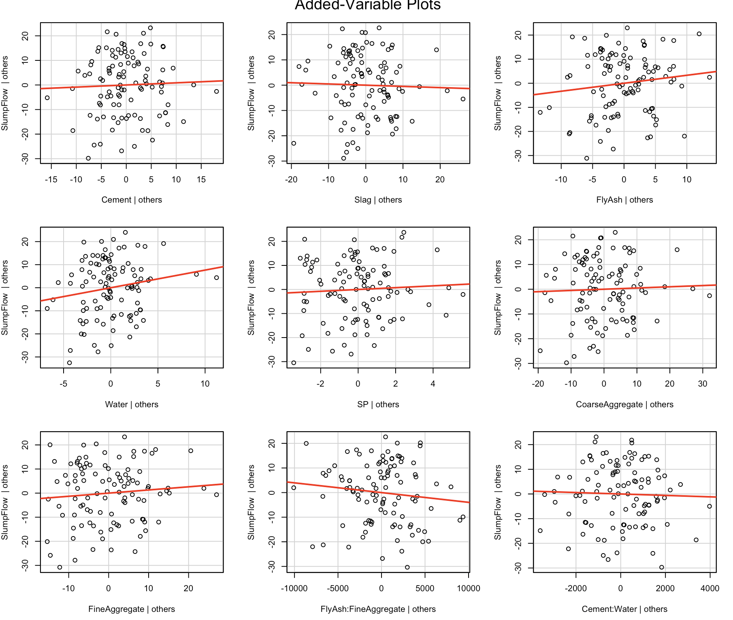

avPlots(fit_SLR, ask=FALSE,id.method ="identify", onepage=TRUE )

**Interpretation:**

The Added-variable plots not only identify influential observations, they also explain the impact of various variables on response variable.

**Combined information by influence plot:**

influencePlot(fit_MLR,id.method="identify", main="Influence Plot:MLR", sub="Circle size is proportial to Cook's Distance")

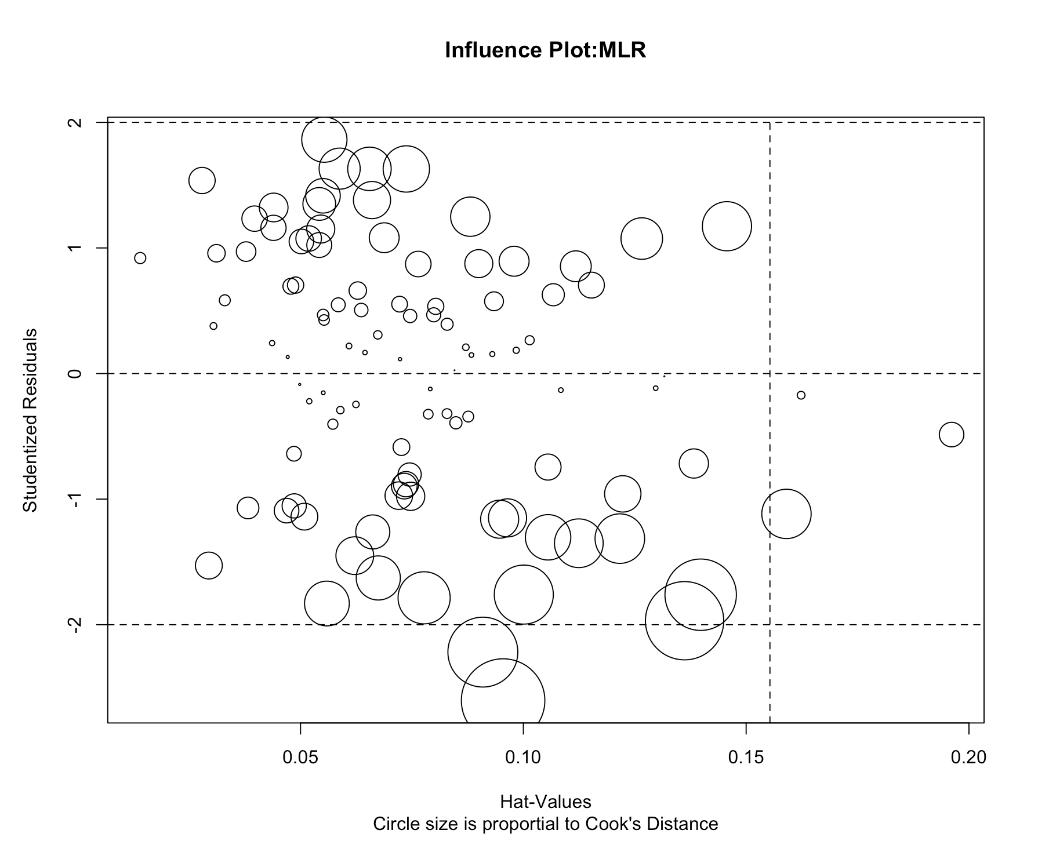

influencePlot(fit_MLR,id.method="identify", main="Influence Plot:MLR with Interactions", sub="Circle size is proportial to Cook's Distance")

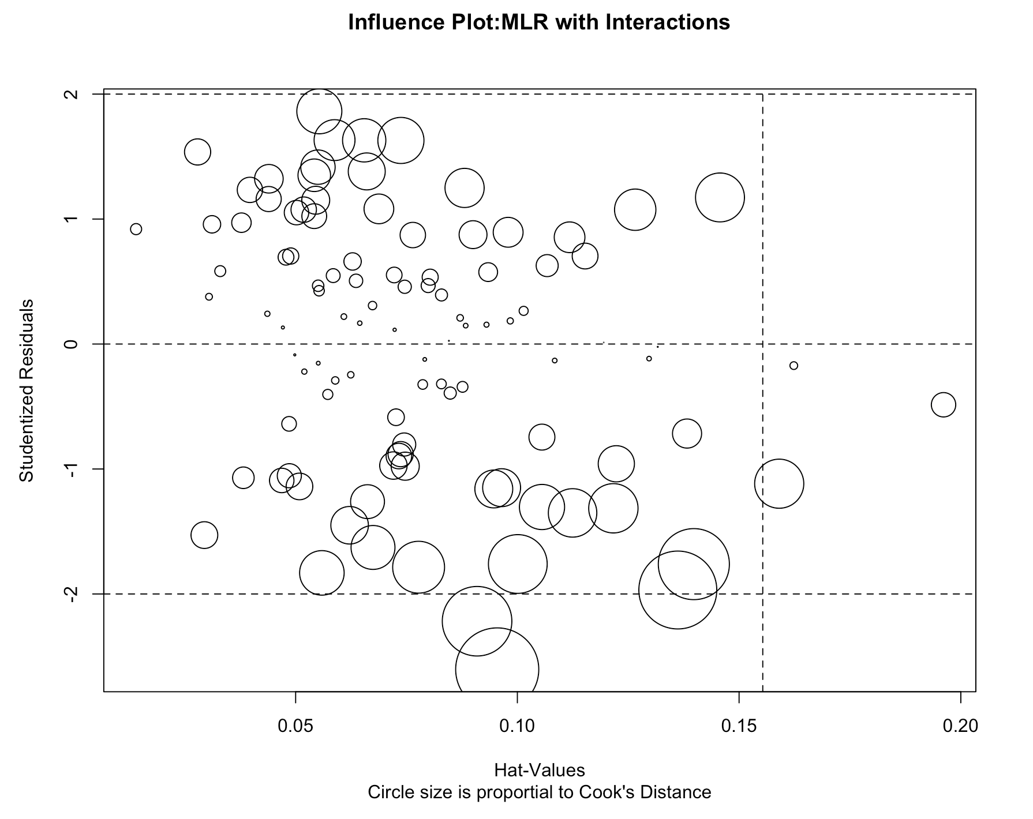

influencePlot(fit_MLR,id.method="identify", main="Influence Plot:Second order", sub="Circle size is proportial to Cook's Distance")

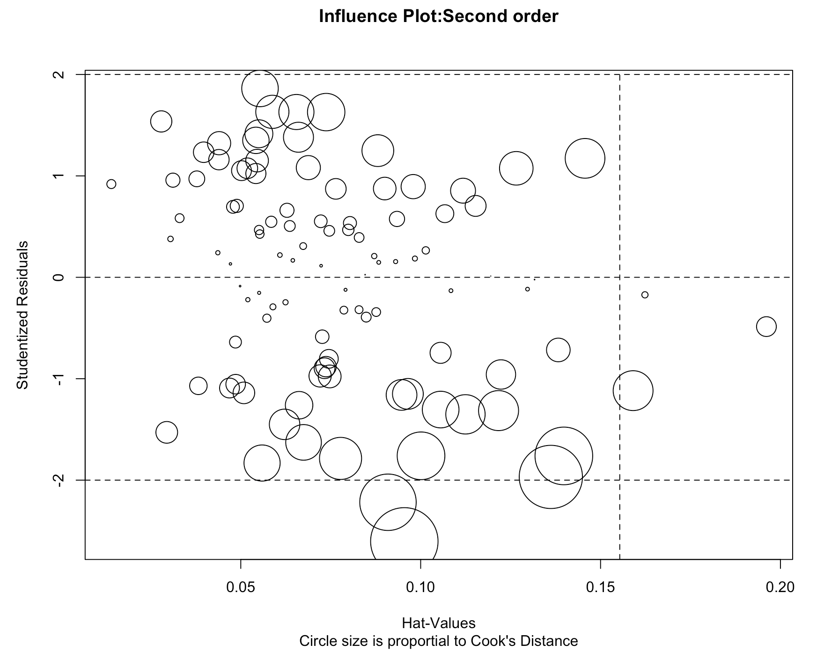

**Interpretation:**

Items above +2 or below -2 on the vertical axis are considered outliers. Items above 0.5 on the horizontal axis have high leverage. Circle size is proportional to influence.

**Corrective measures:**

**Deleting outliers:**

Delete record 69 since it had the largest studentized residual and Cook's distance.

ConcreteData_deleted = conc[c(-69),]

ConcreteData_deleted

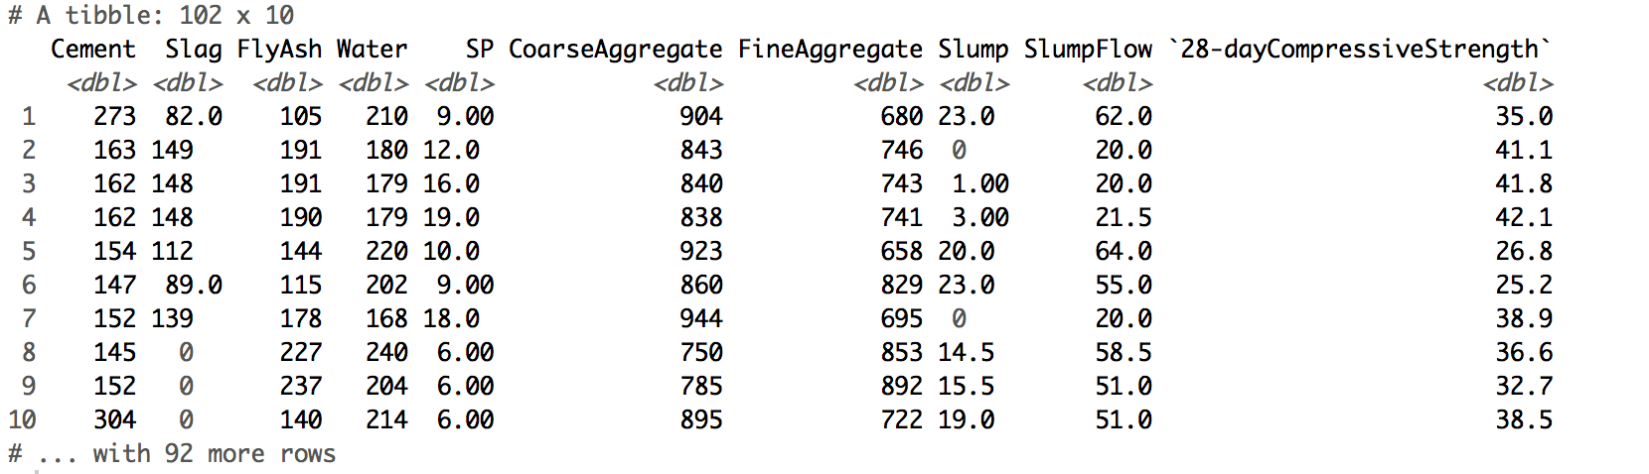

fit_MLR_del<-lm(SlumpFlow ~ Cement + Slag + FlyAsh + Water + SP + CoarseAggregate + FineAggregate,data =ConcreteData_deleted)

summary(fit_MLR_del)

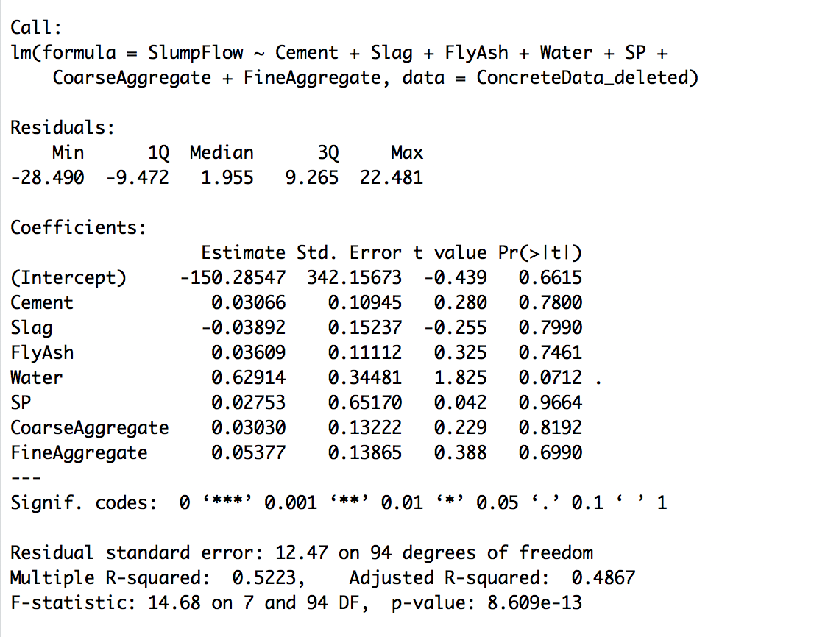

Dplot(fit_MLR_del, ConcreteData_deleted)

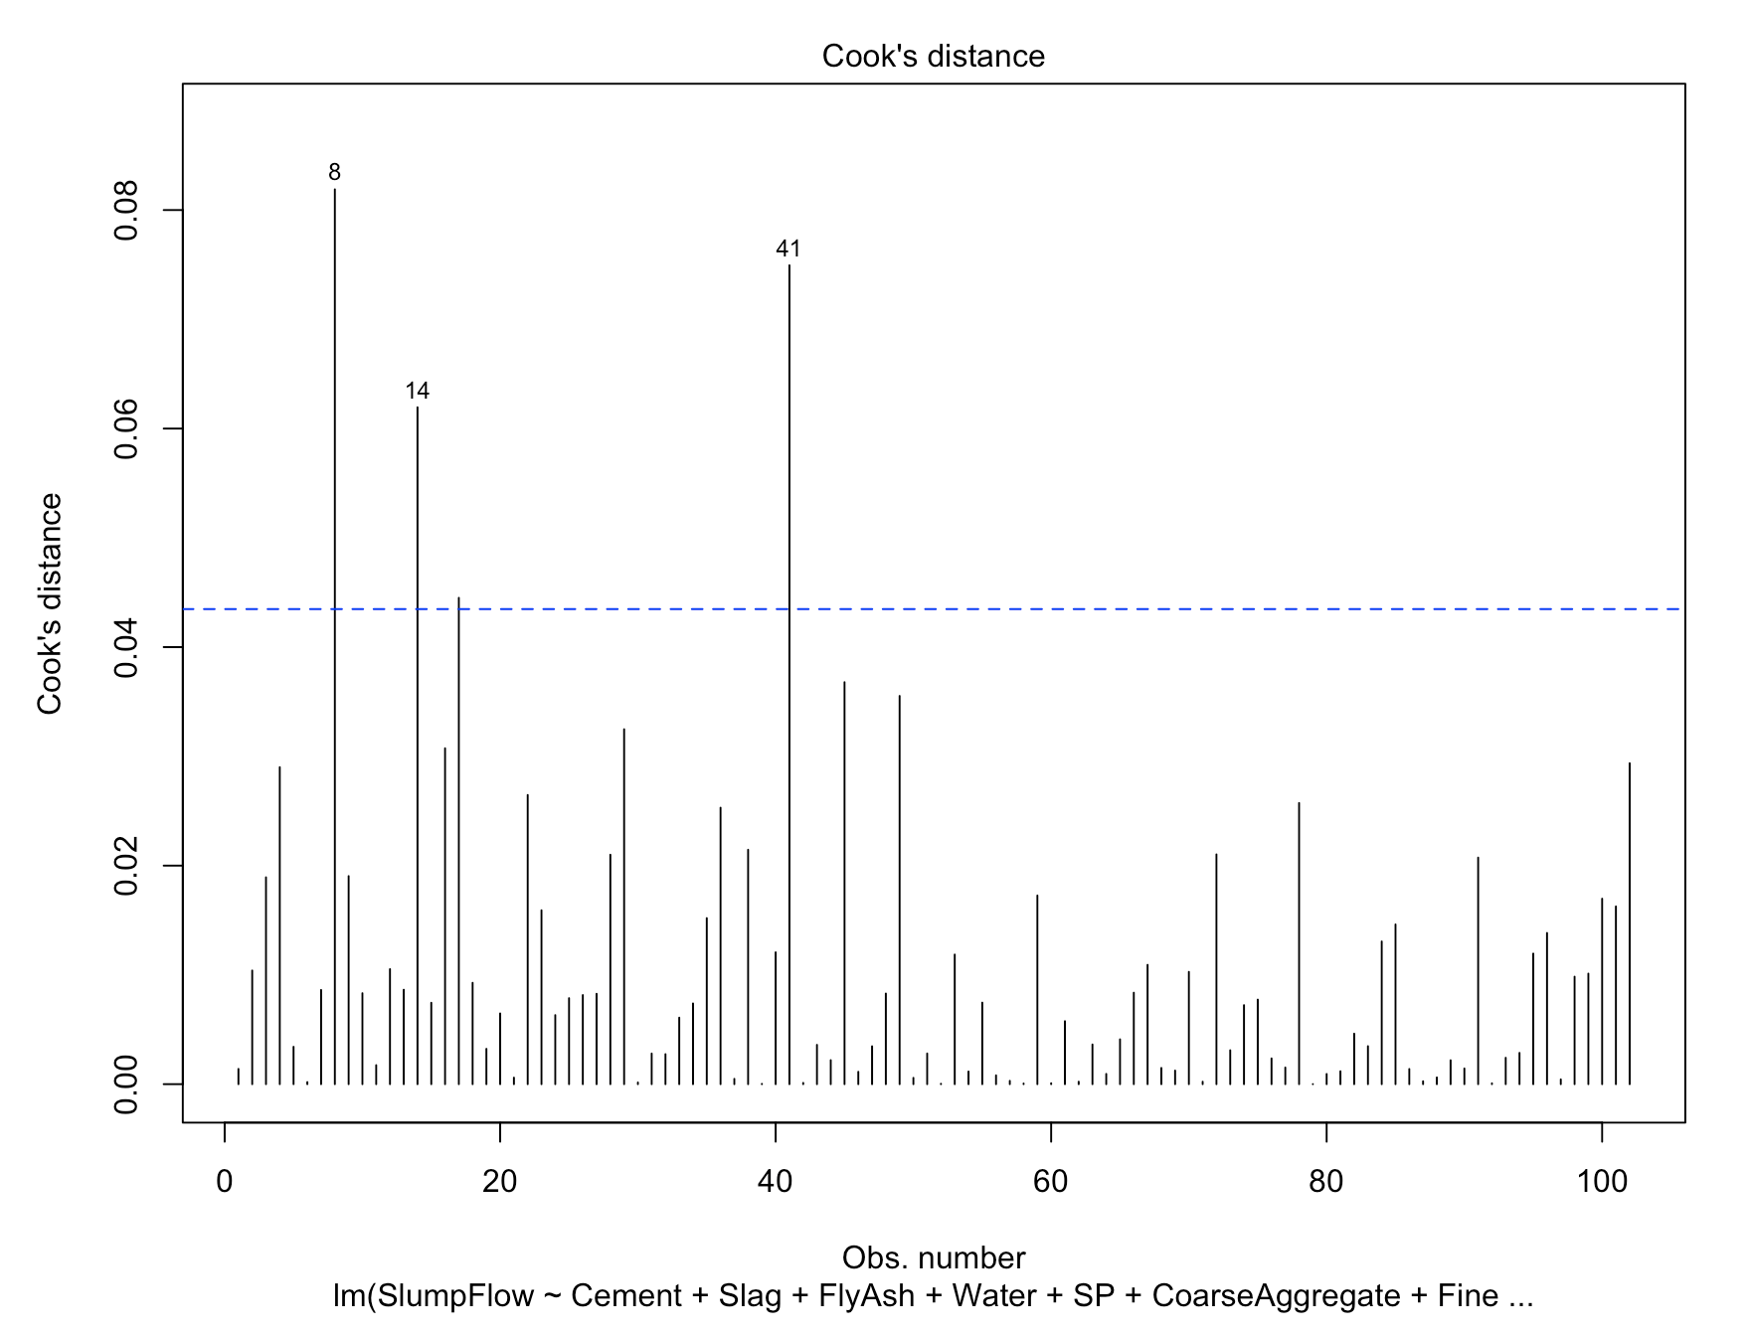

fit_LRI_del<-lm(SlumpFlow~Cement+Slag+FlyAsh+Water+SP+CoarseAggregate+FineAggregate+FineAggregate:FlyAsh+Cement:Water,data =ConcreteData_deleted)

summary(fit_LRI_del)

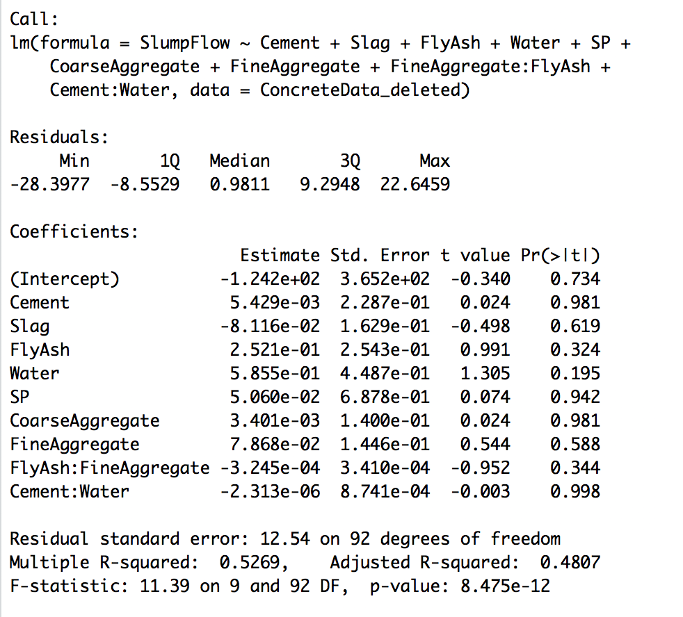

Dplot(fit_LRI_del, ConcreteData_deleted)

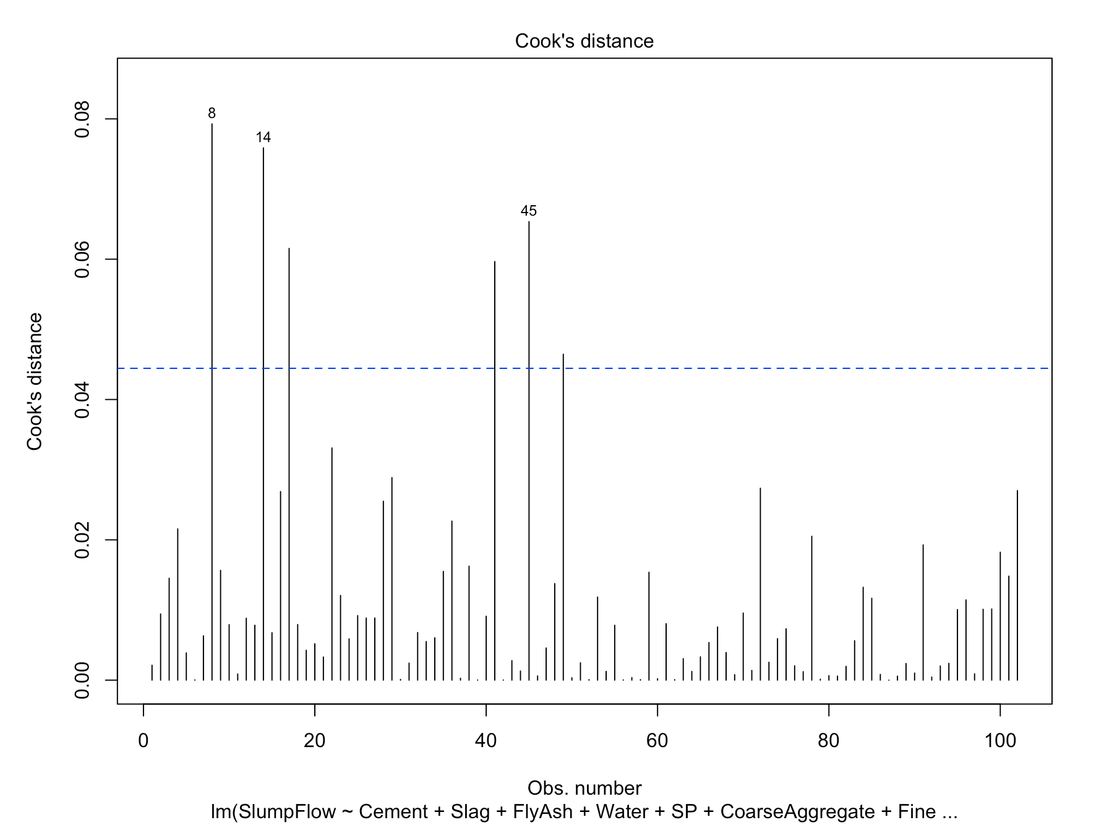

**Interpretation:**

The dataset without record 69 provides better results for both models.

**Transforming variables:**

**Box-cox transformation to Normality:**

summary(powerTransform(fit_MLR_del))

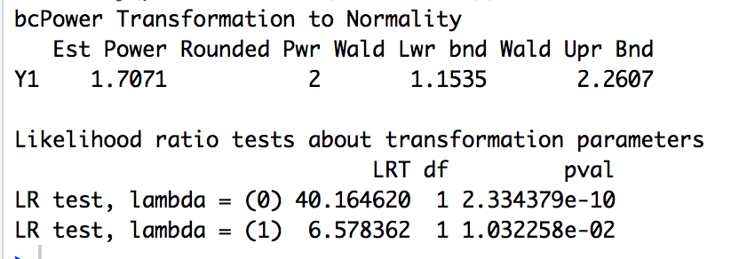

We see that Y1 needs transformation.

Concrete_MLR_del_Trans = ConcreteData_deleted

Concrete_MLR_del_Trans[,1]=Concrete_MLR_del_Trans[,1]^1.707

fit_MLR_del_trans<-lm(SlumpFlow~Cement+Slag+FlyAsh+Water+SP+CoarseAggregate+FineAggregate,data =Concrete_MLR_del_Trans)

summary(powerTransform(fit_MLR_del_trans))

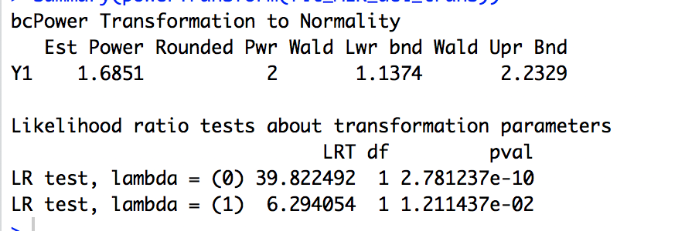

summary(powerTransform(fit_SLR))

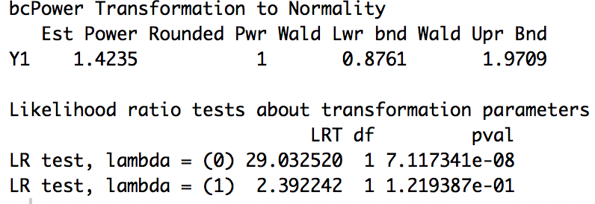

**Interpretation:**

For lambda = 1, pval=0.12. Y1 conforms to Normality and doesn't need transformation

**Adding or deleting variables**

Based on the result of SQRT(vif) > 2 for most of the variables multicollinearity condition is not satisfied. However, we cannot deleting all variables or cannot add anything else.

**Question 1.5:**

**Selecting the best regression model:**

**Comparing Mutiple linear regression, linear regression with interaction and Second order linear regression:**

anova(fit_MLR, fit_LRI, fit_SLR)

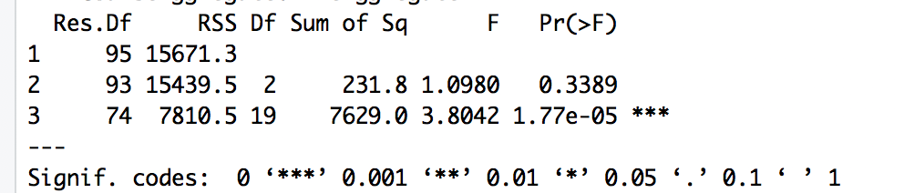

Model with least RSS value is the best- Second order linear regression is the best model.

AIC(fit_MLR, fit_LRI, fit_SLR)

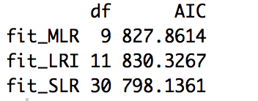

Models with smaller AIC values are preferred- Second order linear regression is the best model.

**Variable selection:**

**Backwards stepwise selection**

library(MASS)

stepAIC(fit_SLR, direction = "backward")

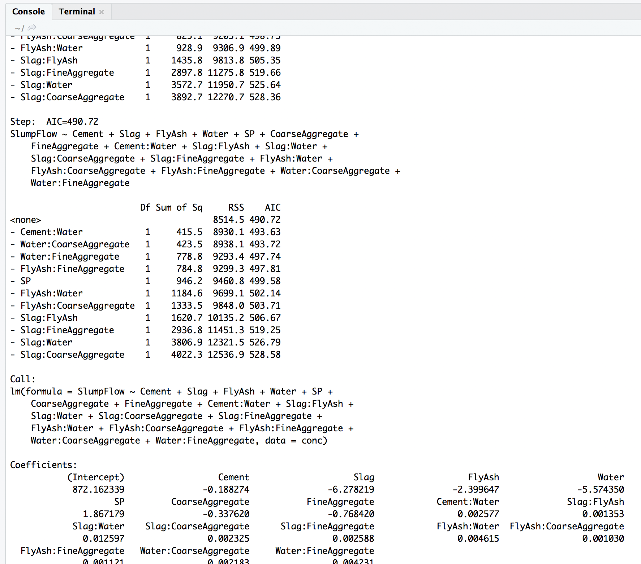

fit_SLR_Back<-lm(SlumpFlow ~ Cement + Slag + FlyAsh + Water + SP + CoarseAggregate +

FineAggregate + Cement:Water + Slag:FlyAsh + Slag:Water +

Slag:CoarseAggregate + Slag:FineAggregate + FlyAsh:Water +

FlyAsh:CoarseAggregate + FlyAsh:FineAggregate + Water:CoarseAggregate +

Water:FineAggregate,data=conc)

summary(fit_SLR_Back)

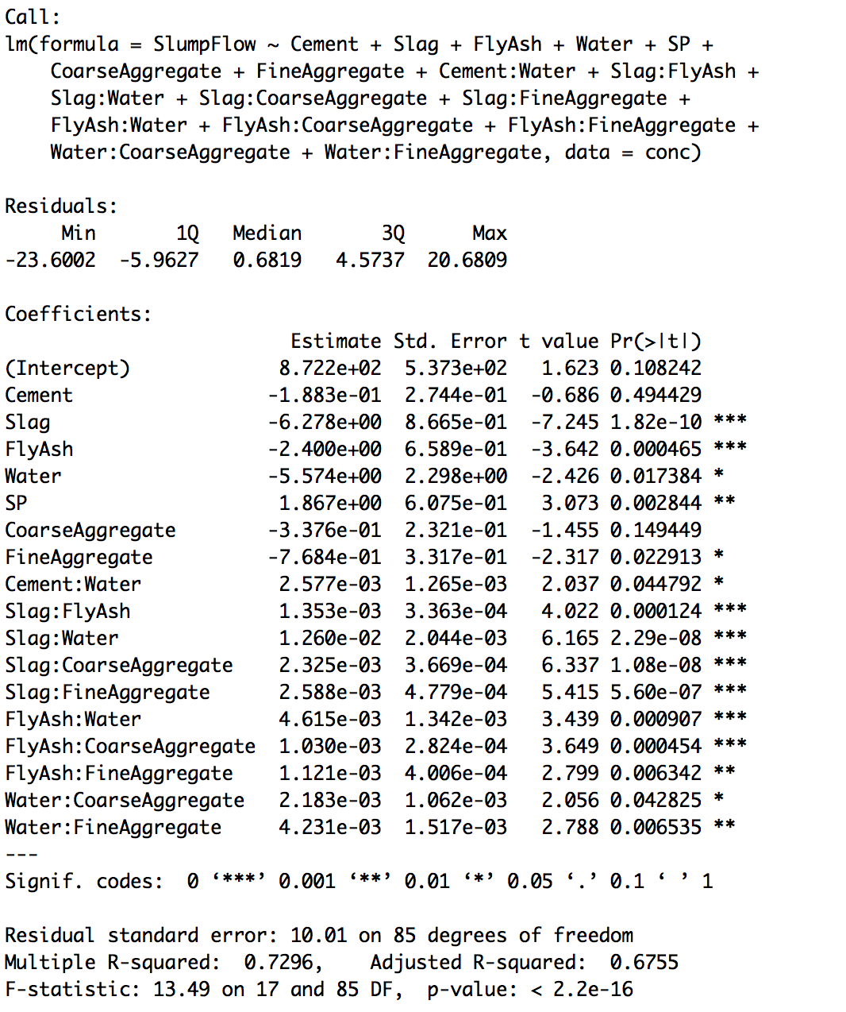

summary(fit_SLR)

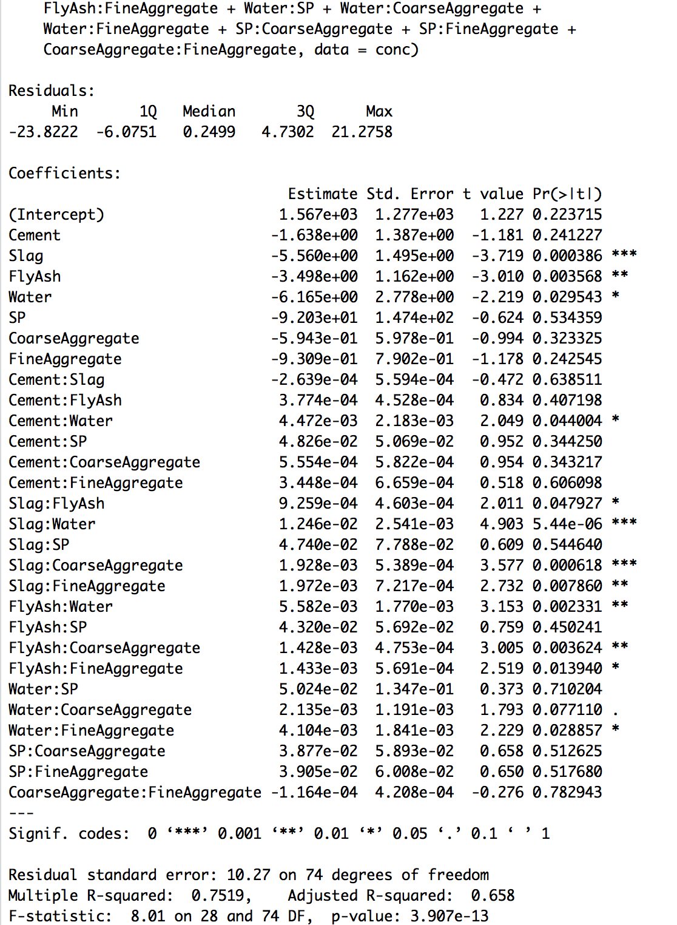

**All subsets regression:**

library(leaps)

leaps<-regsubsets(SlumpFlow~Cement+Slag+FlyAsh+Water+SP+CoarseAggregate+FineAggregate+

Cement:Slag+Cement:FlyAsh+Cement:Water+Cement:SP+Cement:CoarseAggregate+Cement:FineAggregate+ Slag:FlyAsh+Slag:Water+Slag:SP+Slag:CoarseAggregate+Slag:FineAggregate+ FlyAsh:Water+FlyAsh:SP+FlyAsh:CoarseAggregate+FlyAsh:FineAggregate+ Water:SP+Water:CoarseAggregate+Water:FineAggregate+

SP:CoarseAggregate+SP:FineAggregate+

CoarseAggregate:FineAggregate, data = conc, nbest=1)

plot(leaps, scale="adjr2")

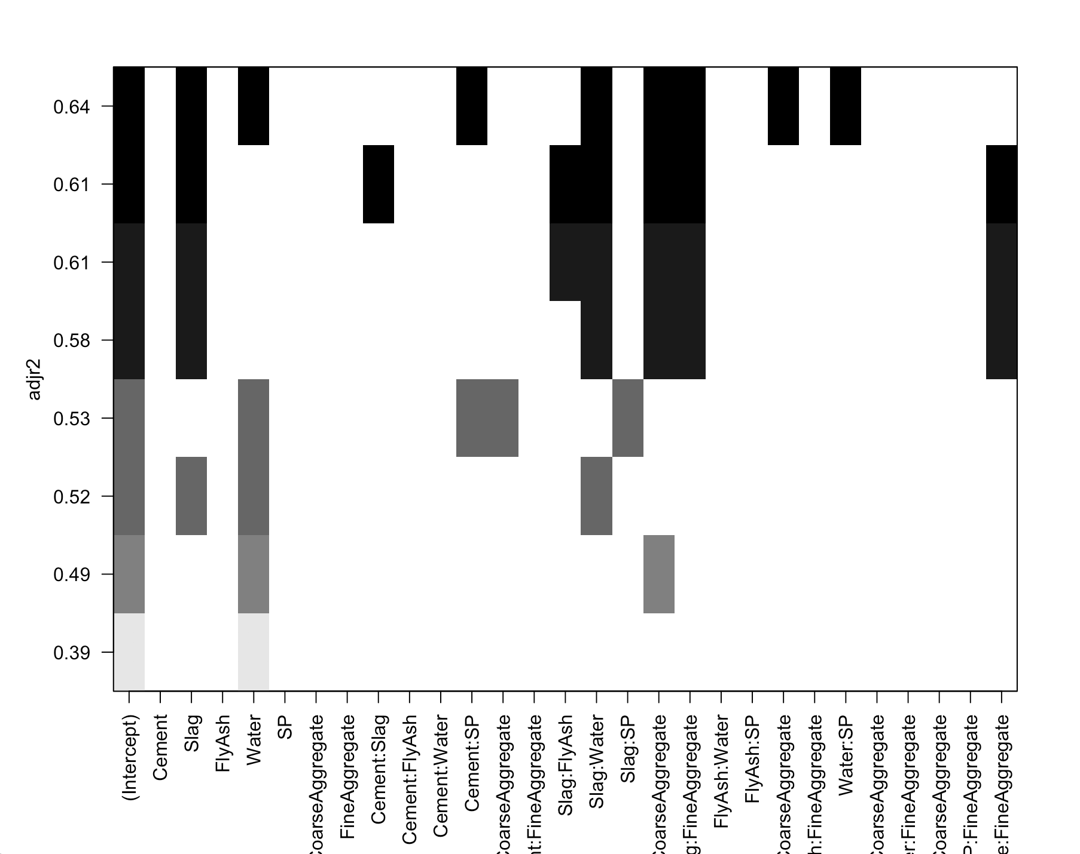

**Interpreting the prediction results:**

The model needs to be refined by reducing redundant variables from a larger group. Based on the Backwards stepwise selection, the model has been refined into a simpler one and its AIC drops from 503.83 to 490.72. Another approach to reselect the variables is all subset regression, either based on adjusted R-squared or on Mallow’s Cp value. Comparing adjusted R-Squared of the refined model and original one, the original model is around 0.66, and the refined model has 0.675. Also, the residual error is lesser for the original model. Therefore, it is the better model.

Task 4:

Forest_Fires_Data <- read_excel("Forest Fires Data.xlsx")

View(Forest_Fires_Data)

Forest_Fires_Data

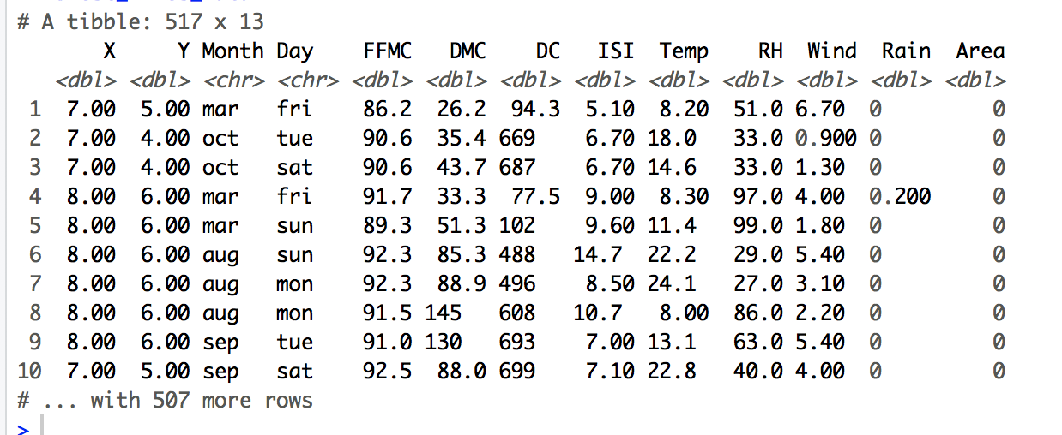

#Question 2.1

Forest_Fires_Data$X.f<-factor(Forest_Fires_Data$X)

Forest_Fires_Data$Y.f<-factor(Forest_Fires_Data$Y)

Forest_Fires_Data$Month.f<-factor(Forest_Fires_Data$Month)

Forest_Fires_Data$Day.f<-factor(Forest_Fires_Data$Day)

Forest_Fires_Data$Area<-log1p(Forest_Fires_Data$Area)

ForestfiresData<-Forest_Fires_Data[,c(13,14:17,5:12)]

ForestfiresData

scatterplotMatrix(ForestfiresData,spread = FALSE,lty.smooth=2,main="Scatter Plot Matrix")

# X-Y coordinates and Month and day information have been transformed into factors

# Area has been transformed into LN(Area+1)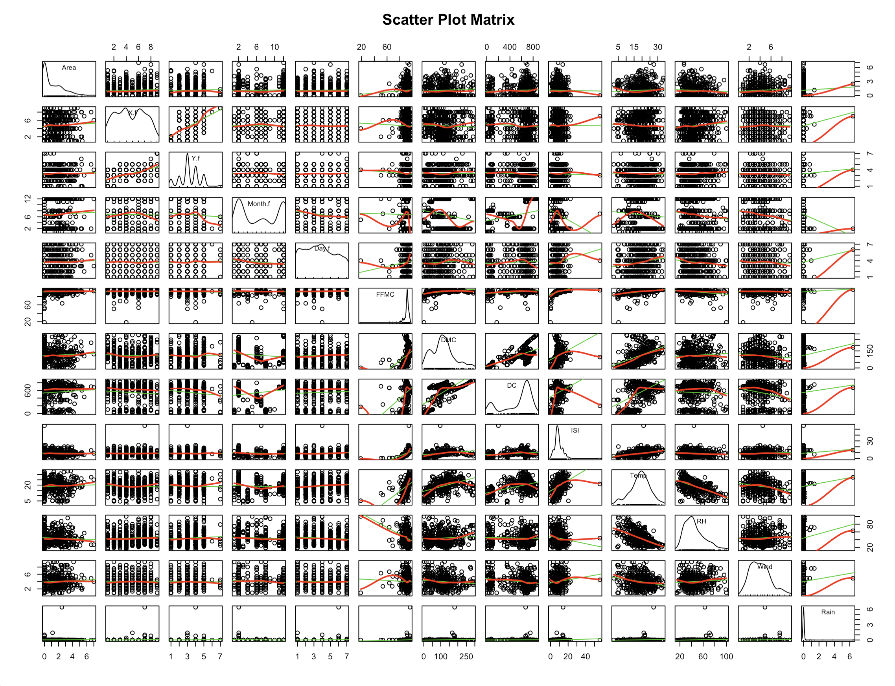

#The 4 categorical variables have been transformed to dummy variables by factor() method. Area has been transformed into Ln(Area+1).

#The output data frame includes one response and twelve independent variables.

#In the scatter plot matrix, the points in four categorical variables are vertically arranged and don’t show much correlation with the outcome variable.

#Question 2.2:

#Use regression models:

#STFWI - Spacial, temporal and WI attributes

FF_fit_STFWI = lm(Area ~ X.f + Y.f + Month.f + Day.f + FFMC + DMC + DC + ISI, data=ForestfiresData)

summary(FF_fit_STFWI)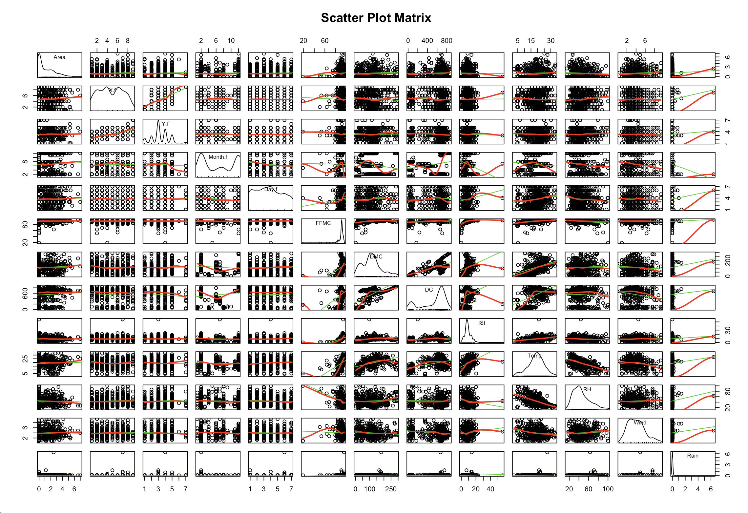

#STM- Spacial, temporal and M( weather conditions)

FF_fit_STM = lm(Area ~ X.f + Y.f + Month.f + Day.f + Temp + RH + Wind + Rain, data=ForestfiresData)

summary(FF_fit_STM)

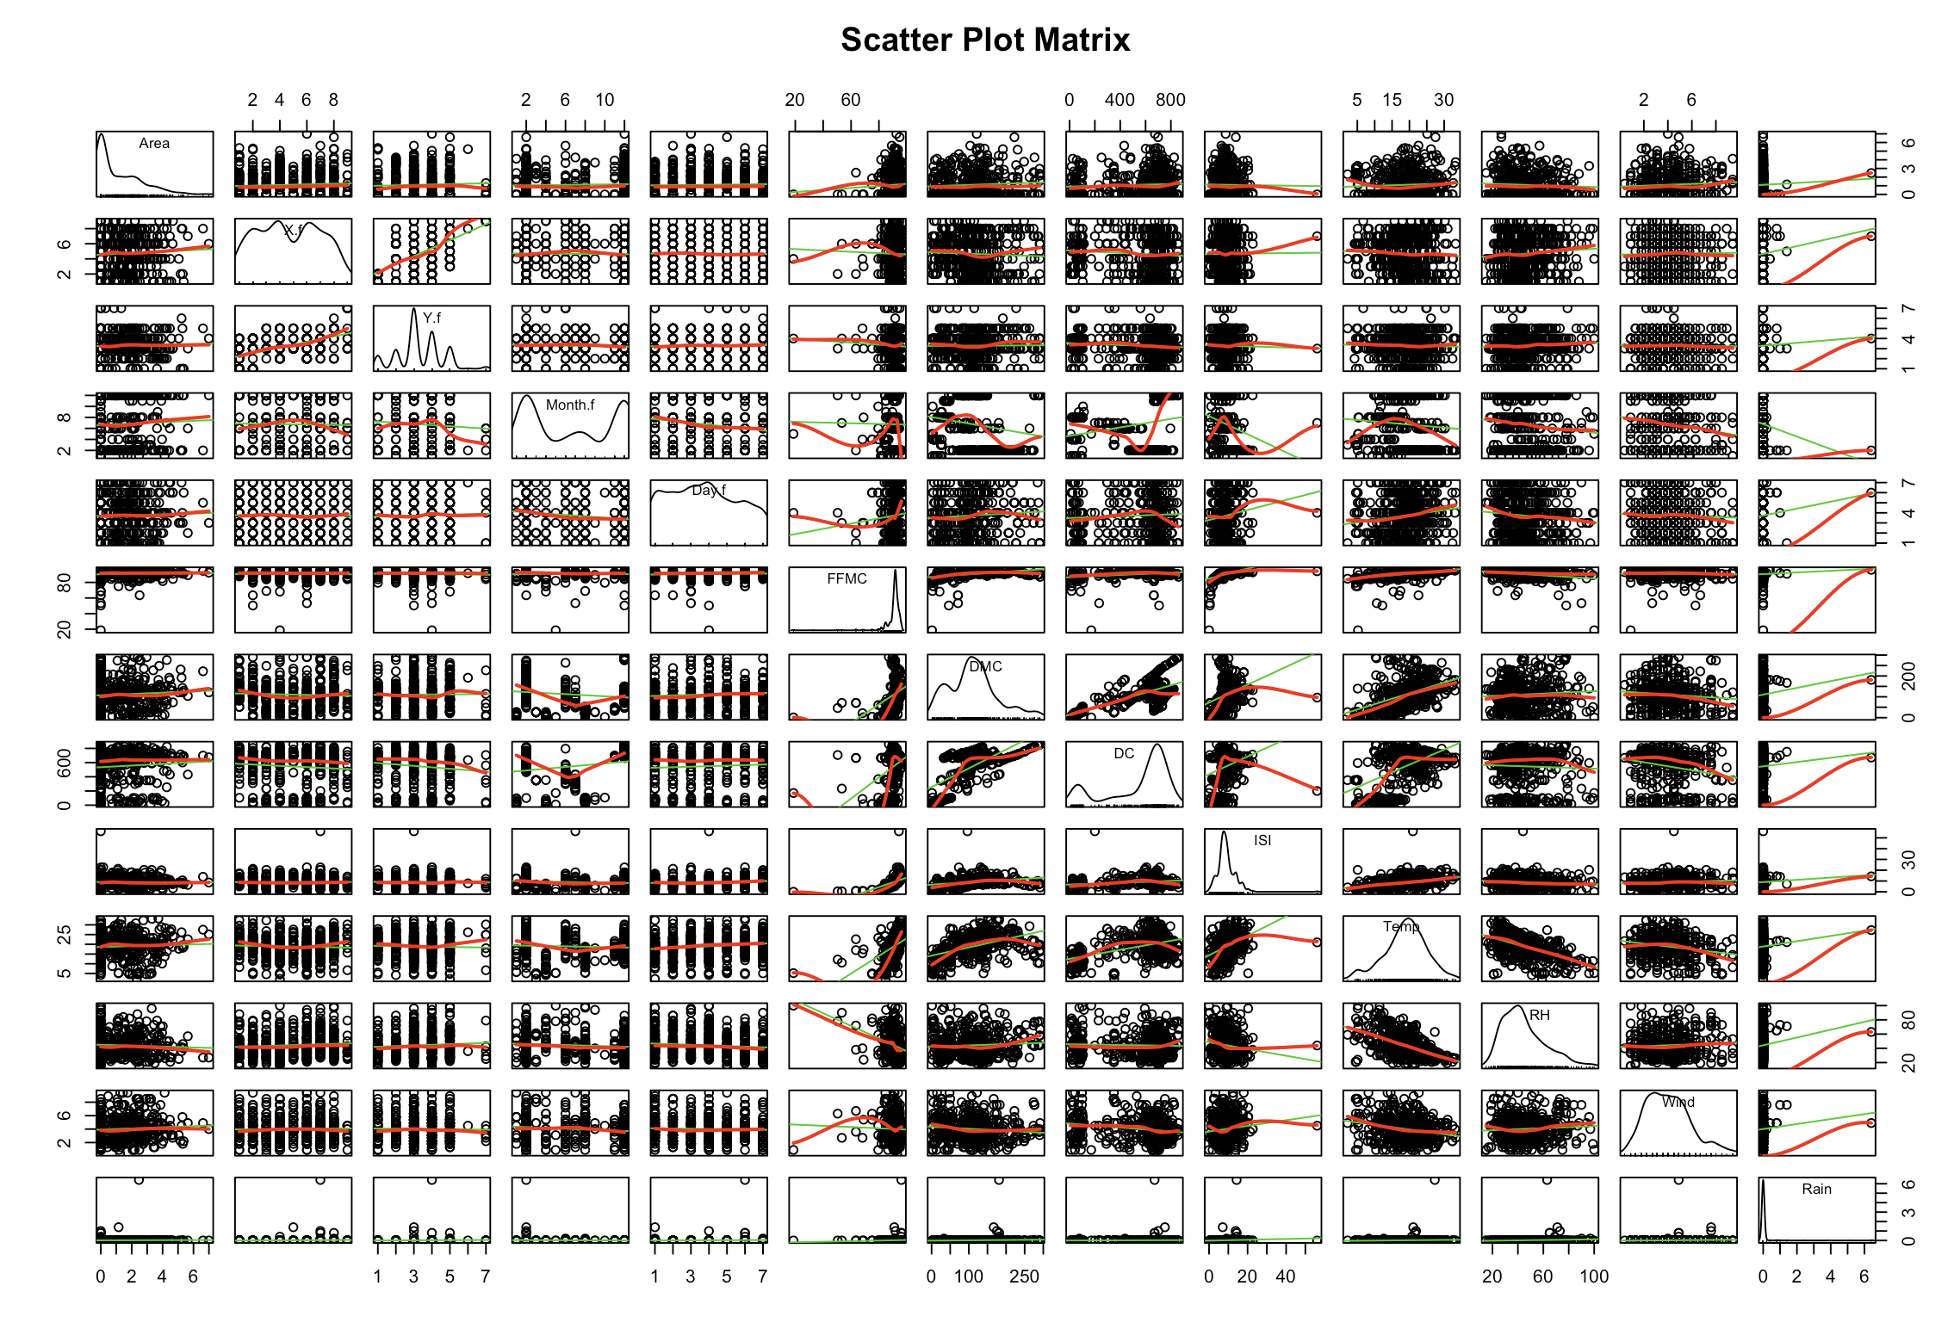

#FWI- Fire Weather Index

FF_fit_FWI = lm(Area ~ FFMC + DMC + DC + ISI, data=ForestfiresData)

summary(FF_fit_FWI)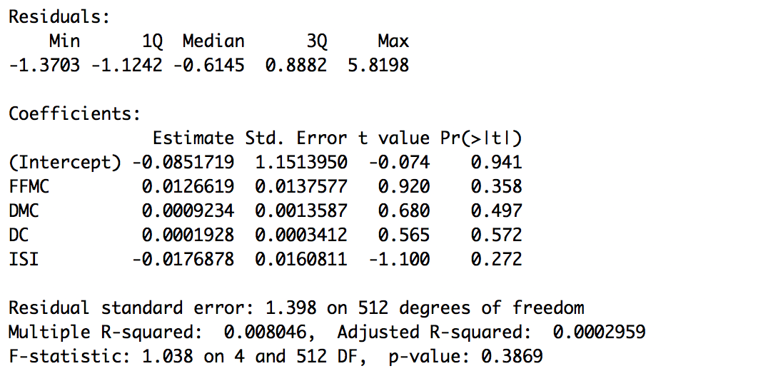

#Model M- uses the four weather conditions

FF_fit_M = lm(Area ~ Temp + RH + Wind + Rain, data=ForestfiresData)

summary(FF_fit_M)

#Interpretation: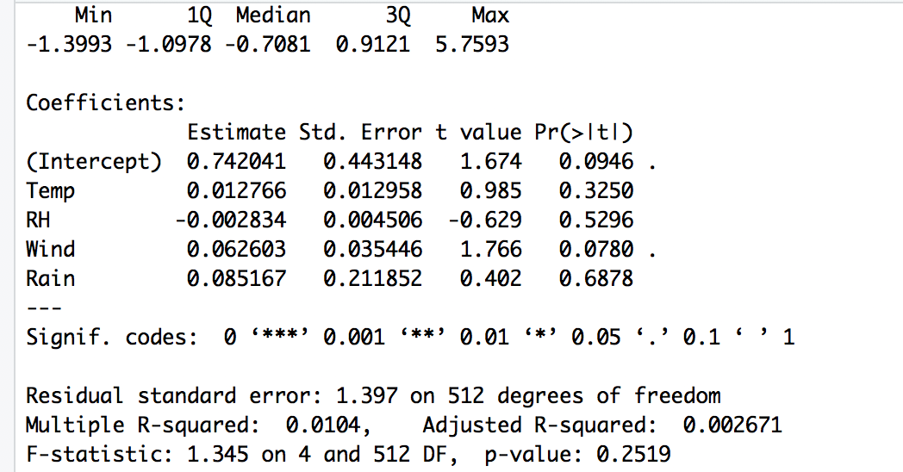

#There are four algorithms mentioned in the paper- STFWI, STM, FWI, M that have been used.

#In terms of spatial and temporal variables lack of linearity as shown

#Question 3.1:

#Regression diagnostics:

#Typical Approach

par(mfrow=c(2,2))

plot(FF_fit_STFWI)

plot(FF_fit_STM)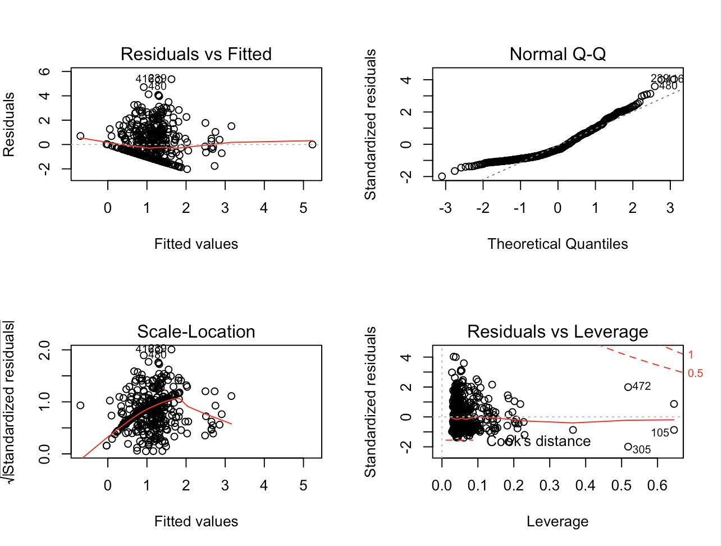

# Point 421 and 517 are highly leveraged that should be considered for deletion in the corrective step #

plot(FF_fit_FWI)

plot(FF_fit_M)

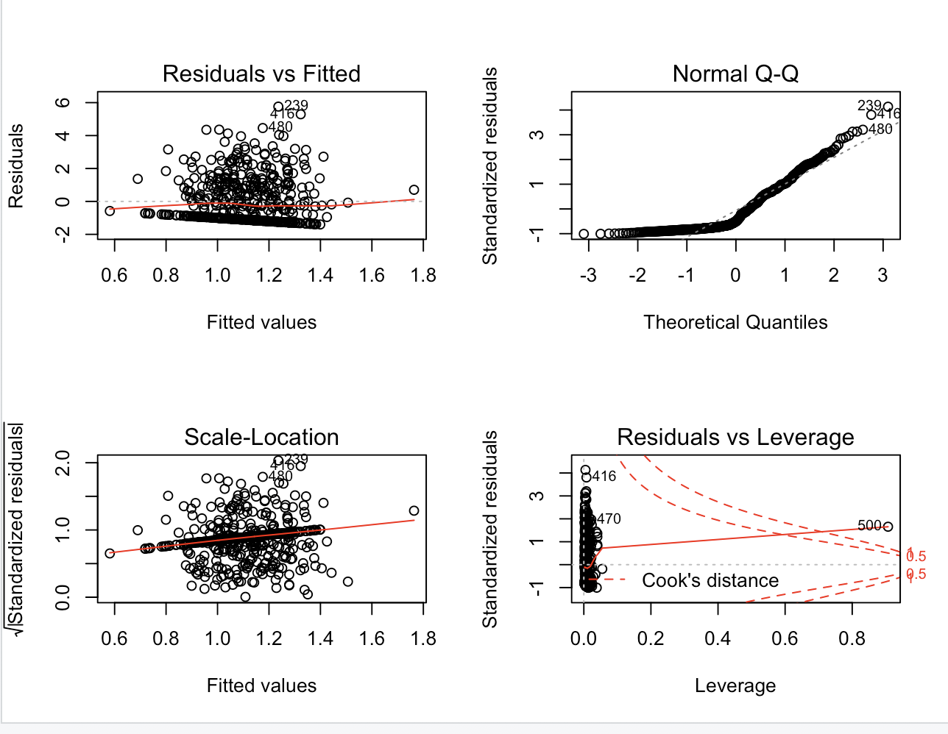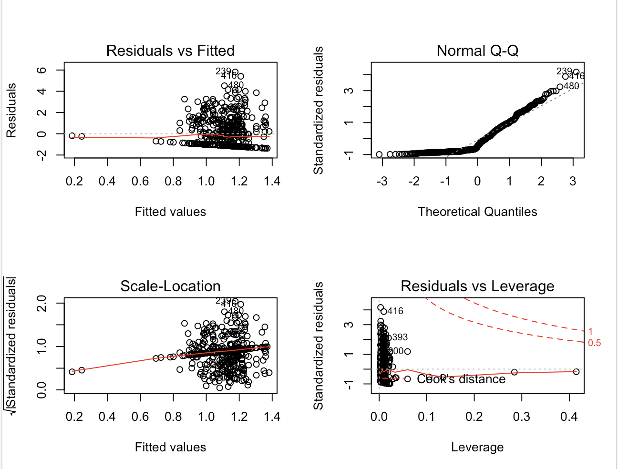

#Interpretation:

#In the normal Q-Q plot, there are too many points that deviate from the 45 degree diagonal- the dataset violates the normality assumption.

#In the residual VS fitted plot, the regression curve is flat.

#In the Scale-Location plot, data points are not randomly around the horizontal line, but align along a convex curve that suggests the dataset doesnt have homoscedasticity.

#The Residuals VS Leverage plot identifies several high-leveraged points.

#Enhanced Approach

#Normality

#Enhanced Q-Q Plot

par(mfrow=c(1,1))

qqPlot(FF_fit_STFWI,labels=row.names(ForestfiresData), id.method="identify", simulate=TRUE,

main="Linear Regression Model Q-Q Plot")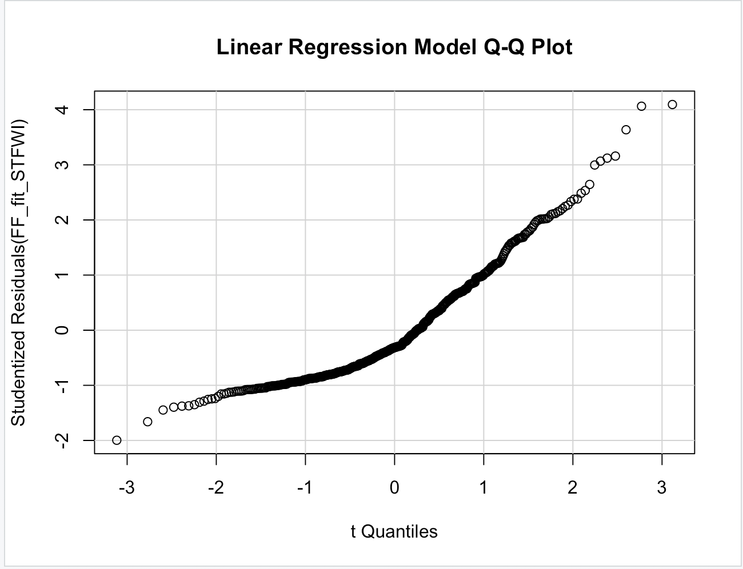

qqPlot(FF_fit_STM,labels=row.names(ForestfiresData), id.method="identify", simulate=TRUE,

main="Linear Regression Model Q-Q Plot")

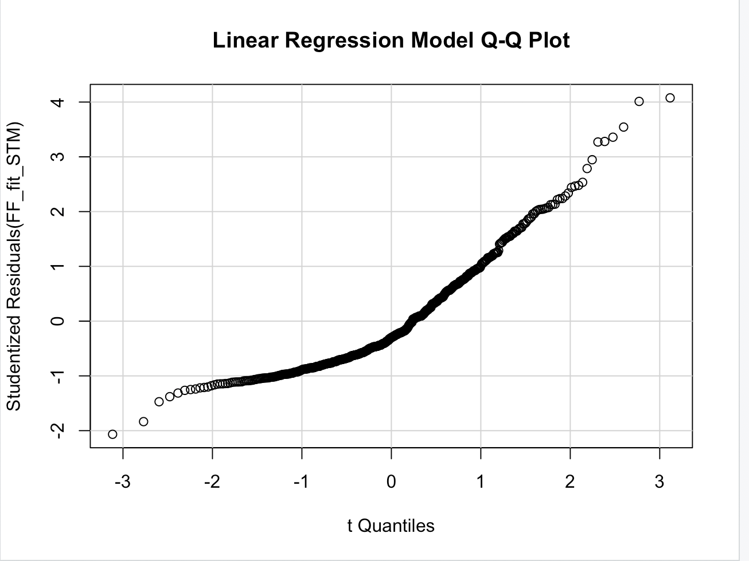

qqPlot(FF_fit_FWI,labels=row.names(ForestfiresData), id.method="identify", simulate=TRUE,

main="Linear Regression Model Q-Q Plot")

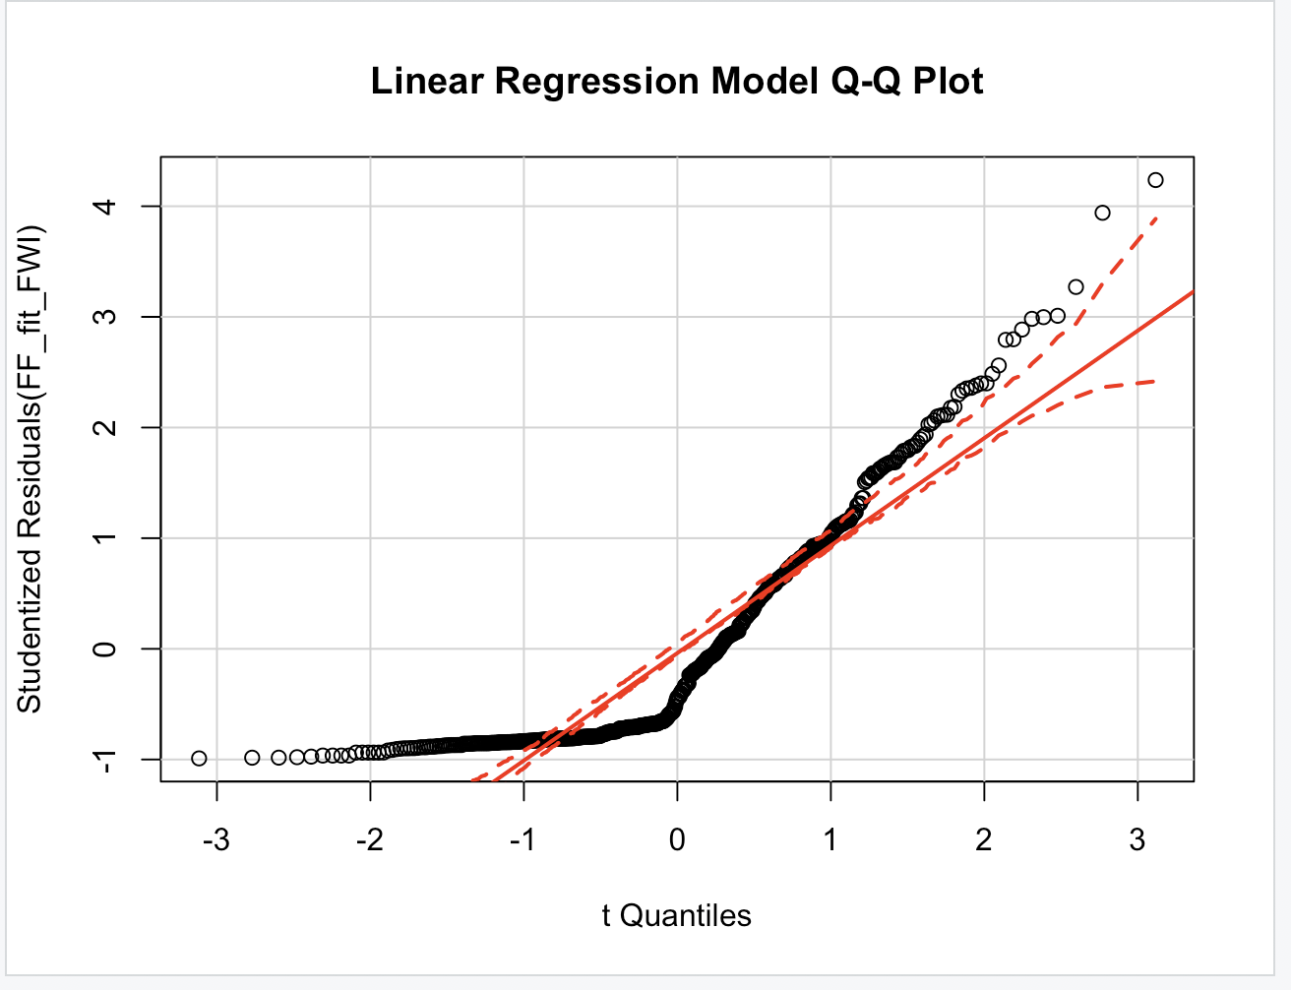

qqPlot(FF_fit_M,labels=row.names(ForestfiresData), id.method="identify", simulate=TRUE,

main="Linear Regression Model Q-Q Plot")

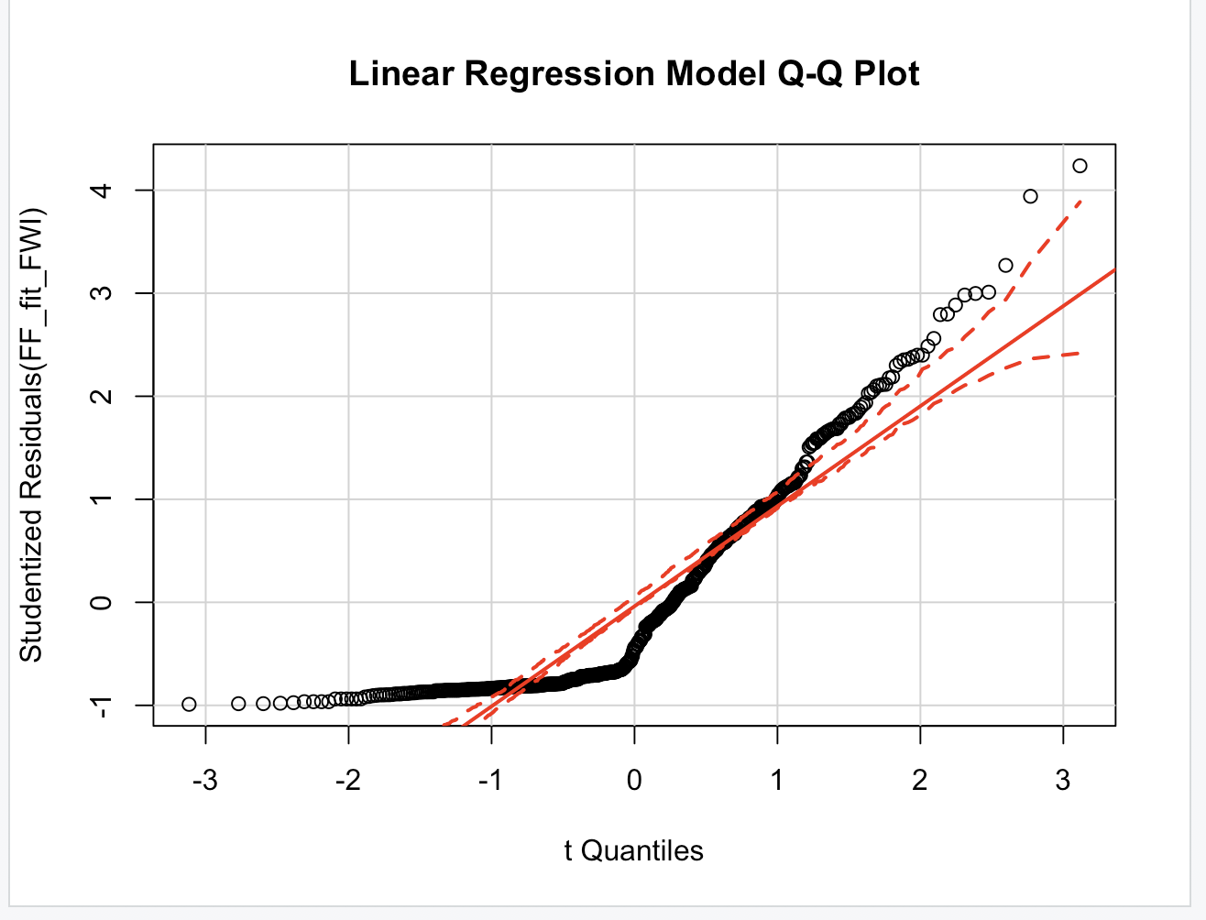

#Interpretation:

#Besides the four dummy variables, ISI and FFMC don’t have linearity with respect to the area.

# Studentized Residuals Distribution

residualPlot = function(fit, nbreaks = 10){

z = rstudent(fit)

hist(z, breaks = nbreaks, freq = FALSE, xlab = "Studentized Residual", main = "Distribution of Errors")

rug(jitter(z), col="brown")

curve(dnorm(x, mean=mean(z), sd=sd(z)), add=TRUE, col="blue", lwd=2)

lines(density(z)$x, density(z)$y, col="red", lwd=2, lty=2)

legend("topright", legend = c("Normal Curve", "Kernel Density Curve"), lty = 1:2, col=c("blue", "red"), cex=.7 )

}

#Interpretation:

#we can clearly see the dependent variable is very much left skewed, though it has been already transformed by log Area.

# Since STFWI and STM contain dummy variables, the normal and Kernel Density curve don't apply to them.

residualPlot(FF_fit_FWI)

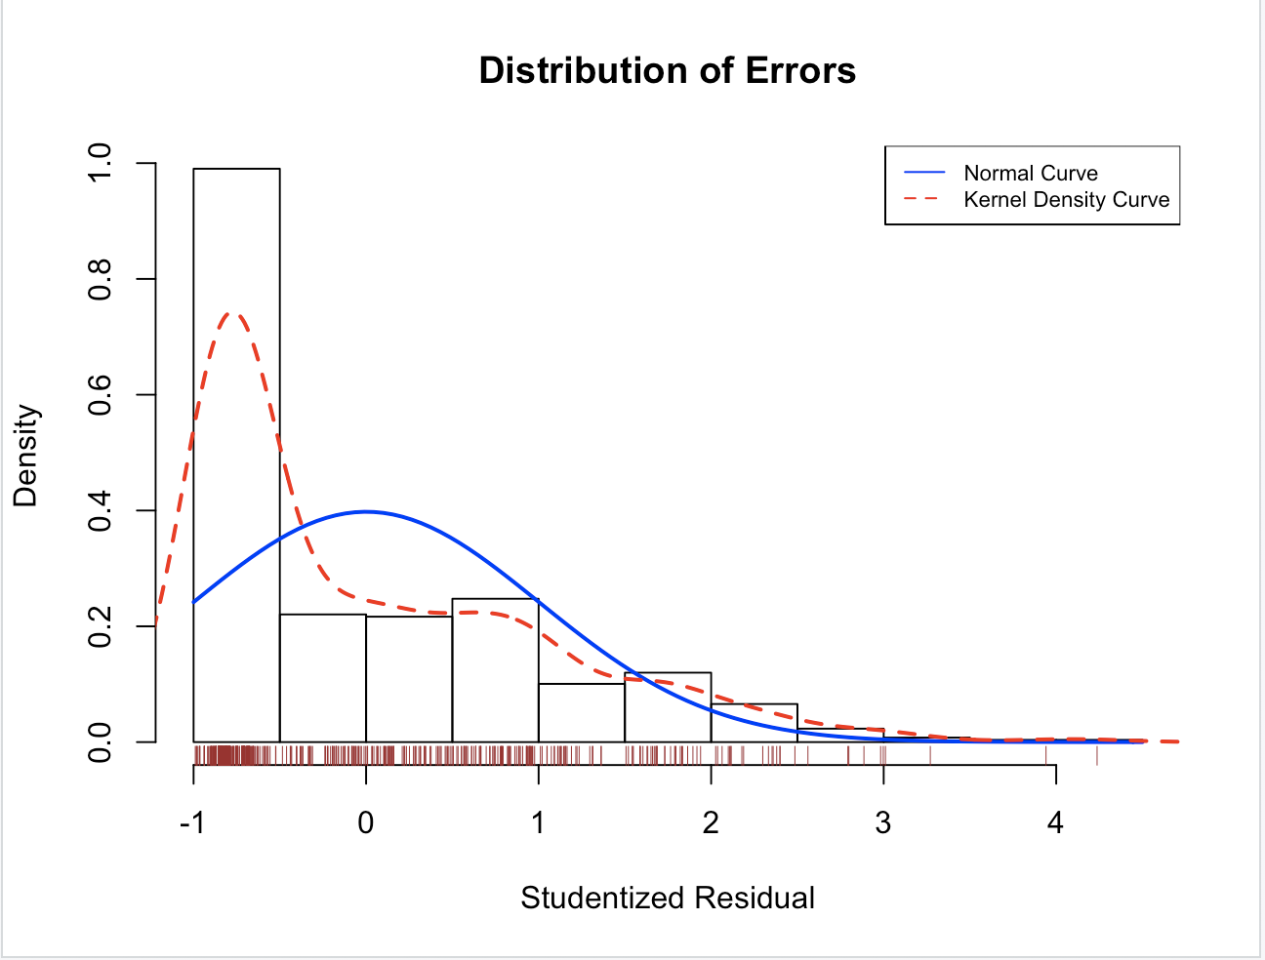

residualPlot(FF_fit_M)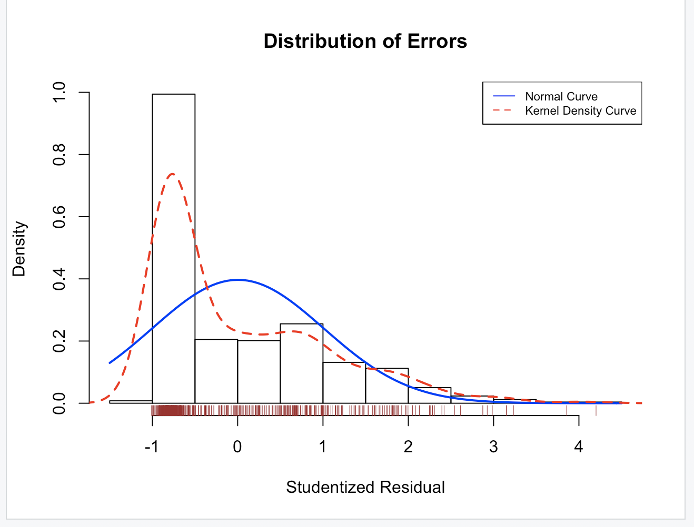

#The two models are consistent with respect to the normal distribution

#Indepedence of Errors

#Durbin-Watson Test

durbinWatsonTest(FF_fit_STFWI)

durbinWatsonTest(FF_fit_STM)

durbinWatsonTest(FF_fit_FWI)

durbinWatsonTest(FF_fit_M)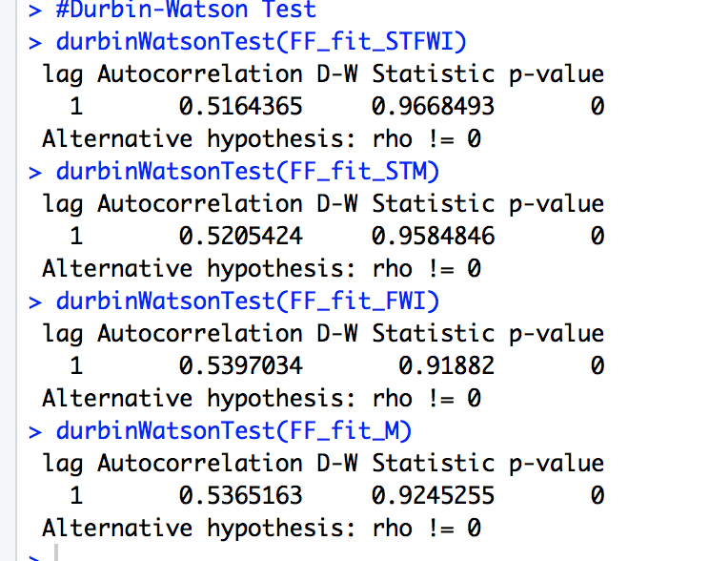

# The durbinWatsonTest checks the residuals for autocorrelation. When the p-value is < 0.5, the residuals are significantly correlated whereas p > 0.05 provides no evidence of correlation.

# All 4 models have autocorrelation feature.

#Linearity- Component plus residual plots

crPlots(FF_fit_STFWI) 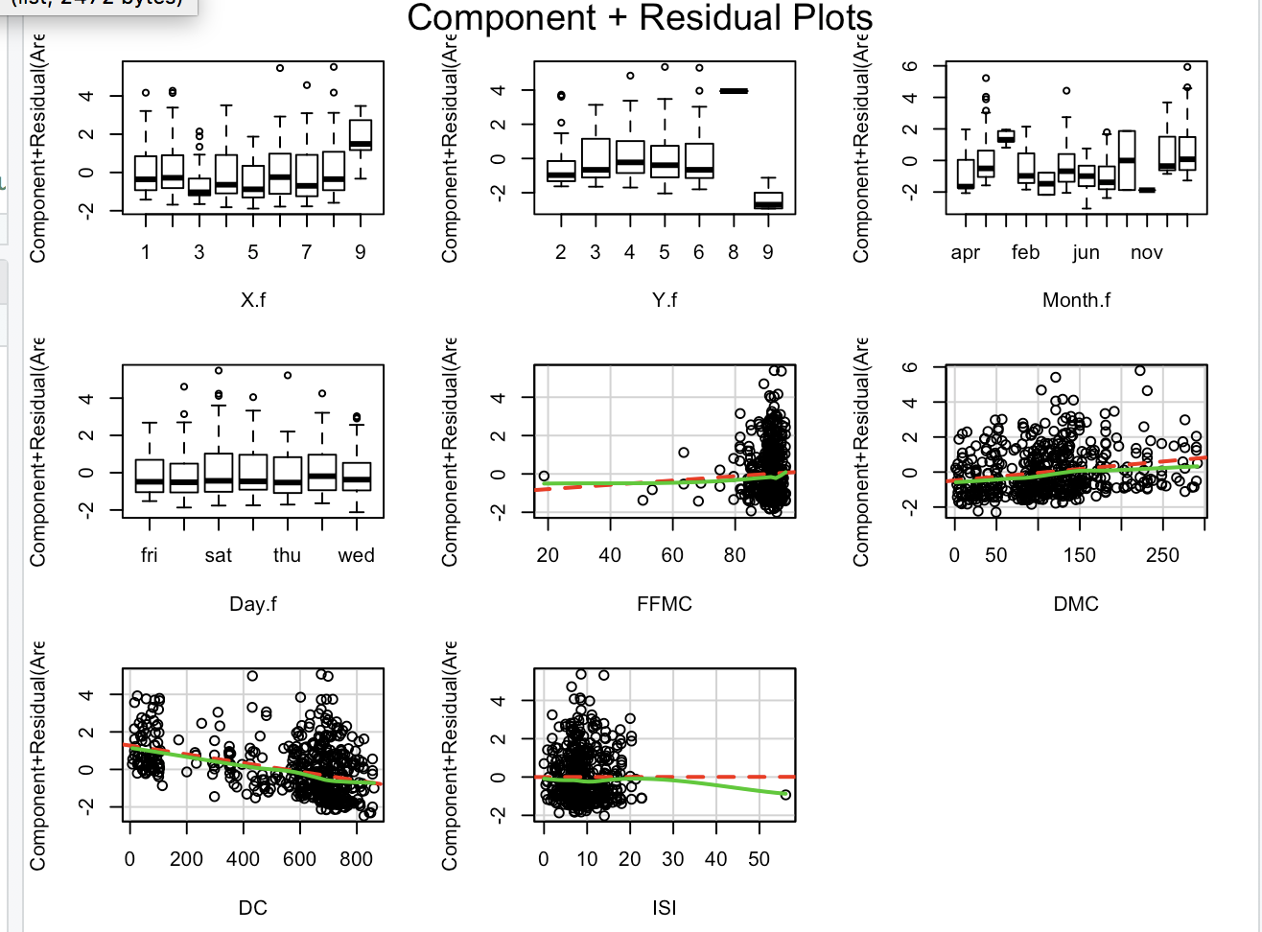

crPlots(FF_fit_STM) 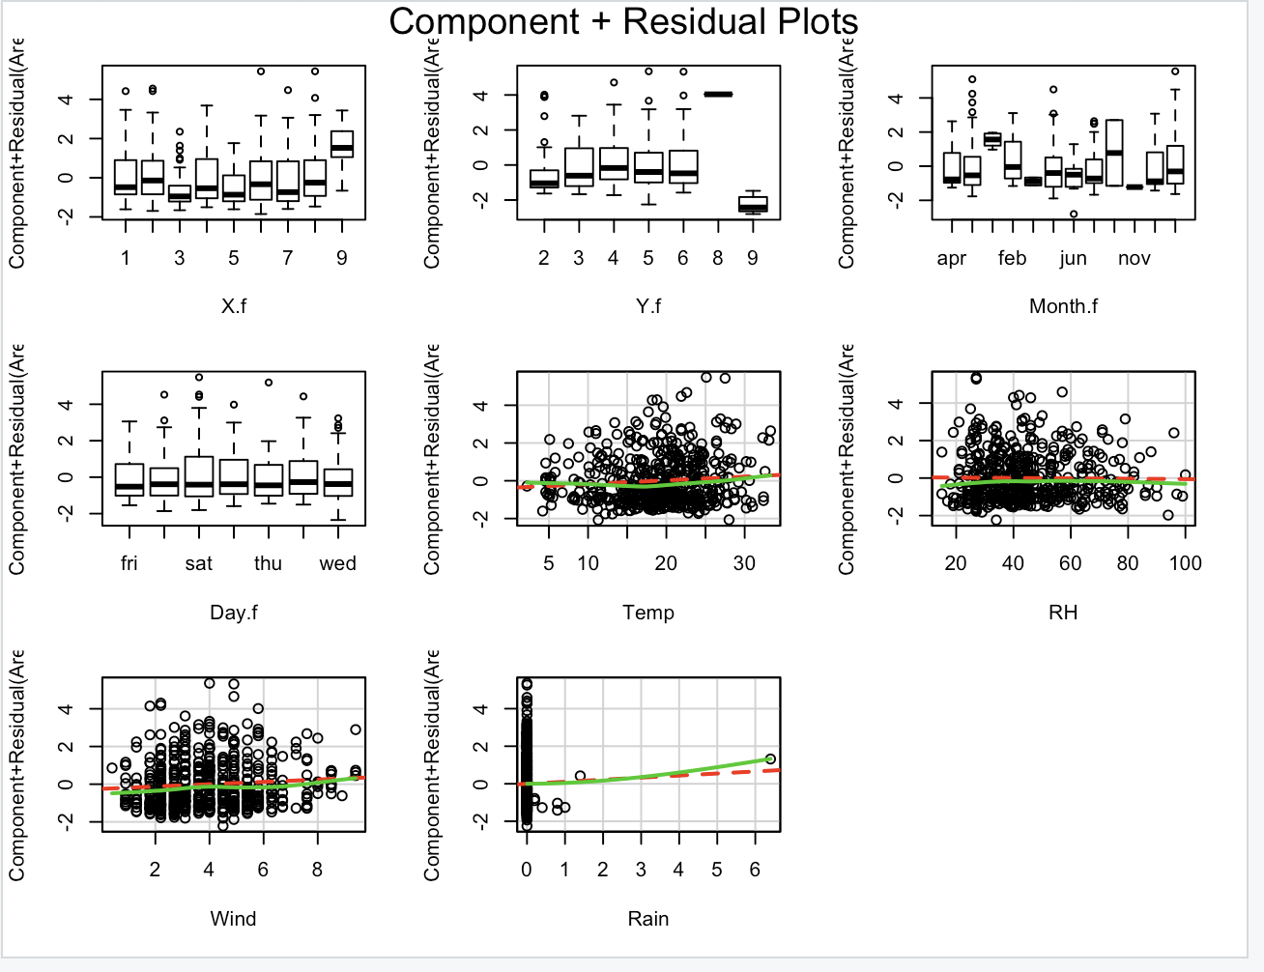

crPlots(FF_fit_FWI) 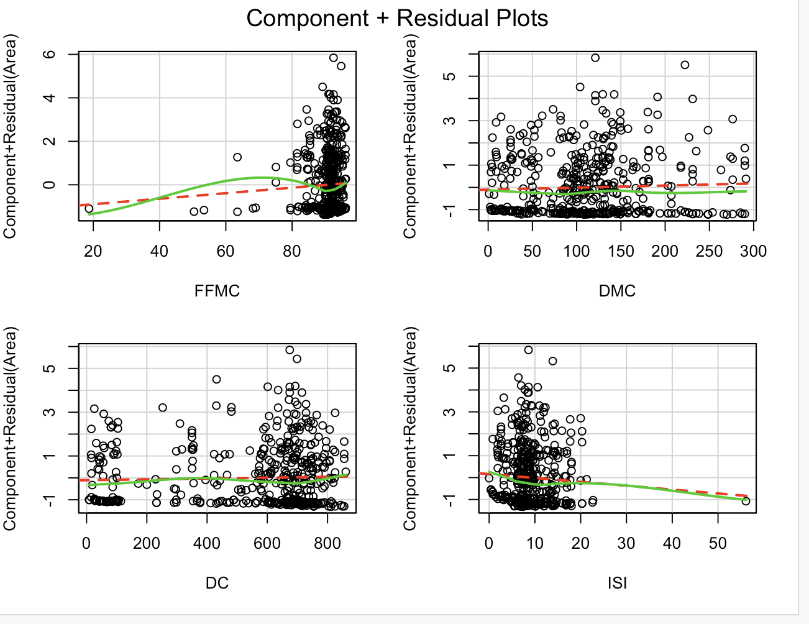

crPlots(FF_fit_M)

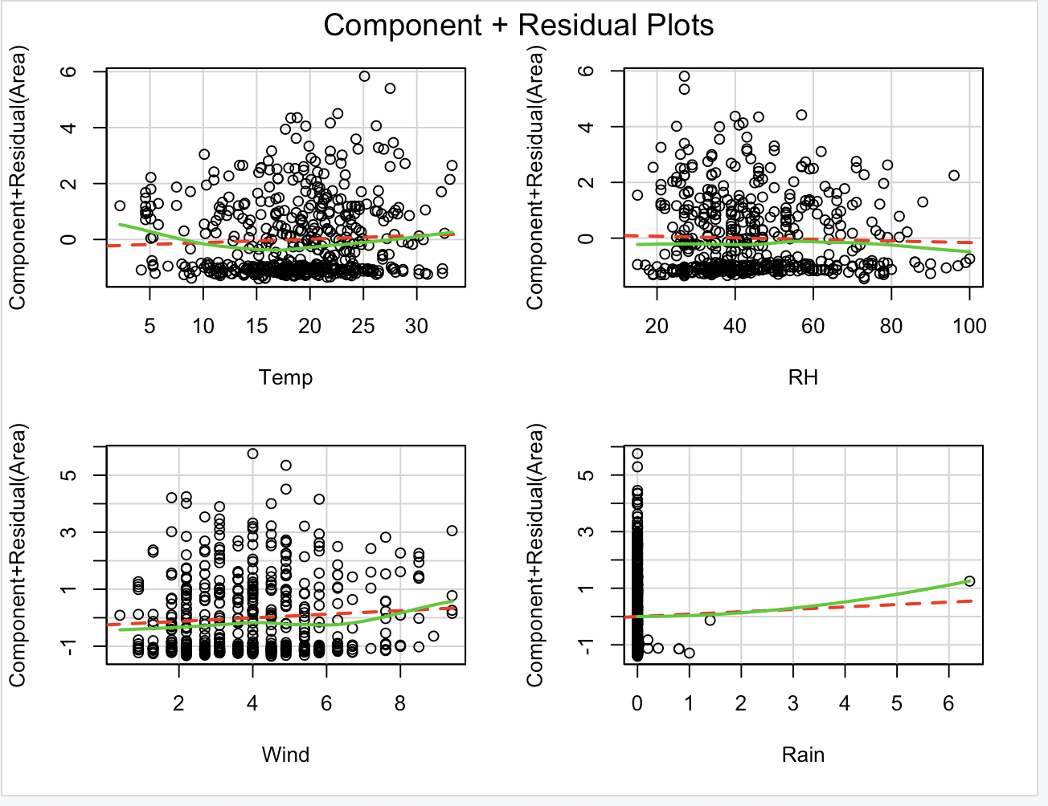

#Any nonlinearity in any of the above graphs suggest that we may have not adequately modeled the functional form of that predictor in the regression.

#From above graphs, we can confirm that we have met the linearity assumption.

#Homoscedasticity

ncvTest(FF_fit_STFWI)

spreadLevelPlot(FF_fit_STFWI)

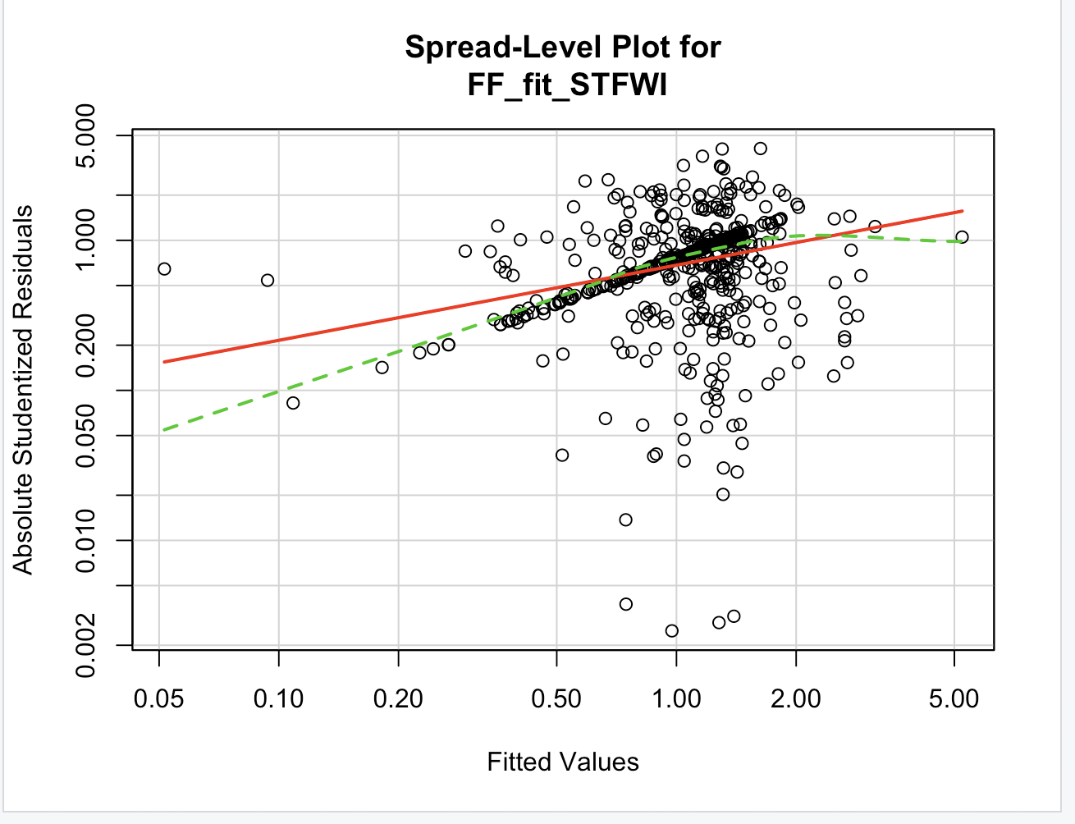

ncvTest(FF_fit_STM)

spreadLevelPlot(FF_fit_STM)

ncvTest(FF_fit_FWI)

spreadLevelPlot(FF_fit_FWI)

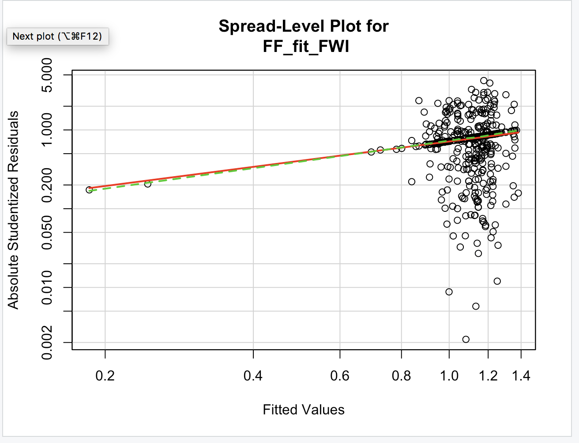

ncvTest(FF_fit_M)

spreadLevelPlot(FF_fit_M)

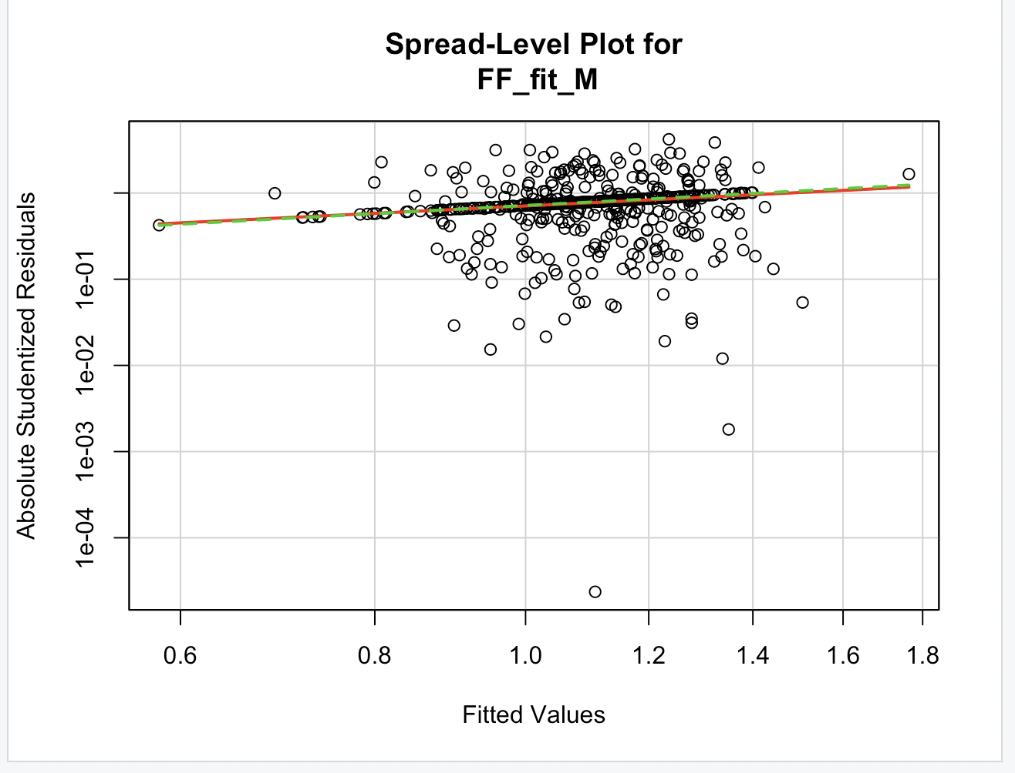

#In all the graphs, there are random points about the horizontal best fit line.

#If we had violated the assumption, we would see non-horizontal line.

# Global validation of linear model assumption

library(gvlma)

gvlma(FF_fit_STFWI)

gvlma(FF_fit_STM)

gvlma(FF_fit_FWI)

gvlma(FF_fit_M)

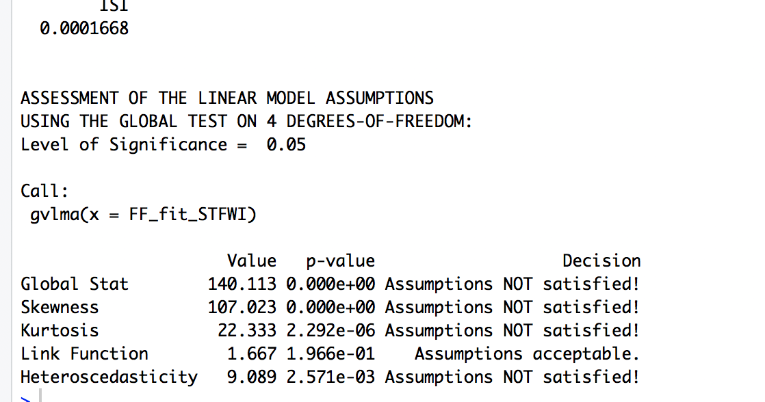

#The spread level plot has a positively correlated curve.

# which means the variances increases as the variables increase.

# Multicollinearity

vif(FF_fit_STFWI)

sqrt(vif(FF_fit_STFWI))>2

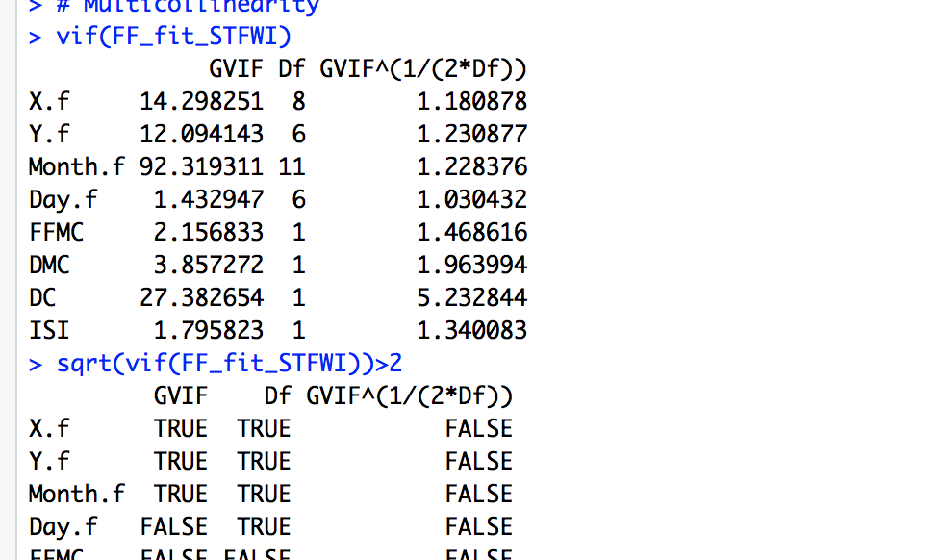

vif(FF_fit_STM)

sqrt(vif(FF_fit_STM))>2

vif(FF_fit_FWI)

sqrt(vif(FF_fit_FWI))>2

vif(FF_fit_M)

sqrt(vif(FF_fit_M))>2

#Only the DC variable has the problem of Multicolinearity

#Question 2.4:

# Identify unusual observations and take corrective measures

#Outlier Test

outlierTest(FF_fit_STFWI)

outlierTest(FF_fit_STM)

outlierTest(FF_fit_FWI)

outlierTest(FF_fit_M)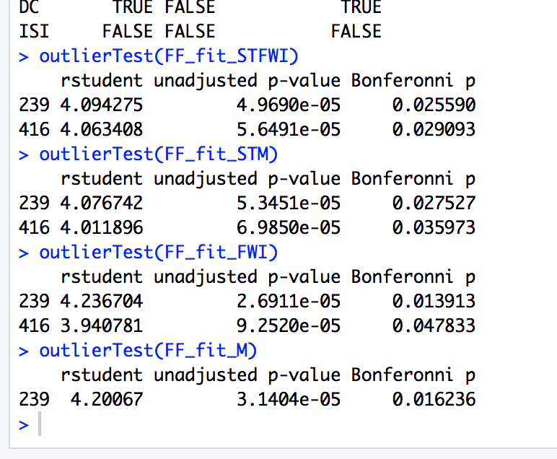

#The results of these models show that points 239 and 416 are outliers.

hat.plot<-function(fit){

p<-length(coefficients(fit))

n<-length(fitted(fit))

plot(hatvalues(fit),main="Index plot of Hat values")

abline(h=c(2,3)*p/n,col="red",lty=2)

identify(1:n,hatvalues(fit),names(hatvalues(fit)))

}

hat.plot(FF_fit_STFWI)

hat.plot(FF_fit_STM)

hat.plot(FF_fit_FWI)

hat.plot(FF_fit_M)

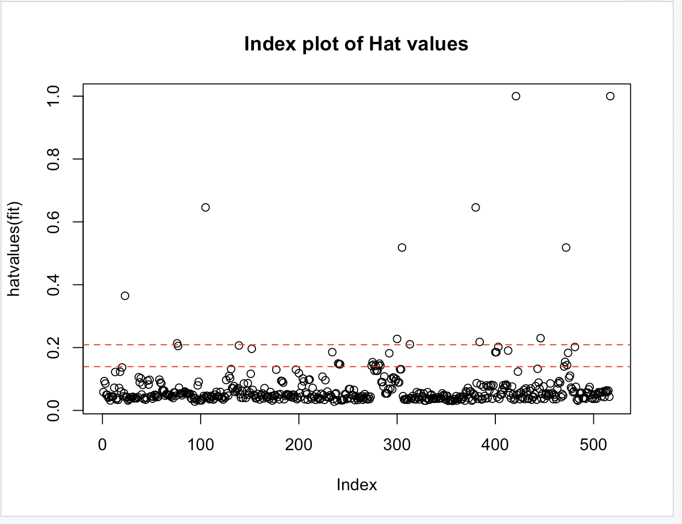

#Influential Observations

#Cook's distance

Dplot=function(fit,data){

cutoff<-4/(nrow(data)-length(fit$coefficients)-2)

plot(fit,which=4,cook.levels=cutoff)

abline(h=cutoff,lty=2,col="blue")

}

Dplot(FF_fit_STFWI,Forest_Fires_Data)

Dplot(FF_fit_STM,Forest_Fires_Data)

Dplot(FF_fit_FWI,Forest_Fires_Data)

Dplot(FF_fit_M,Forest_Fires_Data)

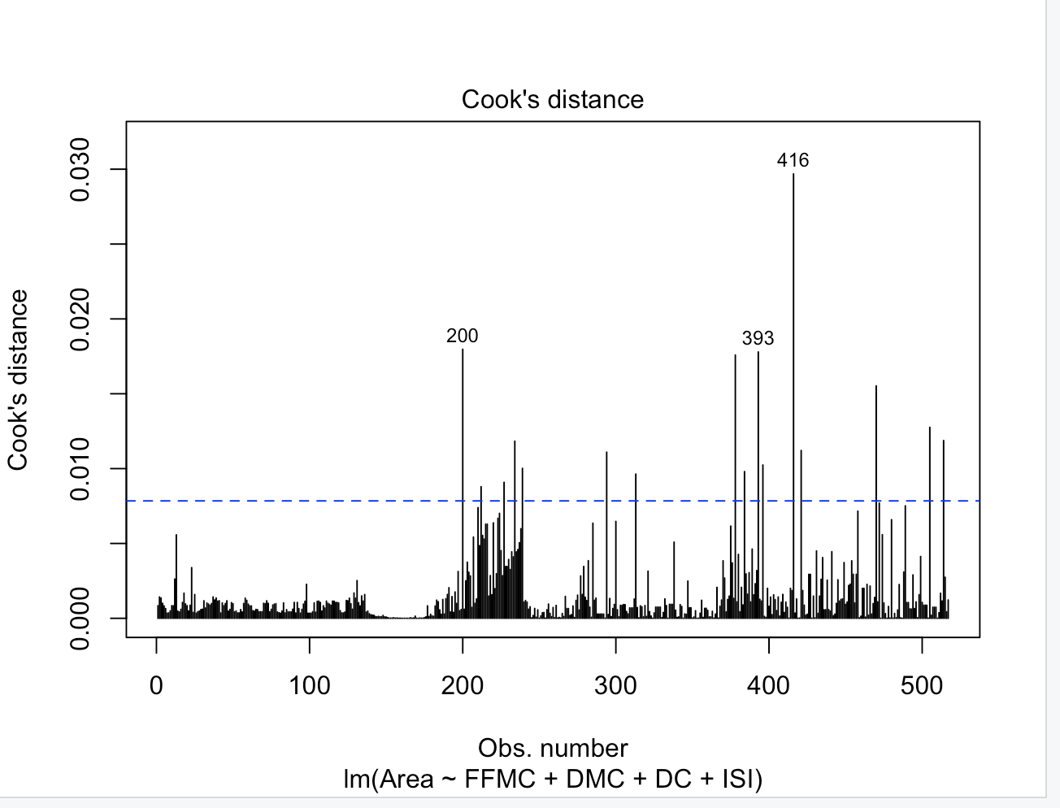

#Added variable plots

avPlots(FF_fit_STFWI, ask=FALSE, id.method ="identify",onepage=TRUE )

avPlots(FF_fit_STM, ask=FALSE, id.method ="identify",onepage=TRUE )

avPlots(FF_fit_FWI, ask=FALSE,id.method ="identify", onepage=TRUE )

avPlots(FF_fit_M, ask=FALSE,id.method ="identify", onepage=TRUE )

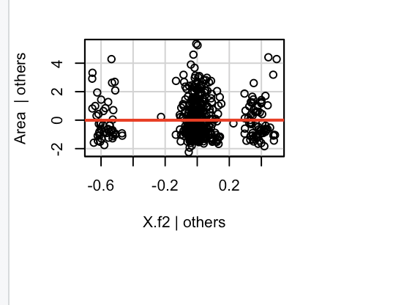

#Combined information by influence plot

influencePlot(FF_fit_STFWI,id.method="identify", main="Influence Plot 1", sub="Circle size is proportial to Cook's Distance")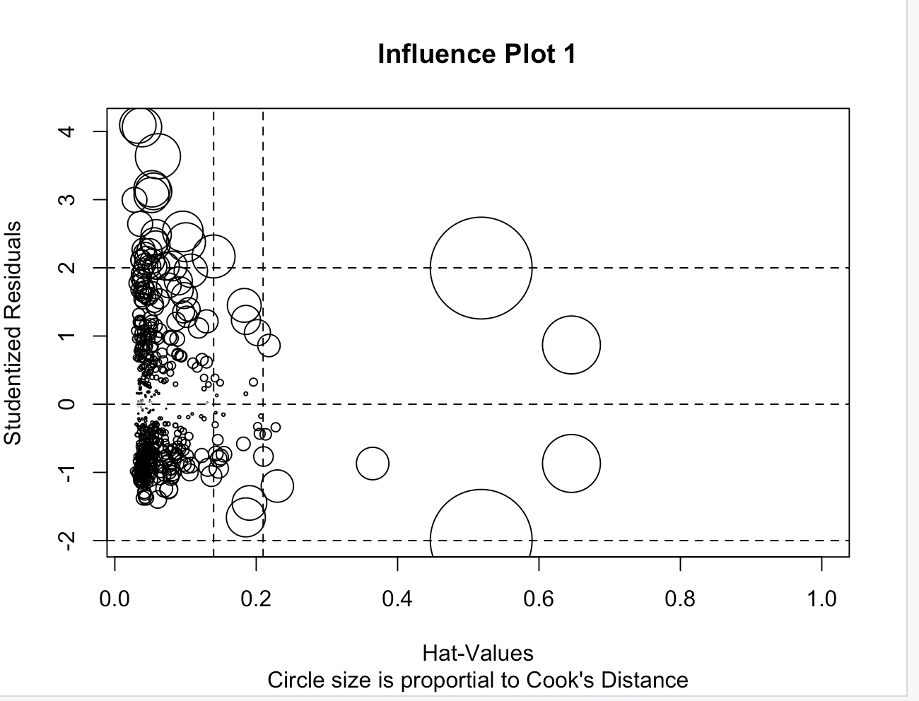

influencePlot(FF_fit_STM,id.method="identify", main="Influence Plot 2", sub="Circle size is proportial to Cook's Distance")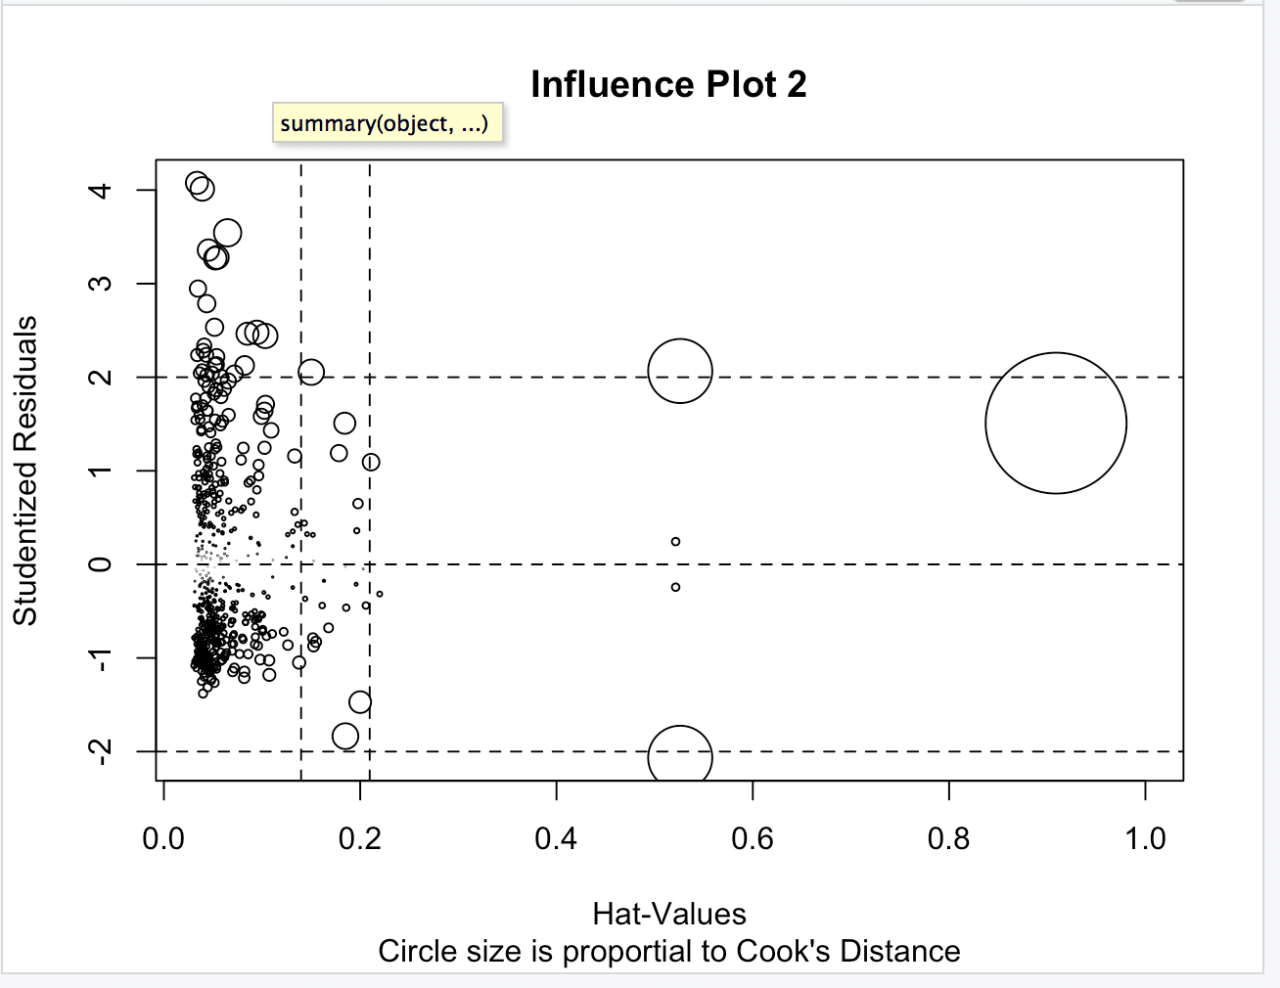

influencePlot(FF_fit_FWI,id.method="identify", main="Influence Plot 3", sub="Circle size is proportial to Cook's Distance")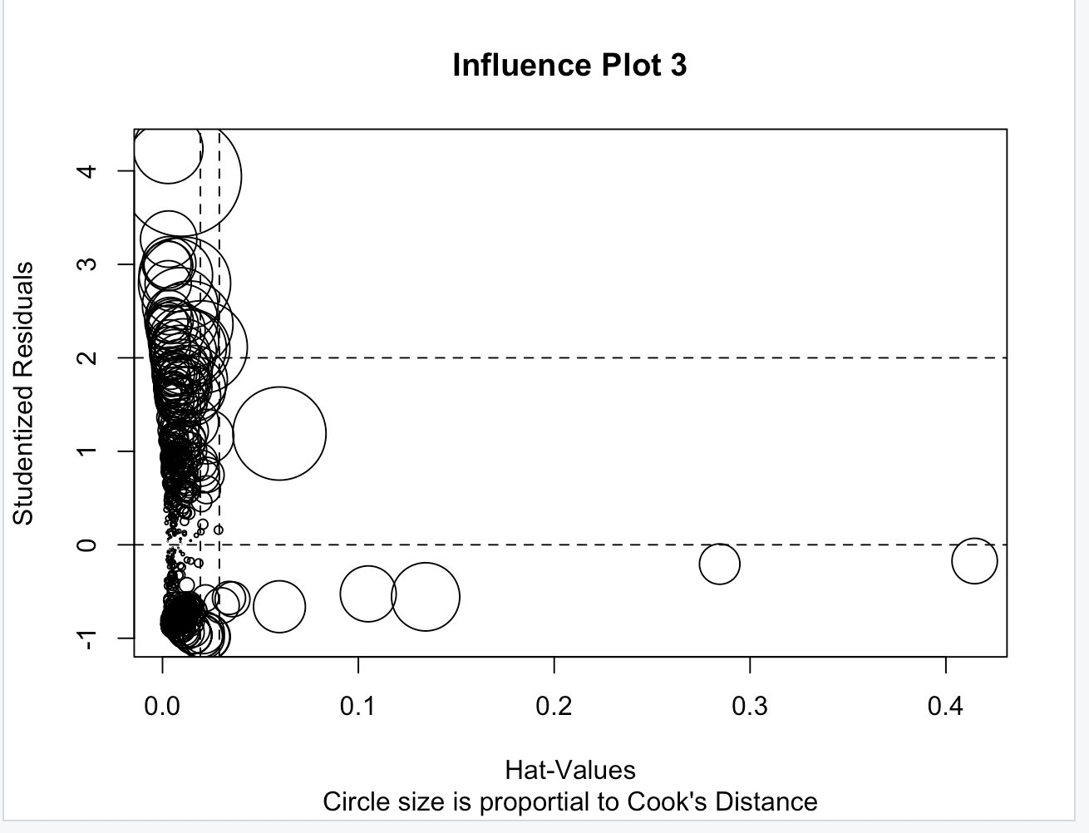

influencePlot(FF_fit_M,id.method="identify", main="Influence Plot 4", sub="Circle size is proportial to Cook's Distance")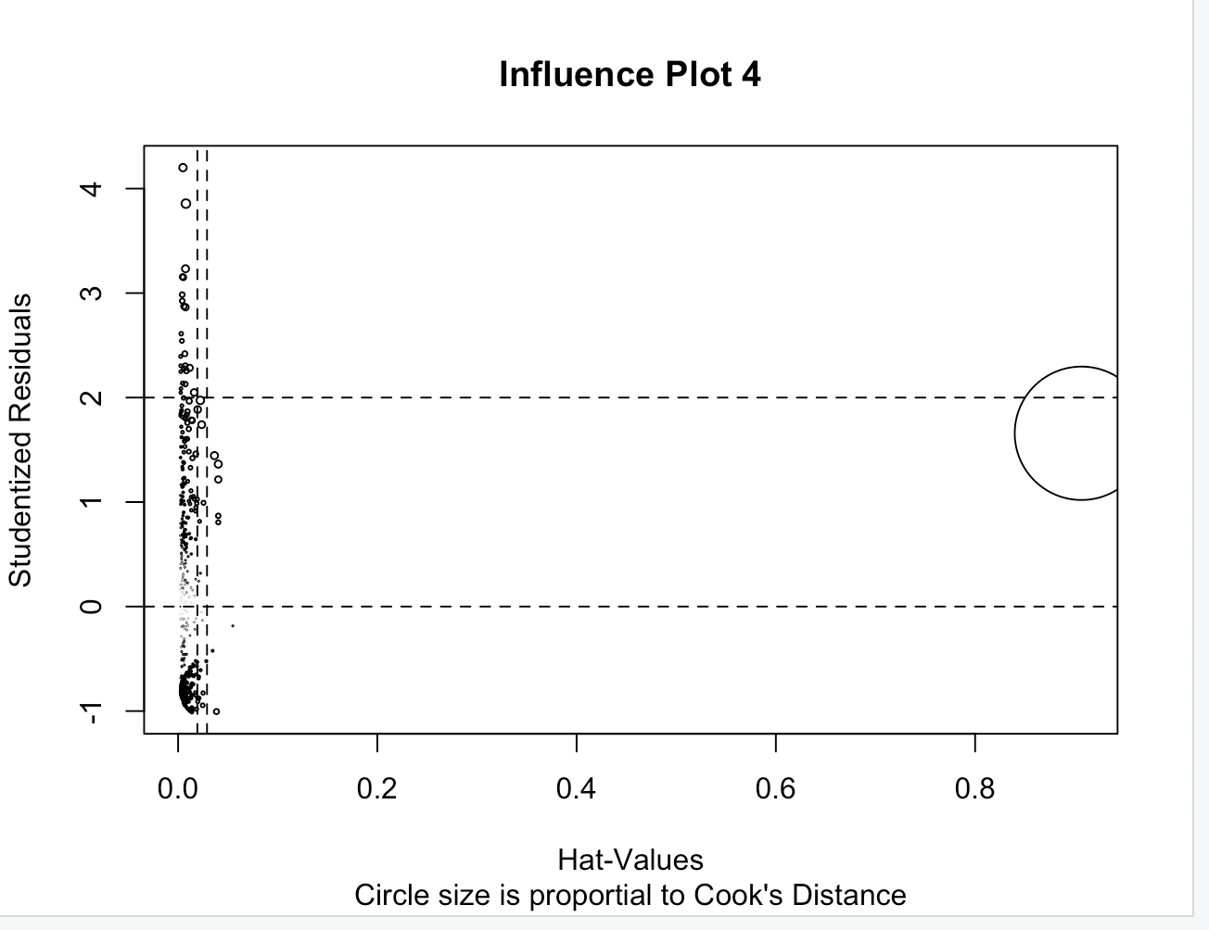

#Corrective measures:

#Deleting outliers

Forest_Fires_Data_Deleted = Forest_Fires_Data[c(-105, -239, -305, -416, -421, -517, -472, -480, -500),]

Forest_Fires_Data_Deleted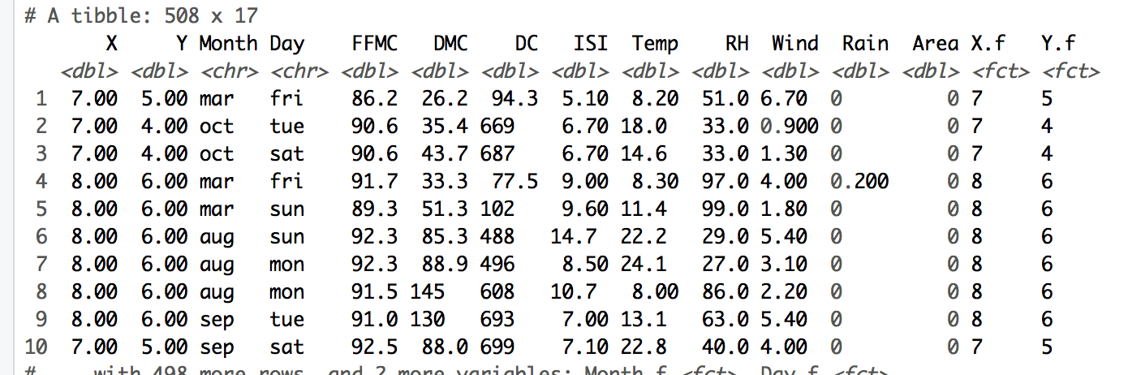

FF_fit_STFWI_Deleted = lm(Area ~ X.f + Y.f + Month.f + Day.f + FFMC + DMC + DC + ISI, data=Forest_Fires_Data_Deleted) summary(FF_fit_STFWI_Deleted)

D.plot(Model_STFWI_Deleted, Model_STFWI_Deleted)

FF_fit_STM_Deleted = lm(Area ~ X.f + Y.f + Month.f + Day.f + Temp + RH + Wind + Rain, data=Forest_Fires_Data_Deleted) summary(FF_fit_STM_Deleted)

FF_fit_FWI_Deleted = lm(Area ~ FFMC + DMC + DC + ISI, data=Forest_Fires_Data_Deleted) summary(FF_fit_FWI_Deleted)

FF_fit_M_Deleted = lm(Area ~ Temp + RH + Wind + Rain, data=Forest_Fires_Data_Deleted) summary(FF_fit_M_Deleted)

Forest_Fires_Data_Transformed = Forest_Fires_Data_Transformed$Area+1

summary(powerTransform(ForestfireData_Trans$Area))

Forest_Fires_Data_Transformed[,1]=Forest_Fires_Data_Transformed[,1]^(-0.7143)

FF_fit_STFWI_Trans = lm(Area ~ X.f + Y.f + Month.f + Day.f + FFMC + DMC + DC + ISI, data=Forest_Fires_Data_Transformed)

summary(powerTransform(FF_fit_STFWI_Trans))

FF_fit_STM_Trans = lm(Area ~ X.f + Y.f + Month.f + Day.f + Temp + RH + Wind + Rain, data=Forest_Fires_Data_Transformed)

summary(powerTransform(FF_fit_STM_Trans))

FF_fit_FWI_Trans = lm(Area ~ FFMC + DMC + DC + ISI, data=Forest_Fires_Data_Transformed)

summary(powerTransform(FF_fit_FWI_Trans))

FF_fit_M_Trans = lm(Area ~ Temp + RH + Wind + Rain, data=Forest_Fires_Data_Transformed)

summary(powerTransform(FF_fit_M_Trans))

#Deleting outliers, performing log transformations and removing influential observations can be executed as corrective measures.

#Question 5:

#Selecting the best regression model

anova(FF_fit_STFWI_Trans, FF_fit_STM_Trans, FF_fit_FWI_Trans, FF_fit_M_Trans)

AIC(FF_fit_STFWI_Trans, FF_fit_STM_Trans, FF_fit_FWI_Trans, FF_fit_M_Trans)

summary(FF_fit_STM_Trans)

summary(FF_fit_M_Trans)

#Variable selection

stepAIC(FF_fit_STM_Trans, direction = "backward")

FF_fit_STM_Back = lm(formula = Area ~ X.f + Y.f + Month.f + Wind, data = ForestfireData_Trans)

# The predicted variables have been refined

stepAIC(FF_fit_STM_Trans, direction = "forward")

FF_fit_STM_Forward = lm(formula = Area ~ X.f + Y.f + Month.f + Day.f + Temp + RH + Wind + Rain, data = ForestfireData_Trans)

# The variables have not changed.

stepAIC(FF_fit_STM_Trans, direction = "both")

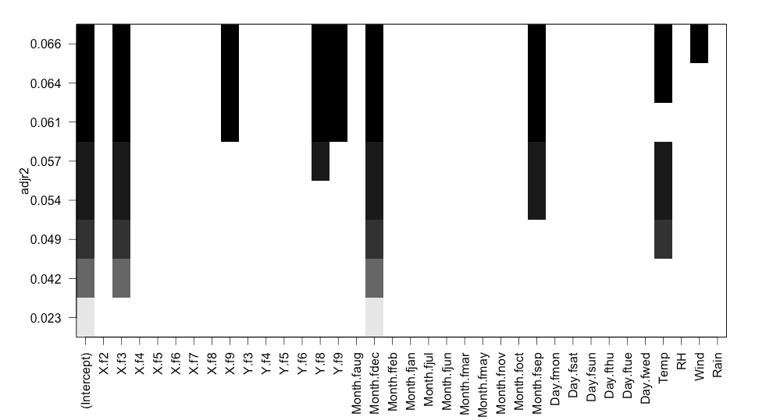

#Comparing the models, the backward model is better.

#Interpretation of the results

#According to the results of the three kinds of stepwise methods, Forward, Backward and stepwise,

#The RSS of the models , both in the forward and backward direction, were pretty close.

#There was a lower AIC model for the backward method which gave it the advantage of being a better model.

#Therefore the lower AIC value of the backward model makes it the optimal model for this dataset

# The Optimal Model would be : Area ~ X.f + Y.f + Month.f + Wind